# System Requirements Specifications (SRS)

## User Requirement Specification

The Law Firm Management System (LFMS) is an internal website, which allows management law office system. It must be includes five basic functions: Case management, Customer management, Staff management, Service management, Office management.

LFMS have only one back end component, system is designed for use by Administrators, Lawyers and Staff have the authority (if any).

## System Requirement Specification (Specific Requirements)

### External Interface Requirements

#### User Interfaces

System is designed so friendly and easy to use with users. Home page list all the records of reception Cases. Besides have the calendar, prompted by notification bar at the top.

All functions in menu must be grouped in a meaningful way to make it easy for users to locate and access the features.

#### Communications Protocol

The system is web base so it’s should be applied Hypertext Transfer Protocol (HTTP) is main communication protocol.

### Functional Requirements

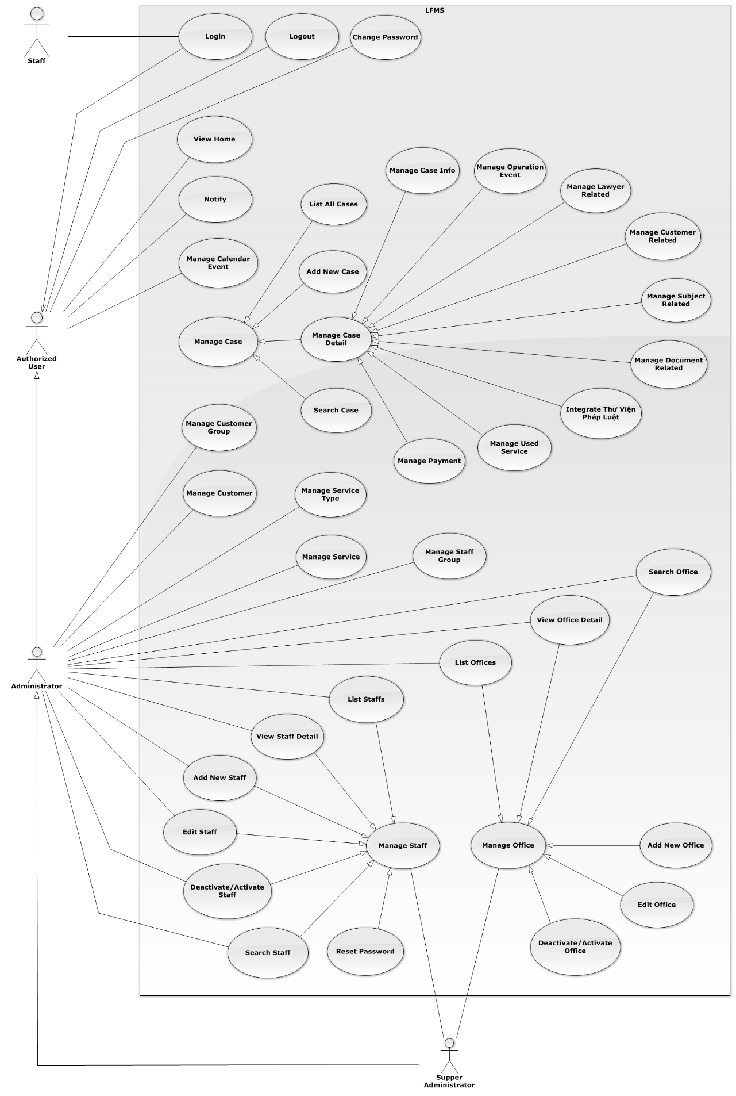

Figure 3: Overview Use-Case Diagram

#### Login

##### Login Use-Case Diagram

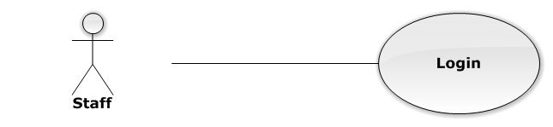

Figure 4: Login Use-Case Diagram

##### Login Use-Case Diagram Specification

|  |  |  |  |
| --- | --- | --- | --- |
| USE CASE SPECIFICATION | | | |
| Use-case No. | UC0001 | Use-case Version | 1.0 |
| Use-case Name | Login | | |
| Author | Nguyễn Thanh Sang | | |
| Date | 24/03/2014 | Priority | Normal |
| Actor:  Staff.  Summary:  This use case allows staff to log on into the system.  **Goal:**  Authenticate user.  Triggers:  User access website area that is intended staff.  Preconditions:  User has an account and has not logged in yet.  Post Conditions:  **Success**: User logged in. System redirects user to “Home” page.  **Failure**: System redirects to “Login” page.  Main Success Scenario:   |  |  |  | | --- | --- | --- | | *Step* | *User* | *System* | | 1 | User go to website page | Website will show [Login] page | | 2 | User input information into username field and password field |  | | 3 | Presses “Đăng nhập” button or click “Enter” key | Checks username and password.  Redirect to “Home” page.  [Exception 1]  [Exception 2] |   Alternative Scenario:  N/A  Exceptions:   |  |  |  | | --- | --- | --- | | *#* | *User* | *System* | | 1 | Presses “Login” button. If invalid username or password. | System redirect to “Login” page and display error message “Tên đăng nhập hoặc mật khẩu không đúng!” | | 2 | Presses “Login” button. If have error when connect database | System redirect to “Login” page and display error message “Lỗi kết nối đến máy chủ!” |   Relationships:  N/A  Business Rules:  N/A | | | |

#### Logout

##### Logout Use-Case Diagram

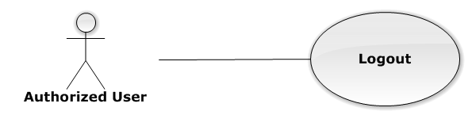

Figure 5: Logout Use-Case Diagram

##### Logout Use-Case Specification

|  |  |  |  |
| --- | --- | --- | --- |
| USE CASE SPECIFICATION | | | |
| Use-case No. | UC0002 | Use-case Version | 1.0 |
| Use-case Name | Logout | | |
| Author | Nguyễn Thanh Sang | | |
| Date | 24/03/2014 | Priority | Normal |
| Actor:  Authorized User.  Summary:  This use case allows staff to logout the system.  **Goal:**  The users can log out successful from their roles.  Triggers:  Staff click on “Đăng xuất” on User Control Panel.  Preconditions:  Staff has logged in to the website.  Post Conditions:  Success: Back to login screen  Failure: An error message is displayed.  Main Success Scenario:   |  |  |  | | --- | --- | --- | | *Step* | *User* | *System* | | 1 | Staff click “Đăng xuất” button on User Control Panel | The user name of user will be disappeared on webstie, Redirect to “Login” page. |   Alternative Scenario:  N/A  Exceptions:  N/A  Relationships:  N/A  Business Rules:  N/A | | | |

#### Change Password

##### Change Password Use-Case Diagram

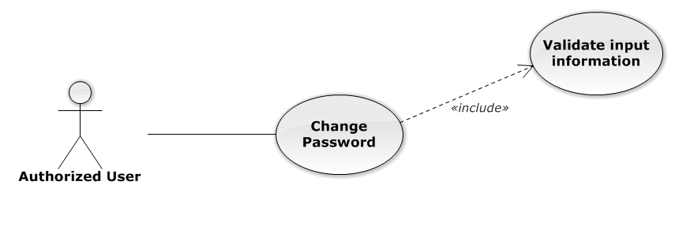

Figure 6: Change Password Use-Case Diagram

##### Change Password Use-Case Specification

|  |  |  |  |
| --- | --- | --- | --- |
| USE CASE SPECIFICATION | | | |
| Use-case No. | UC0003 | Use-case Version | 1.0 |
| Use-case Name | Change Password | | |
| Author | Nguyễn Thanh Sang | | |
| Date | 24/03/2014 | Priority | Normal |
| Actor:  Authorized User.  Summary:  This use case allows staff can change password of them.  **Goal:**  Change password.  Triggers:  User access website area and click on “Đổi mật khẩu”.  Preconditions:  User has logged in.  Post Conditions:  **Success**: The password is changed and display message “Cập nhật mật khẩu nhân viên thành công!”  **Failure**: Password is not changed. Display error message.  Main Success Scenario:   |  |  |  | | --- | --- | --- | | *Step* | *User* | *System* | | 1 | Staff has logged in, click on “Đổi mật khẩu” on User Control Panel. | Modal Popup “Thay đổi mật khẩu”is display with three fields:“Mật khẩu cũ, “Mật khẩu mới and “Lặp lại mật khẩu mới  Two button “Đóng” , “Đổi mật khẩu” | | 2 | User input information, Click “Đổi mật khẩu” button  [Alternative 1]  [Exception 1] | Check information validity and change password |   Alternative Scenario:   |  |  |  | | --- | --- | --- | | *#* | *User* | *System* | | 1 | Click on [X] button, “Đóng” button, or click out of modal | Modal popup is close |   Exceptions:   |  |  |  | | --- | --- | --- | | *#* | *User* | *System* | | 1 | Field “Mật khẩu cũ” are blank | Shows error message “Hãy nhập lại mật khẩu cũ” | | Field “Mật khẩu mới”, are blank | Shows error message “Hãy nhập mật khẩu mới” | | Field “Lặp lại mật khẩu mới ” are blank | Shows error message “Hãy nhập lại mật khẩu mới” | | Input to field “Mật khẩu cũ”, “Mật khẩu mới” and field “Lặp lại mật khẩu mới” regular expression. | Shows error message “Mật khẩu không được có kí tự đặc biệt” | | Input to field “Mật khẩu mới ” and field “Lặp lại mật khẩu mới ” not enough 6 character | Shows error message “Mật khẩu mới phải có ít nhất 6 kí tự” | | Input to field “Mật khẩu mới ” and field “Lặp lại mật khẩu mới ” are diffirent | Shows error message “Mật khẩu 2 không trùng khớp” | | Input to field “Mật khẩu cũ” not the same with database | Shows error message “Mật khẩu cũ không đúng!”. |   Relationships:  N/A  Business Rules:  N/A | | | |

#### View Home

##### View Home Use-Case Diagram

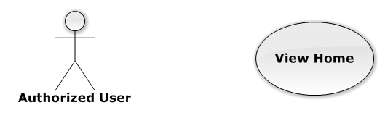

Figure 7: View Home Use-Case Diagram

##### View Home Use-Case Specification

|  |  |  |  |
| --- | --- | --- | --- |
| USE-CASE SPECIFICATION | | | |
| Use-case No. | UC0004 | Use-case Version | 1.0 |
| Use-case Name | View Home | | |
| Author | Nguyễn Thế Vinh | | |
| Date | 30/01/2014 | Priority | Normal |
| Actor:  Authorized User  Summary:  User must be Login before and then redirect them to “Trang Chủ” page.  Goal:  To allowing user to view some information of all Cases, which is operating and assigned by Staff related.  Triggers:   * User click on logo LFMS * Click on “Trang Chủ” link.   Preconditions:   * Must be logged-in * The page is fully loaded   Post Conditions:  Success: System redirect user to “Trang Chủ” page and list cases  Failure: Do nothing.  Main Success Scenario:   |  |  |  | | --- | --- | --- | | *Step* | *User* | *System* | | 1 | Click on logo LFMS or “Trang Chủ” link | * Redirect to “Trang Chủ” page * List Cases by Office filter |   Alternative Scenario:  N/A  Exceptions:  N/A  Relationships:  N/A  Business Rules:  N/A | | | |

#### Notify

##### Notify Use-Case Diagram

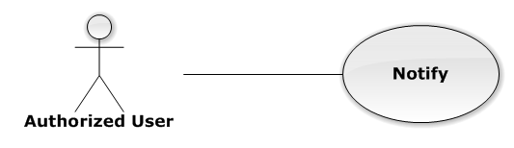

Figure 8: Notify Use-Case Diagram

##### Notify Use-Case Specification

|  |  |  |  |
| --- | --- | --- | --- |
| USE-CASE SPECIFICATION | | | |
| Use-case No. | UC0005 | Use-case Version | 1.0 |
| Use-case Name | Notify | | |
| Author | Nguyễn Thế Vinh | | |
| Date | 30/01/2014 | Priority | Normal |
| Actor:  Authorized User  Summary:  User must be login before and then the system will be show notification in navigation bar.  Goal:  User can see all Today's events.  Triggers:  The notification is always to show.  Preconditions:   * Must be logged-in * The page is fully loaded   Post Conditions:  Success: Show to user  Failure: Do nothing.  Main Success Scenario:   |  |  |  | | --- | --- | --- | | *Step* | *User* | *System* | | 1 | Login into the system | User can see notification about all Today's events |   Alternative Scenario:  N/A  Exceptions:  N/A  Relationships:  N/A  Business Rules:  N/A | | | |

#### Manage Calendar Event

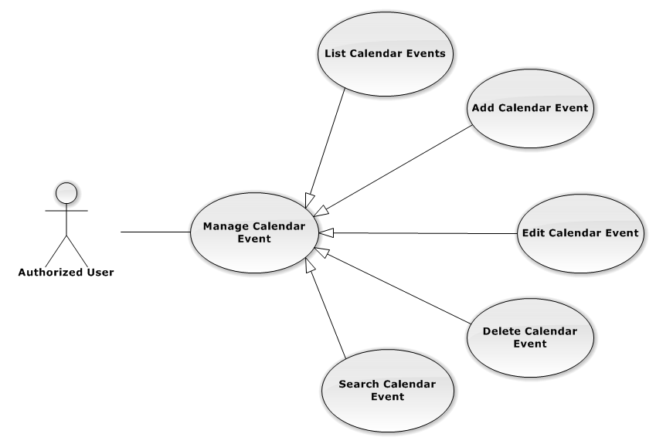

Figure 9: Manage Calendar Event Use-Case Diagram

##### List Calendar Events

###### List Calendar Events Use-Case Diagram

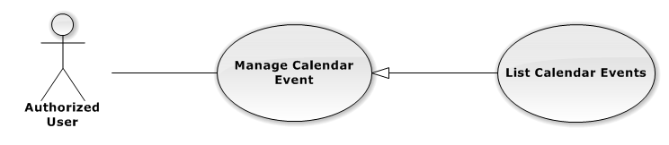

Figure 10: List Calendar Event Use-Case Diagram

###### List Calendar Events Use-Case Specification

|  |  |  |  |
| --- | --- | --- | --- |
| USE CASE SPECIFICATION | | | |
| Use-case No. | UC0006 | Use-case Version | 1.0 |
| Use-case Name | List Calendar Events | | |
| Author | Lê Duy Hoàng | | |
| Date | 30/01/2014 | Priority | Normal |
| Actor:  Authorized User.  Summary:  List All Calendar Event.  Goal:  The purpose of List Calendar Event use case is allowing User to view all Events in full-calendar.  Triggers:  User choose “Lịch làm việc” tab in Homepage.  Preconditions:  User is authenticated.  Post Conditions:  Success: All Calendar Events are listed.  Failure: N/A  Main Success Scenario:   |  |  |  | | --- | --- | --- | | *Step* | *User* | *System* | | 1 | Click “Lịch làm việc” tab in home page. | All Calendar Events are loaded. |   Alternative Scenario:  N/A  Exceptions:  N/A  Relationships:  Manage Calendar Event  Business Rules:  N/A | | | |

##### Add New Calendar Event

###### Add New Calendar Event Use-Case Diagram

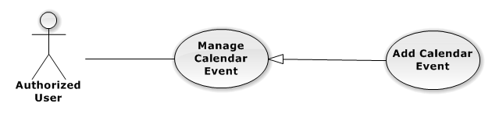

Figure 11: Add New Calendar Event

###### Add New Calendar Event Use-Case Specification

|  |  |  |  |
| --- | --- | --- | --- |
| USE CASE SPECIFICATION | | | |
| Use-case No. | UC0007 | Use-case Version | 1.0 |
| Use-case Name | Add New Calendar Event | | |
| Author | Lê Duy Hoàng | | |
| Date | 30/01/2014 | Priority | Normal |
| Actor:  Authorized User.  Summary:  Add new Calendar Event.  Goal:  The purpose of Add Calendar Event use case is allowing User to add new Calendar Event.  Triggers:  User choose “Lịch làm việc” tab in home page.  Preconditions:  User is authenticated.  Post Conditions:  Success: New Calendar Event is created.  Failure: N/A  Main Success Scenario:   |  |  |  | | --- | --- | --- | | *Step* | *User* | *System* | | 1 | Click anywhere in calendar. | Show Add new calendar event pop-up. | | 2 | Enters the Calendar Event Name |  | | 3 | Presses “Thêm Sự kiện” button.  [Alternative: 1] | Add new Calendar Event to database. |   Alternative Scenario:   |  |  |  | | --- | --- | --- | | *#* | *User* | *System* | | 1 | Presses “Đóng”, “X” button or click outside pop-up. | The Add New Calendar event pop-up is close. |   Exceptions:  N/A  Relationships:  Manage Calendar Event  Business Rules:  N/A | | | |

##### Edit Calendar Event

###### Edit Calendar Event Use-Case Diagram

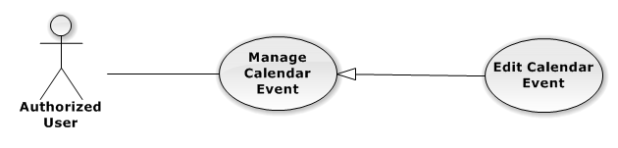

Figure 12: Edit Calendar Event Use-Case Diagram

###### Edit Calendar Event Use-Case Specification

|  |  |  |  |
| --- | --- | --- | --- |
| USE CASE SPECIFICATION | | | |
| Use-case No. | UC0008 | Use-case Version | 1.0 |
| Use-case Name | Edit Calendar Event | | |
| Author | Lê Duy Hoàng | | |
| Date | 30/01/2014 | Priority | Normal |
| Actor:  Authorized User.  Summary:  Update Calendar Event.  Goal:  The purpose of Update Calendar Event use case is allowing User to edit Calendar Event.  Triggers:  User choose “Lịch làm việc” tab in Homepage.  Preconditions:  User is authenticated.  Post Conditions:  Success: The Calendar Event is Updated.  Failure: N/A  Main Success Scenario:   |  |  |  | | --- | --- | --- | | *Step* | *User* | *System* | | 1 | Click at an exist event. | Show edit calendar event pop-up. | | 2 | Enters the new Calendar Event Name |  | | 3 | Presses “Lưu chỉnh sửa” button.  [Alternative: 1] | Update Calendar event to database. | | 1 | Drag and drop an exist event. | Update Calendar event to database. | | 1 | Reside an exist event. | Update Calendar event to database. |   Alternative Scenario:   |  |  |  | | --- | --- | --- | | *#* | *User* | *System* | | 1 | Presses “Đóng”, “X” button or click outside pop-up. | The Update Clendar event pop-up is close. |   Exceptions:  N/A  Relationships:  Manage Calendar Event  Business Rules:  N/A | | | |

##### Delete Calendar Event

###### Delete Calendar Event Use-Case Diagram

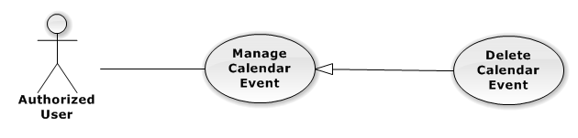

Figure 13: Delete Calendar Event Use-Case Diagram

###### Delete Calendar Event Use-Case Specification

|  |  |  |  |
| --- | --- | --- | --- |
| USE CASE SPECIFICATION | | | |
| Use-case No. | UC0009 | Use-case Version | 1.0 |
| Use-case Name | Delete Calendar Event | | |
| Author | Lê Duy Hoàng | | |
| Date | 30/01/2014 | Priority | Normal |
| Actor:  Authorized User.  Summary:  Delete Calendar Event.  Goal:  The purpose of Delete Calendar Event use case is allowing User to delete Calendar Event.  Triggers:  User choose “Lịch làm việc” tab in Homepage.  Preconditions:  User is authenticated.  Post Conditions:  Success: The Calendar Event is deleted.  Failure: N/A  Main Success Scenario:   |  |  |  | | --- | --- | --- | | *Step* | *User* | *System* | | 1 | Click at an exist event. | Show confirm pop-up | | 2 | Presses “Xóa sự kiện” button.  [Alternative: 1] | Delete Calendar Event from database. |   Alternative Scenario:   |  |  |  | | --- | --- | --- | | *#* | *User* | *System* | | 1 | Presses “Đóng”, “X” button or click outside pop-up. | The confirm pop-up is close. |   Exceptions:  N/A  Relationships:  Manage Calendar Event  Business Rules:  N/A | | | |

##### Search Calendar Event

###### Search Calendar Event Use-Case Diagram

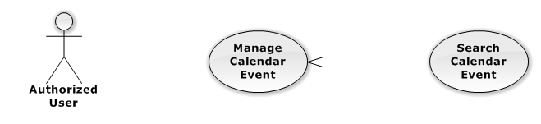

Figure 14: Search Calendar Event Use-Case Diagram

###### Search Calendar Event Use-Case Specification

|  |  |  |  |
| --- | --- | --- | --- |
| USE CASE SPECIFICATION | | | |
| Use-case No. | UC0010 | Use-case Version | 1.0 |
| Use-case Name | Search Calendar Event | | |
| Author | Lê Duy Hoàng | | |
| Date | 30/01/2014 | Priority | Normal |
| Actor:  Authorized User.  Summary:  Show all Calendar Event of a Staff.  Goal:  The purpose of Search Calendar Event use case is allowing User to view Calendar event of other staff.  Triggers:  Click at “Lịch làm việc luật sư khác” button.  Preconditions:  User is authenticated.  Post Conditions:  Success: The Calendar Event is showed.  Failure: Do nothing.  Main Success Scenario:   |  |  |  | | --- | --- | --- | | *Step* | *User* | *System* | | 1 | Click at “Lịch làm việc luật sư khác” button. | Show helper frame. | | 2 | Choose a staff in combo-box | Show al Calendar Event of these Staff. |   Alternative Scenario:  N/A  Exceptions:  N/A  Relationships:  Manage calendar event  Business Rules:  N/A | | | |

#### Manage Case

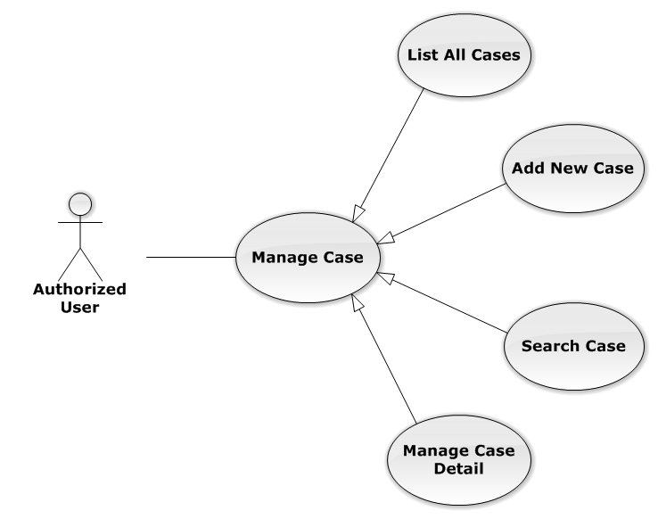

Figure 15: Manage Case Use-Case Diagram

##### List All Cases

###### List All Cases Use-Case Diagram

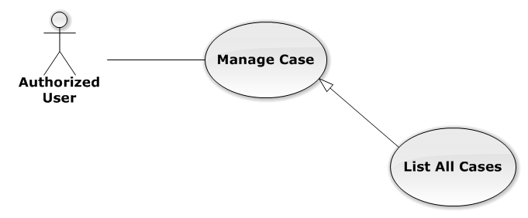

Figure 16: List All Cases Use-Case Diagram

###### List All Cases Use-Case Specification

|  |  |  |  |
| --- | --- | --- | --- |
| USE-CASE SPECIFICATION | | | |
| Use-case No. | UC0011 | Use-case Version | 1.0 |
| Use-case Name | List All Cases | | |
| Author | Nguyễn Thế Vinh | | |
| Date | 30/01/2014 | Priority | Normal |
| Actor:  Authorized User  Summary:  Redirect to “Danh sách hồ sơ” page and list all cases.  Goal:  To allowing customer to view any detail information of all Cases  Triggers:   * User click on User Control Panel and then click on “Danh sách hồ sơ” link * Click on “Danh sách hồ sơ” link in Case Detail of each Case   Preconditions:   * Must be logged-in * The page is fully loaded   Post Conditions:  Success: System redirects user to “Danh sách hồ sơ” page.  Failure: Do nothing.  Main Success Scenario:   |  |  |  | | --- | --- | --- | | *Step* | *User* | *System* | | 1 | Click on “Danh sách hồ sơ” link | * Redirect to “Danh sách hồ sơ” page * Show all Cases by searching condition |   Alternative Scenario:  N/A  Exceptions:  N/A  Relationships:  Manage Case  Business Rules:  N/A | | | |

##### Add New Case

###### Add New Case Use-Case Diagram

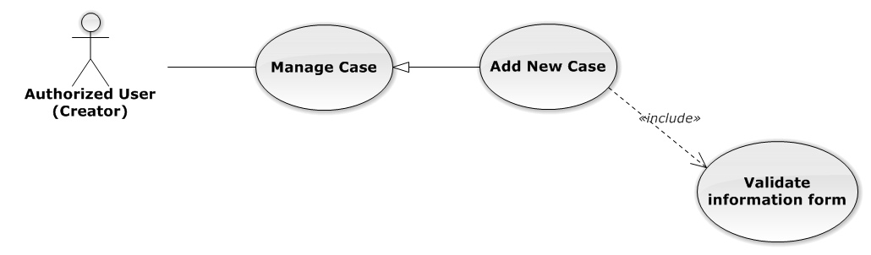

Figure 17: Add New Case Use-Case Diagram

###### Add New Case Use-Case Specification

|  |  |  |  |
| --- | --- | --- | --- |
| USE-CASE SPECIFICATION | | | |
| Use-case No. | UC0012 | Use-case Version | 1.0 |
| Use-case Name | Add New Case | | |
| Author | Nguyễn Thế Vinh | | |
| Date | 30/01/2014 | Priority | High |
| Actor:  Authorized User have “Creator” role  Summary:  Staff can add new case by input data on form modal  Goal:  Helps Staff input information of a case when they add new one  Triggers:  Staff click on “Thêm mới” button in modal  Preconditions:   * Must be logged-in with “Creator” role * The page is fully loaded   Post Conditions:  Success:   * Add new case successful * Add current Staff to Lawyer Related of the new Case * Redirect to view detail page of new case   Failure: System display error message “Thêm hồ sơ thất bại!”  Main Success Scenario:   |  |  |  | | --- | --- | --- | | *Step* | *User* | *System* | | 1 | * Staff click on icon-plus button in “Trang chủ” page * Click on “Thêm hồ sơ tác nghiệp” button in “Danh sách hồ sơ” page | Modal popup is displayed with fields for input information of new case | | 2 | Input corresponding information in form then click “Thêm mới” button  [Alternative 1]  [Exception 1] | * Modal popup is close * System display successful message “Thêm hồ sơ thành công!” * Update list case on page |   Alternative Scenario:   |  |  |  | | --- | --- | --- | | *#* | *User* | *System* | | 1 | Click on [X] button, “Đóng” button, or click out of modal | Modal popup is close |   Exceptions:   |  |  |  | | --- | --- | --- | | *#* | *User* | *System* | | 1 | Leave empty require fields then click on “Thêm mới” button | Modal popup display validation for needed to input field |   Relationships:  Manage Case  Business Rules:   * Authorized User must have “Creator” role to use this function * After create case successfully, system will be automatically assign Creator into that new case | | | |

##### Search Case

###### Search Case Use-Case Diagram

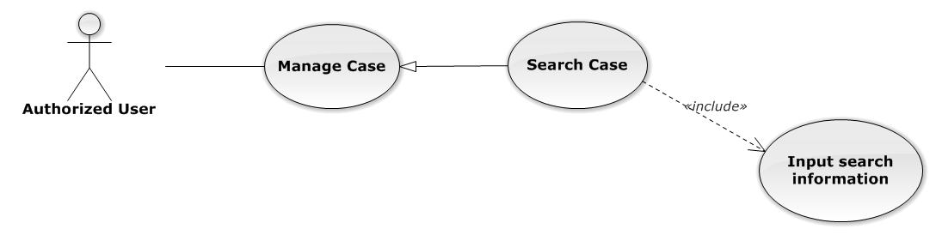

Figure 18: Search Case Use-Case Diagram

###### Search Case Use-Case Specification

|  |  |  |  |
| --- | --- | --- | --- |
| USE-CASE SPECIFICATION | | | |
| Use-case No. | UC0013 | Use-case Version | 1.0 |
| Use-case Name | Search Case | | |
| Author | Nguyễn Thế Vinh | | |
| Date | 30/01/2014 | Priority | Normal |
| Actor:  Authorized User  Summary:  Staff can search Cases by multi condition  Goal:  Helps Staff to search Cases of system more easy  Triggers:  Staff inputs key words on “Tìm kiếm” textbox at the top right of case list table to search follow key words inputted. When the key up, system will be automatic search.  Preconditions:   * Must be logged-in * The page is fully loaded * Inputs key words on “Tìm kiếm” textbox   Post Conditions:  Success: Cases of the system are displayed page by page  Failure: Do nothing  Main Success Scenario:   |  |  |  | | --- | --- | --- | | *Step* | *User* | *System* | | 1 | Input key words into textbox and then key up  [Alternative 1]  [Alternative 2]  [Alternative 3] | Display cases matches key words and multi condition |   Alternative Scenario:   |  |  |  | | --- | --- | --- | | *#* | *User* | *System* | | 1 | Select number result in page | Display many cases follow number result in page | | 2 | Click on another page number | Display many cases result in another page | | 3 | Click on “Mã hồ sơ” link | Redirect to view Case detail |   Exceptions:  N/A  Relationships:  Manage Case  Business Rules:  N/A | | | |

##### Manage Case Detail

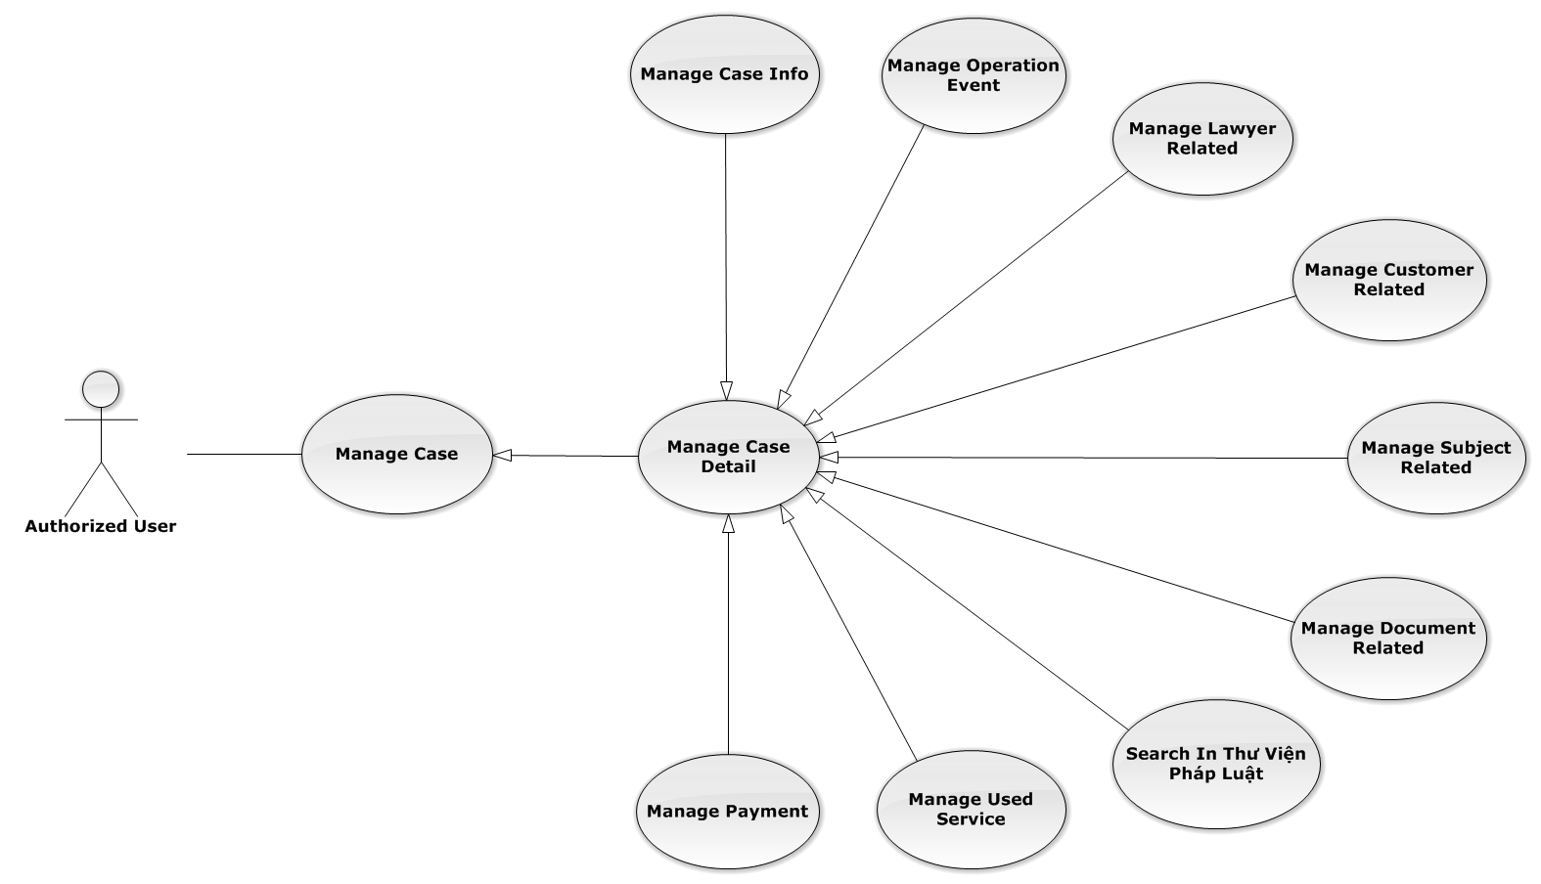

Figure 19: Manage Case Detail Use-Case Diagram

###### Manage Case Info

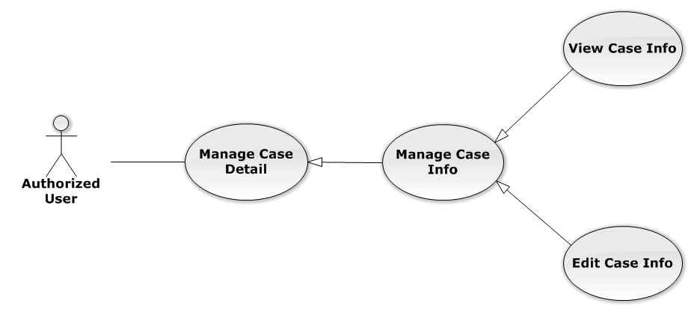

Figure 20: Manage Case Info Use-Case Diagram

View Case Info

View Case Info Use-Case Diagram

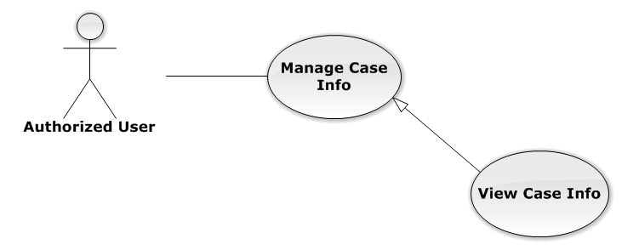

Figure 21: View Case Info Use-Case Diagram

View Case Info Use-Case Specification

|  |  |  |  |
| --- | --- | --- | --- |
| USE-CASE SPECIFICATION | | | |
| Use-case No. | UC0014 | Use-case Version | 1.0 |
| Use-case Name | View Case Info | | |
| Author | Nguyễn Thế Vinh | | |
| Date | 30/01/2014 | Priority | Normal |
| Actor:  Authorized User  Summary:  Staff can view current case’s information  Goal:  Helps staff to get detail and main content of the case quickly  Triggers:   * Staff click on “Mã hồ sơ” link in “Danh sách hồ sơ” * Staff click on big button corresponding with each case on “Trang chủ”   Preconditions:   * Must be logged-in * The page is fully loaded * Must be in Case Detail page   Post Conditions:  Success: The case’s detail is displayed correctly and successfully  Failure: Do nothing  Main Success Scenario:   |  |  |  | | --- | --- | --- | | *Step* | *User* | *System* | | 1 | * Staff click on “Mã hồ sơ” link in “Danh sách hồ sơ” * Staff click on big button on “Trang chủ” | * System redirect to Case Detail page * Show detail of main case content |   Alternative Scenario:  N/A  Exceptions:  N/A  Relationships:  Manage Case Info  Business Rules:  N/A | | | |

Edit Case Info

Edit Case Info Use-Case Diagram

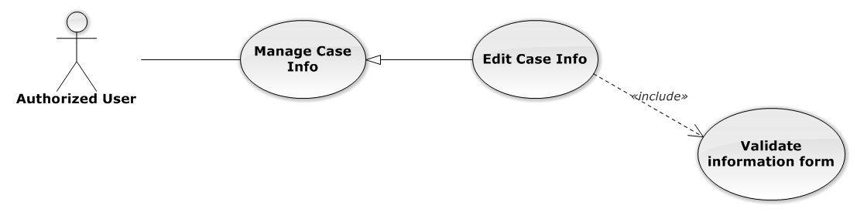

Figure 22: Edit Case Info Use-Case Diagram

Edit Case Info Use-Case Specification

|  |  |  |  |
| --- | --- | --- | --- |
| USE-CASE SPECIFICATION | | | |
| Use-case No. | UC0015 | Use-case Version | 1.0 |
| Use-case Name | Edit Case Info | | |
| Author | Nguyễn Thế Vinh | | |
| Date | 30/01/2014 | Priority | Normal |
| Actor:  Authorized User who is assigned in current case  Summary:  Staff can edit and update case detail  Goal:  Helps Staff easy to update case information  Triggers:  Staff click on “Lưu chỉnh sửa” button  Preconditions:   * Must be logged-in * The page is fully loaded * Must be in Case Detail page * Click on edit icon beside “Thông tin chung” label before and the case have “Đang thụ lý” status   Post Conditions:  Success: The case detail will be updated and system display message “Cập nhật chi tiết hồ sơ thành công!”  Failure: System display message “Cập nhật chi tiết hồ sơ thất bại!”  Main Success Scenario:   |  |  |  | | --- | --- | --- | | *Step* | *User* | *System* | | 1 | Click on edit icon beside “Thông tin chung” label  [Exception 1] | * All off fields will enable to input * “Hủy chỉnh sửa” and “Lưu chỉnh sửa” button is display | | 2 | Input information and then click “Lưu chỉnh sửa” button  [Alternative 1]  [Exception 2] | * The case detail will be updated * System display message “Cập nhật chi tiết hồ sơ thành công!” * All off fields will disable * “Hủy chỉnh sửa” and “Lưu chỉnh sửa” button is hidden |   Alternative Scenario:   |  |  |  | | --- | --- | --- | | *#* | *User* | *System* | | 1 | Click on “Hủy chỉnh sửa” button | * The case detail will be reloaded * All off fields will disable * “Hủy chỉnh sửa” and “Lưu chỉnh sửa” button is hidden |   Exceptions:   |  |  |  | | --- | --- | --- | | *#* | *User* | *System* | | 1 | Click on edit icon when the case have “Đã thụ lý” status | System display message “Hồ sơ đã thụ lý!” | | 2 | Leave empty require fields then click on “Lưu chỉnh sửa” button | Display validation message for needed to input field |   Relationships:  Manage Case Info  Business Rules:  Only Administrator or Authorized User is assigned in current case can be use this function when status of case is “Đang thụ lý” and Office that have current case must is active. | | | |

###### Manage Operation Event

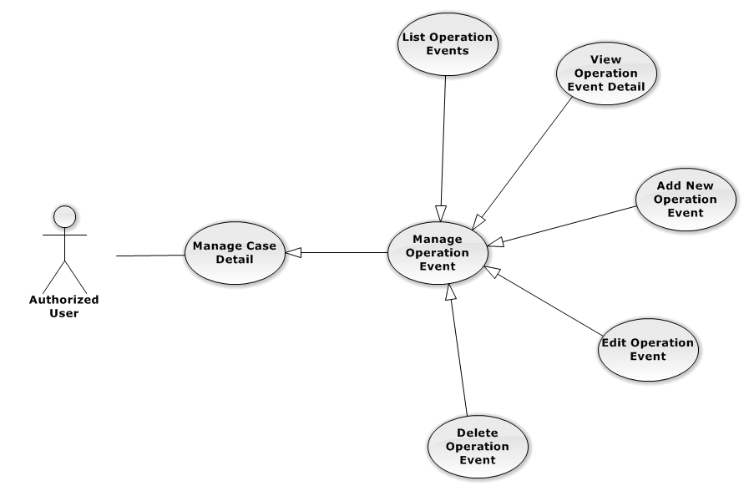

Figure 23: Manage Operation Event Use-Case Diagram

List Operation Events

List Operation Events Use-Case Diagram

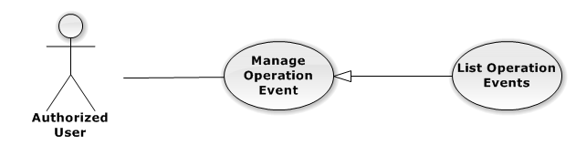

Figure 24: List Operation Events Use-Case Diagram

List Operation Events Use-Case Specification

|  |  |  |  |
| --- | --- | --- | --- |
| USE-CASE SPECIFICATION | | | |
| Use-case No. | UC0016 | Use-case Version | 1.0 |
| Use-case Name | List Operation Events | | |
| Author | Nguyễn Tiến Thành | | |
| Date | 30/01/2014 | Priority | Normal |
| Actor:  Authorized User  Summary:  Show all event of case.  Goal:  Help staff to view all event of case.  Triggers:  User click on “Sự kiện” link in Case Detail page  Preconditions:   * Must be logged-in * The page is fully loaded * Must be in Case Detail page   Post Conditions:  Success: List all event in current case  Failure: Do nothing  Main Success Scenario:   |  |  |  | | --- | --- | --- | | *Step* | *User* | *System* | | 1 | Click on “Sự kiện” link | Show all event in current case |   Alternative Scenario:  N/A  Exceptions:  N/A  Relationships:  Manage Operation Event  Business Rules:  N/A | | | |

View Operation Event Detail

View Operation Event Detail Use-Case Diagram

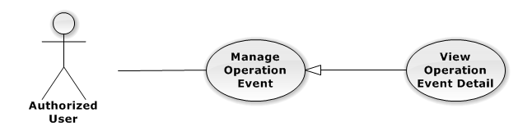

Figure 25: View Operation Event Detail Use-Case Diagram

View Operation Event Detail Use-Case Specification

|  |  |  |  |
| --- | --- | --- | --- |
| USE-CASE SPECIFICATION | | | |
| Use-case No. | UC0017 | Use-case Version | 1.0 |
| Use-case Name | View operation event detail | | |
| Author | Nguyễn Tiến Thành | | |
| Date | 30/01/2014 | Priority | Normal |
| Actor:  Authorized User  Summary:  Staff can view detail of event information  Goal:  Helps staff to view event information  Triggers:   * Staff click on “Sự kiện” link * Click on one event * Click on “Mở rộng” button   Preconditions:   * Must be logged-in * The page is fully loaded * Must be in Lawyer related page   Post Conditions:  Success: The detail event information is displayed  Failure: Do nothing  Main Success Scenario:   |  |  |  | | --- | --- | --- | | *Step* | *User* | *System* | | 1 | Staff click on event day’s link  [Alternative 1], [Alternative 2] | The detail event information is displayed |   Alternative Scenario:   |  |  |  | | --- | --- | --- | | *#* | *User* | *System* | | 1 | Click on “Mở rộng” button | Display detail of all event of current case | | 2 | Click on “Thu nhỏ” button | Close all detail event of current case, back to list event screen. |   Exceptions:  N/A  Relationships:  Manage Operation Event  Business Rules:  N/A | | | |

Add New Operation Event

Add New Operation Event Use-Case Diagram

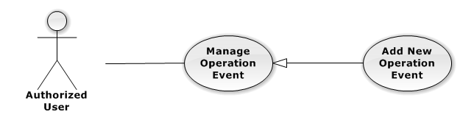

Figure 26: Add New Operation Event Use-Case Diagram

Add New Operation Event Use-Case Specification

|  |  |  |  |
| --- | --- | --- | --- |
| USE-CASE SPECIFICATION | | | |
| Use-case No. | UC0018 | Use-case Version | 1.0 |
| Use-case Name | Add New Operation Event | | |
| Author | Nguyễn Tiến Thành | | |
| Date | 30/01/2014 | Priority | High |
| Actor:  Authorized User, who is assigned in current case  Summary:  Staff can add new event into Case  Goal:  Helps Staff create event into Case  Triggers:   * Staff click on “Sự kiện” link in Case Detail page * Click on edit icon beside “Sư kiện tác nghiệp” button * Click on “Thêm mới” button to add new event to current case.   Preconditions:   * Must be logged-in * The page is fully loaded * Must be in event page * Click on edit icon beside “Sự kiện tác nghiệp” label before   Post Conditions:  Success:   * At new event into current Case * Show message successfully: “Thêm sự kiện thành công!”   Failure: System display error message “Thêm sự kiện thất bại!", "hãy kiểm tra lại kết nối database!”  Main Success Scenario:   |  |  |  | | --- | --- | --- | | *Step* | *User* | *System* | | 1 | Click on edit icon beside “Sự kiện tác nghiệp” label | Form, “Thêm sự kiện” and “Hoàn thành” button is display | | 2 | Click on the “Thêm sự kiện” button | Input form display , “Đóng” and “Tạo sự kiện” button is display | | 3 | Input information into fields and click button “Hoàn thành” button  [Alternative 1], [Exception 1] | System display message “Thêm sự kiện thành công!” |   Alternative Scenario:   |  |  |  | | --- | --- | --- | | *#* | *User* | *System* | | 1 | Click on “Đóng” button | Input form close back to list all event screen. |   Exceptions:   |  |  |  | | --- | --- | --- | | *#* | *User* | *System* | | 1 | System cannot insert event to data base. | Shows error message “Tạo sự kiện thất bại, hãy kiểm tra lại kết nối database”. |   Relationships:  Manage Operation Event  Business Rules:  Only Administrator or Authorized User is assigned in current case can be use this function when status of case is “Đang thụ lý” and Office that have current case must is active. | | | |

Edit Operation Event

Edit Operation Event Use-Case Diagram

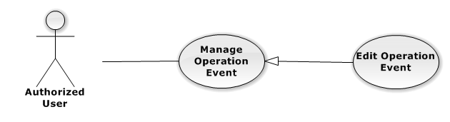

Figure 27: Edit Operation Event Use-Case Diagram

Edit Operation Event Use-Case Specification

|  |  |  |  |
| --- | --- | --- | --- |
| USE-CASE SPECIFICATION | | | |
| Use-case No. | UC0019 | Use-case Version | 1.0 |
| Use-case Name | Edit Operation Event | | |
| Author | Nguyễn Tiến Thành | | |
| Date | 30/01/2014 | Priority | Normal |
| Actor:  Authorized User, who is assigned in current case  Summary:  Staff can update event into Case  Goal:  Helps Staff update event into Case  Triggers:   * Staff click on “Sự kiện” link in Case Detail page * Click on edit icon beside “Sư kiện tác nghiệp” button * Click on “Edit” button to update event.   Preconditions:   * Must be logged-in * The page is fully loaded * Must be in event page * Click on edit icon beside “Sự kiện tác nghiệp” label before   Post Conditions:  Success:   * Update event into current Case * Show message successfully: “Sửa sự kiện thành công!”   Failure: System display error message “Sửa sự kiện thất bại!", "hãy kiểm tra lại kết nối database!”  Main Success Scenario:   |  |  |  | | --- | --- | --- | | *Step* | *User* | *System* | | 1 | Click on edit icon beside “Sự kiện tác nghiệp” label | List all event in current case, “Edit” and “Delete” icon is display, “Thêm sự kiện” and “Hoàn thành” button is display | | 2 | Click on the “Edit” button | Input form display , “Đóng” and “Lưu chỉnh sửa” button is display | | 3 | Edit information into fields and click button “Lưu chỉnh sửa” button  [Alternative 1] , [Exception 1] | System display message “Sửa sự kiện thành công!” |   Alternative Scenario:   |  |  |  | | --- | --- | --- | | *#* | *User* | *System* | | 1 | Click on “Đóng” button | Input form close back to list all event screen. |   Exceptions:   |  |  |  | | --- | --- | --- | | *#* | *User* | *System* | | 1 | While edit information of event click edit icon beside “Sư kiện tác nghiệp” button | Shows error message “Chỉnh sửa chưa hoàn thành! Hãy lưu hoặc đóng chỉnh sửa”. | | System cannot insert event to data base. | Shows error message “Chỉnh sửa sự kiện thất bại, hãy kiểm tra lại kết nối database”. |   Relationships:  Manage Operation Event  Business Rules:  Only Administrator or Authorized User is assigned in current case can be use this function when status of case is “Đang thụ lý” and Office that have current case must is active. | | | |

Delete Operation Event

Delete Operation Event Use-Case Diagram

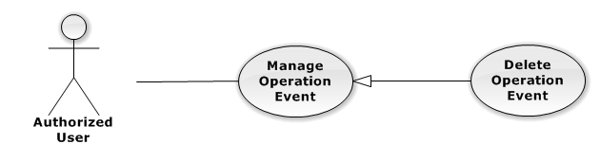

Figure 28: Delete Operation Event Use-Case Diagram

Delete Operation Event Use-Case Specification

|  |  |  |  |
| --- | --- | --- | --- |
| USE-CASE SPECIFICATION | | | |
| Use-case No. | UC0020 | Use-case Version | 1.0 |
| Use-case Name | Delete Operation Event | | |
| Author | Nguyễn Tiến Thành | | |
| Date | 30/01/2014 | Priority | Normal |
| Actor:  Authorized User, who is assigned in current case  Summary:  Staff can remove Event in Case  Goal:  Helps Staff remove Event in Case  Triggers:  Staff click on delete icon in the end table list  Preconditions:   * Must be logged-in * The page is fully loaded * Must be in Lawyer related page * Click on edit icon beside “Sự kiện tác nghiệp” label before   Post Conditions:  Success:   * Remove the Event out of current Case * Show message remove successfully: “Xóa sự kiện thành công!”   Failure: System display error message “Xóa sự kiện thất bại!”  Main Success Scenario:   |  |  |  | | --- | --- | --- | | *Step* | *User* | *System* | | 1 | Click on edit icon beside “Sự kiện tác nghiệp” label | Icon delete is display | | 2 | Click on icon delete corresponding with Event want to remove | Show a modal popup to confirm | | 3 | Click on “Xác nhận” button  [Alternative 1] | System display message “Xóa sự kiện thành công!” |   Alternative Scenario:   |  |  |  | | --- | --- | --- | | *#* | *User* | *System* | | 1 | Click on “Bỏ qua” button | Modal popup is close and system do not remove the Event |   Exceptions:  N/A  Relationships:  Manage Operation Event  Business Rules:  Only Administrator or Authorized User is assigned in current case can be use this function when status of case is “Đang thụ lý” and Office that have current case must is active. | | | |

###### Manage Lawyer Related

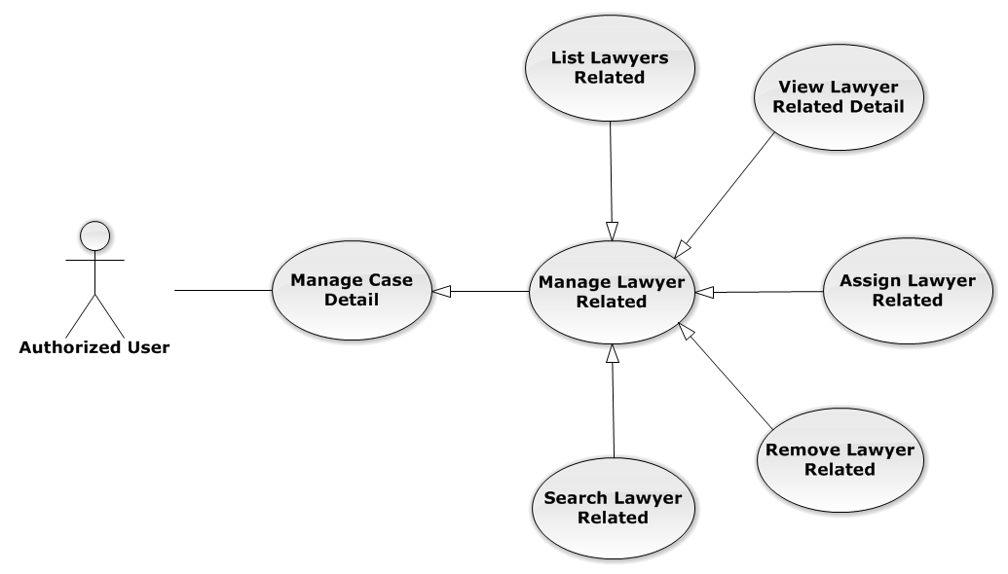

Figure 29: Manage Lawyer Related Use-Case Diagram

List Lawyers Related

List Lawyers Related Use-Case Diagram

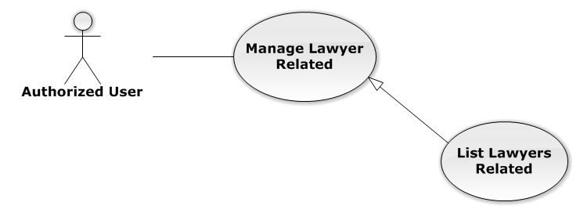

Figure 30: List Lawyers Related Use-Case Diagram

List Lawyers Related Use-Case Specification

|  |  |  |  |
| --- | --- | --- | --- |
| USE-CASE SPECIFICATION | | | |
| Use-case No. | UC0021 | Use-case Version | 1.0 |
| Use-case Name | List Lawyers Related | | |
| Author | Nguyễn Thế Vinh | | |
| Date | 30/01/2014 | Priority | Normal |
| Actor:  Authorized User  Summary:  Show all Lawyers, who is assigned in current case  Goal:  Help to view all Lawyers, who is assigned in current case  Triggers:   * User click on “Người liên quan” link in Case Detail page * Click on “Luật sư” link at right top page   Preconditions:   * Must be logged-in * The page is fully loaded * Must be in Case Detail page   Post Conditions:  Success: List all Staffs is assigned in current case  Failure: Do nothing  Main Success Scenario:   |  |  |  | | --- | --- | --- | | *Step* | *User* | *System* | | 1 | Click on “Người liên quan” link or “Luật sư” link | Show all Lawyers is assigned in current case |   Alternative Scenario:  N/A  Exceptions:  N/A  Relationships:  Manage Lawyer Related  Business Rules:  N/A | | | |

View Lawyer Related Detail

View Lawyer Related Detail Use-Case Diagram

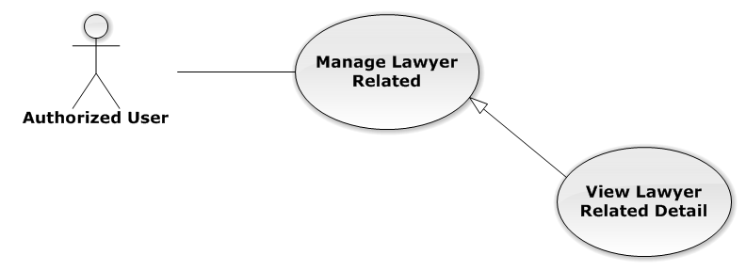

Figure 31: View Lawyer Related Detail Use-Case Diagram

View Lawyer Related Detail Use-Case Specification

|  |  |  |  |
| --- | --- | --- | --- |
| USE-CASE SPECIFICATION | | | |
| Use-case No. | UC0022 | Use-case Version | 1.0 |
| Use-case Name | View Lawyer Related Detail | | |
| Author | Nguyễn Thế Vinh | | |
| Date | 30/01/2014 | Priority | Normal |
| Actor:  Authorized User  Summary:  Staff can view Lawyer related information  Goal:  Helps staff to view Lawyer related information  Triggers:   * Staff click on “Họ và tên” link * Click on avatar image   Preconditions:   * Must be logged-in * The page is fully loaded * Must be in “Người liên quan” page   Post Conditions:  Success: The popup modal have lawyer information is displayed  Failure: Do nothing  Main Success Scenario:   |  |  |  | | --- | --- | --- | | *Step* | *User* | *System* | | 1 | Staff click on “Họ và tên” link or avatar image | The popup modal have lawyer information is displayed  [Alternative 1] |   Alternative Scenario:   |  |  |  | | --- | --- | --- | | *#* | *User* | *System* | | 1 | Click on [X] button, “Đóng” button, or click out of modal | Modal popup is close |   Exceptions:  N/A  Relationships:  Manage Lawyer Related  Business Rules:  N/A | | | |

Assign Lawyer Related

Assign Lawyer Related Use-Case Diagram

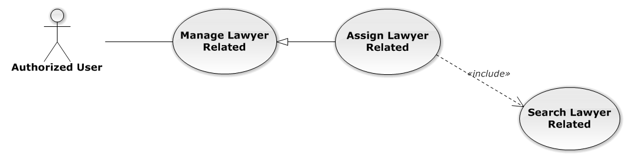

Figure 32: Assign Lawyer Related Use-Case Diagram

Assign Lawyer Related Use-Case Specification

|  |  |  |  |
| --- | --- | --- | --- |
| USE-CASE SPECIFICATION | | | |
| Use-case No. | UC0023 | Use-case Version | 1.0 |
| Use-case Name | Assign Lawyer Related | | |
| Author | Nguyễn Thế Vinh | | |
| Date | 30/01/2014 | Priority | High |
| Actor:  Authorized User, who create the current Case  Summary:  Staff can assign Lawyer into Case  Goal:  Helps Staff assign any Lawyers into Case  Triggers:  Staff click on “Thêm vào danh sách” button after choose Lawyer in search form beside  Preconditions:   * Must be logged-in * The page is fully loaded * Must be in “Người liên quan” page * Click on edit icon beside “Luật sư phụ trách” label and used Search Lawyer Related function before   Post Conditions:  Success:   * Assign the Lawyer in search form to current Case * Show message assign successfully: “Đã phân công luật sư!”   Failure: System display error message “Phân công luật sư thất bại!”  Main Success Scenario:   |  |  |  | | --- | --- | --- | | *Step* | *User* | *System* | | 1 | Click on edit icon beside “Luật sư phụ trách” label | Search form, “Thêm vào danh sách” and “Hoàn thành” button is display | | 2 | After search and choose a Lawyer, Staff click on “Thêm vào danh sách” button  [Alternative 1]  [Exception 1]  [Exception 2] | System display message “Đã phân công luật sư!” |   Alternative Scenario:   |  |  |  | | --- | --- | --- | | *#* | *User* | *System* | | 1 | Click on “Hoàn thành” button | Search form, “Thêm vào danh sách” and “Hoàn thành” button is hidden |   Exceptions:   |  |  |  | | --- | --- | --- | | *#* | *User* | *System* | | 1 | Not search lawyer then click on “Thêm vào danh sách” button | Display validation message for needed to search lawyer before: “Hãy chọn 1 luật sư!” | | 2 | Lawyer is exist in list lawyer related | Display message “Đã tồn tại luật sư!” |   Relationships:  Manage Lawyer Related  Business Rules:  Only Administrator or Authorized User, who create the current Case can be use this function when status of case is “Đang thụ lý” and Office that have current case must is active. | | | |

Remove Lawyer Related

Remove Lawyer Related Use-Case Diagram

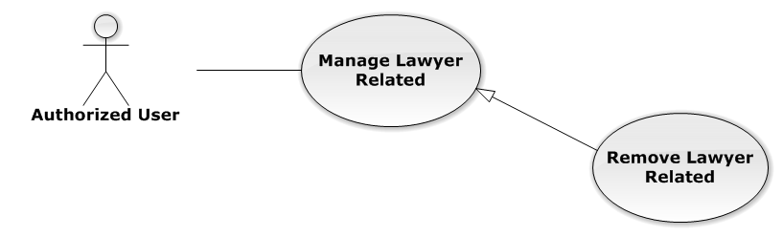

Figure 33: Remove Lawyer Related Use-Case Diagram

Remove Lawyer Related Use-Case Specification

|  |  |  |  |
| --- | --- | --- | --- |
| USE-CASE SPECIFICATION | | | |
| Use-case No. | UC0024 | Use-case Version | 1.0 |
| Use-case Name | Remove Lawyer Related | | |
| Author | Nguyễn Thế Vinh | | |
| Date | 30/01/2014 | Priority | Normal |
| Actor:  Authorized User, who create the current Case  Summary:  Staff can remove Lawyer related in Case  Goal:  Helps Staff remove Lawyer related in Case  Triggers:  Staff click on delete icon in the end table list  Preconditions:   * Must be logged-in * The page is fully loaded * Must be in “Người liên quan” page * Click on edit icon beside “Luật sư phụ trách” label before   Post Conditions:  Success:   * Remove the Lawyer out of current Case * Show message remove successfully: “Loại bỏ luật sư thành công!”   Failure: System display error message “Loại bỏ luật sư thất bại!”  Main Success Scenario:   |  |  |  | | --- | --- | --- | | *Step* | *User* | *System* | | 1 | Click on edit icon beside “Luật sư phụ trách” label | Icon delete is display | | 2 | Click on icon delete corresponding with Lawyer want to remove | Show a modal popup to confirm | | 3 | Click on “Xác nhận” button  [Alternative 1] | System display message “Loại bỏ luật sư thành công!” |   Alternative Scenario:   |  |  |  | | --- | --- | --- | | *#* | *User* | *System* | | 1 | Click on “Bỏ qua” button | Modal popup is close and system do not remove the Lawyer |   Exceptions:  N/A  Relationships:  Manage Lawyer Related  Business Rules:  Only Administrator or Authorized User, who create the current Case can be use this function when status of case is “Đang thụ lý” and Office that have current case must is active. | | | |

Search Lawyer Related

Search Lawyer Related Use-Case Diagram

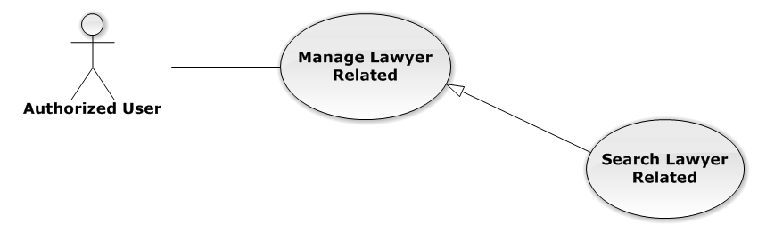

Figure 34: Search Lawyer Related Use-Case Diagram

Search Lawyer Related Use-Case Specification

|  |  |  |  |
| --- | --- | --- | --- |
| USE-CASE SPECIFICATION | | | |
| Use-case No. | UC0025 | Use-case Version | 1.0 |
| Use-case Name | Search Lawyer Related | | |
| Author | Nguyễn Thế Vinh | | |
| Date | 30/01/2014 | Priority | Normal |
| Actor:  Authorized User, who create the current Case  Summary:  Staff can search Lawyer for assign into Case  Goal:  Helps Staff can assign Lawyer easily  Triggers:  Staff input key word is StaffName or Username of Lawyer. When the key up, system will be automatic search.  Preconditions:   * Must be logged-in * The page is fully loaded * Must be in “Người liên quan” page * Click on edit icon beside “Luật sư phụ trách” label before   Post Conditions:  Success: The lawyer has been choose in search form by StaffName or Username  Failure: Do nothing  Main Success Scenario:   |  |  |  | | --- | --- | --- | | *Step* | *User* | *System* | | 1 | Click on edit icon beside “Luật sư phụ trách” label | Search form is display | | 2 | Input key words into search form and then key up | Display lawyers matches key words by StaffName and Username | | 3 | Click on result have lawyer want to assign  [Alternative 1] | The lawyer has been choose, wait for assign |   Alternative Scenario:   |  |  |  | | --- | --- | --- | | *#* | *User* | *System* | | 1 | Click out of result list | Result list is clear |   Exceptions:  N/A  Relationships:  Manage Lawyer Related  Business Rules:  Only Administrator or Authorized User, who create the current Case can be use this function when status of case is “Đang thụ lý” and Office that have current case must is active. | | | |

###### Manage Customer Related

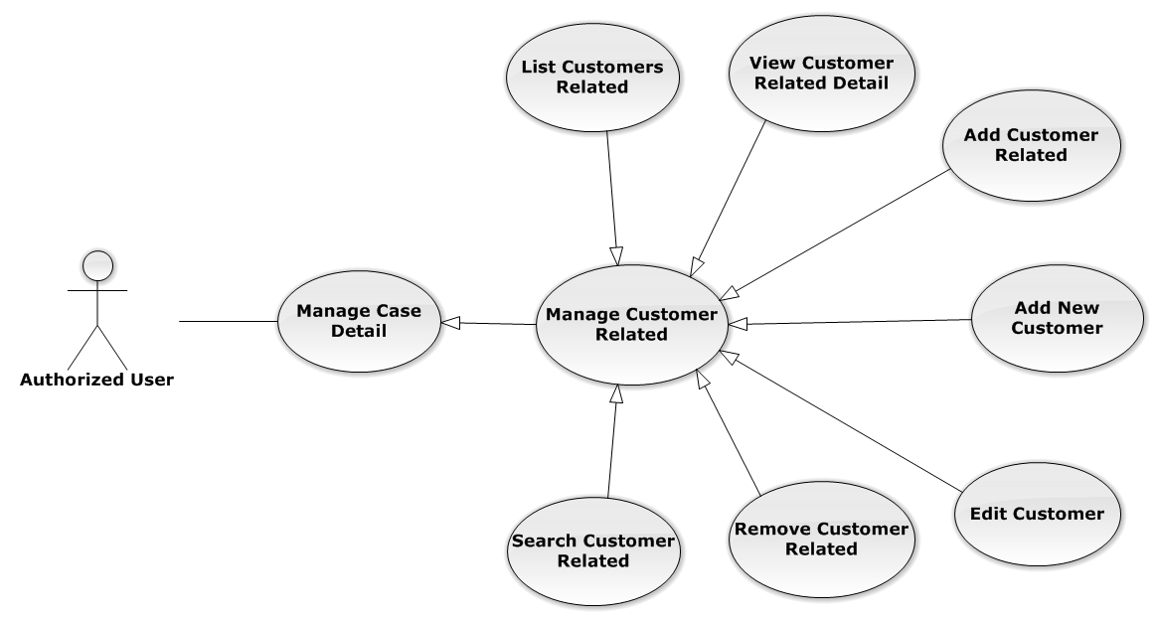

Figure 35: Manage Customer Related Use-Case Diagram

List Customers Related

List Customers Related Use-Case Diagram

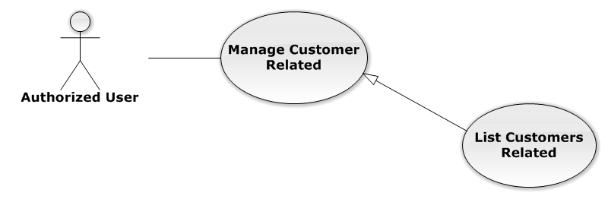

Figure 36: List Customers Related Use-Case Diagram

List Customers Related Use-Case Specification

|  |  |  |  |
| --- | --- | --- | --- |
| USE-CASE SPECIFICATION | | | |
| Use-case No. | UC0026 | Use-case Version | 1.0 |
| Use-case Name | List Customers Related | | |
| Author | Nguyễn Thế Vinh | | |
| Date | 30/01/2014 | Priority | Normal |
| Actor:  Authorized User  Summary:  List all Customers of current case, each case can have one or more customers  Goal:  Help to view all Customers related  Triggers:  User click on “Khách hàng” link at right top page  Preconditions:   * Must be logged-in * The page is fully loaded * Must be in “Người liên quan” page   Post Conditions:  Success: Show all Customers of current case in table  Failure: Do nothing  Main Success Scenario:   |  |  |  | | --- | --- | --- | | *Step* | *User* | *System* | | 1 | Click on “Khách hàng” link | Show all Customers of current case in table line by line |   Alternative Scenario:  N/A  Exceptions:  N/A  Relationships:  Manage Customer Related  Business Rules:  N/A | | | |

View Customer Related Detail

View Customer Related Detail Use-Case Diagram

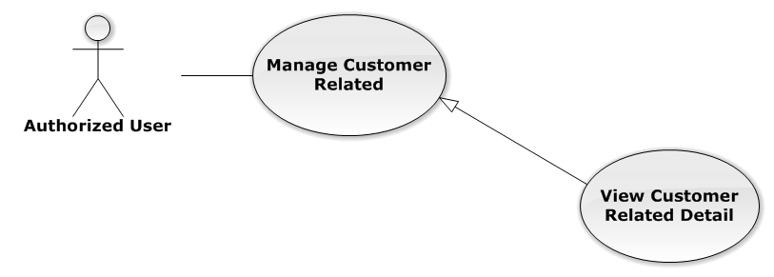

Figure 37: View Customer Related Detail Use-Case Diagram

View Customer Related Detail Use-Case Specification

|  |  |  |  |
| --- | --- | --- | --- |
| USE-CASE SPECIFICATION | | | |
| Use-case No. | UC0027 | Use-case Version | 1.0 |
| Use-case Name | View Customer Related Detail | | |
| Author | Nguyễn Thế Vinh | | |
| Date | 30/01/2014 | Priority | Normal |
| Actor:  Authorized User  Summary:  Staff can view Customer related information  Goal:  Helps staff to view Customer related information  Triggers:  Staff click on “Họ và tên” link  Preconditions:   * Must be logged-in * The page is fully loaded * Must be in “Khách hàng” page   Post Conditions:  Success: The popup modal have customer information is displayed  Failure: Do nothing  Main Success Scenario:   |  |  |  | | --- | --- | --- | | *Step* | *User* | *System* | | 1 | Staff click on “Họ và tên” link | The popup modal have customer information is displayed  [Alternative 1] |   Alternative Scenario:   |  |  |  | | --- | --- | --- | | *#* | *User* | *System* | | 1 | Click on [X] button, “Đóng” button, or click out of modal | Modal popup is close |   Exceptions:  N/A  Relationships:  Manage Customer Related  Business Rules:  N/A | | | |

Add Customer Related

Add Customer Related Use-Case Diagram

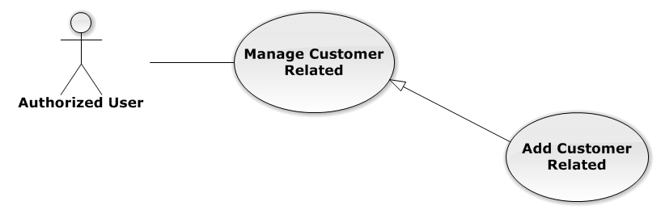

Figure 38: Add Customer Related Use-Case Diagram

Add Customer Related Use-Case Specification

|  |  |  |  |
| --- | --- | --- | --- |
| USE-CASE SPECIFICATION | | | |
| Use-case No. | UC0028 | Use-case Version | 1.0 |
| Use-case Name | Add Customer Related | | |
| Author | Nguyễn Thế Vinh | | |
| Date | 30/01/2014 | Priority | Normal |
| Actor:  Authorized User, who is assigned in current case  Summary:  Staff can add a available customer on Database into Case  Goal:  Helps Staff add a available customer into Case  Triggers:  Staff click on “Thêm vào danh sách” button after choose Customer in search form beside  Preconditions:   * Must be logged-in * The page is fully loaded * Must be in “Khách hàng” page * Click on edit icon beside “Khách hàng” label and used Search Customer Related function before   Post Conditions:  Success:   * Add a customer into Case * Show message assign successfully: “Thêm khách hàng thành công!”   Failure: System display error message “Thêm khách hàng thất bại!”  Main Success Scenario:   |  |  |  | | --- | --- | --- | | *Step* | *User* | *System* | | 1 | Click on edit icon beside “Khách hàng” label | Search form, “Thêm vào danh sách” and “Hoàn thành” button is display | | 2 | After search and choose a Customer, Staff click on “Thêm vào danh sách” button  [Alternative 1]  [Exception 1]  [Exception 2] | System display message “Thêm khách hàng thành công!” |   Alternative Scenario:   |  |  |  | | --- | --- | --- | | *#* | *User* | *System* | | 1 | Click on “Hoàn thành” button | Search form, “Thêm vào danh sách” and “Hoàn thành” button is hidden |   Exceptions:   |  |  |  | | --- | --- | --- | | *#* | *User* | *System* | | 1 | Not search customer then click on “Thêm vào danh sách” button | Display validation message for needed to search lawyer before: “Hãy chọn 1 khách hàng!” | | 2 | Customer is exist in list customer related | Display message “Đã tồn tại khách hàng!” |   Relationships:  Manage Customer Related  Business Rules:  Only Administrator or Authorized User is assigned in current case can be use this function when status of case is “Đang thụ lý” and Office that have current case must is active. | | | |

Add New Customer

Reference to Add New Customer function in Manage Customer

Edit Customer

Reference to Edit Customer function in Manage Customer

Remove Customer Related

Remove Customer Related Use-Case Diagram

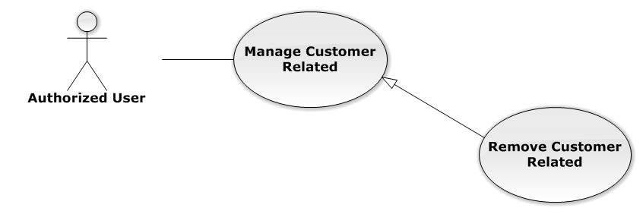

Figure 39: Remove Customer Related Use-Case Diagram

Remove Customer Related Use-Case Specification

|  |  |  |  |
| --- | --- | --- | --- |
| USE-CASE SPECIFICATION | | | |
| Use-case No. | UC0029 | Use-case Version | 1.0 |
| Use-case Name | Remove Customer Related | | |
| Author | Nguyễn Thế Vinh | | |
| Date | 30/01/2014 | Priority | Normal |
| Actor:  Authorized User, who is assigned in current case  Summary:  Staff can remove Customer related in Case  Goal:  Helps Staff remove Customer related in Case  Triggers:  Staff click on delete icon in the end table list  Preconditions:   * Must be logged-in * The page is fully loaded * Must be in “Khách hàng” page * Click on edit icon beside “Khách hàng” label before   Post Conditions:  Success:   * Remove the Customer out of current Case * Show message remove successfully: “Loại bỏ khách hàng thành công!”   Failure: System display error message “Loại bỏ khách hàng thất bại!”  Main Success Scenario:   |  |  |  | | --- | --- | --- | | *Step* | *User* | *System* | | 1 | Click on edit icon beside “Khách hàng” label | Icon delete is display | | 2 | Click on icon delete corresponding with Customer want to remove | Show a modal popup to confirm | | 3 | Click on “Xác nhận” button  [Alternative 1] | System display message “Loại bỏ khách hàng thành công!” |   Alternative Scenario:   |  |  |  | | --- | --- | --- | | *#* | *User* | *System* | | 1 | Click on “Bỏ qua” button | Modal popup is close and system do not remove the Customer |   Exceptions:  N/A  Relationships:  Manage Customer Related  Business Rules:  Only Administrator or Authorized User is assigned in current case can be use this function when status of case is “Đang thụ lý” and Office that have current case must is active. | | | |

Search Customer Related

Search Customer Related Use-Case Diagram

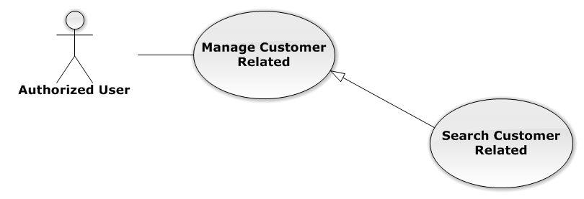

Figure 40: Search Customer Related Use-Case Diagram

Search Customer Related Use-Case Specification

|  |  |  |  |
| --- | --- | --- | --- |
| USE-CASE SPECIFICATION | | | |
| Use-case No. | UC0030 | Use-case Version | 1.0 |
| Use-case Name | Search Customer Related | | |
| Author | Nguyễn Thế Vinh | | |
| Date | 30/01/2014 | Priority | Normal |
| Actor:  Authorized User, who is assigned in current case  Summary:  Staff can search Customer for add customer related  Goal:  Helps Staff can search Customer easily  Triggers:  Staff input key word is CustomerName or Address of Customer. When the key up, system will be automatic search after 500ms delay time.  Preconditions:   * Must be logged-in * The page is fully loaded * Must be in “Khách hàng” page * Click on edit icon beside “Khách hàng” label before   Post Conditions:  Success: The customer has been choose in search form by CustomerName or Address  Failure: Do nothing  Main Success Scenario:   |  |  |  | | --- | --- | --- | | *Step* | *User* | *System* | | 1 | Click on edit icon beside “Khách hàng” label | Search form is display | | 2 | Input key words into search form and then key up | Display customers matches key words by CustomerName or Address | | 3 | Click on result have customer want to add  [Alternative 1] | The customer has been choose, wait for add |   Alternative Scenario:   |  |  |  | | --- | --- | --- | | *Step* | *User* | *System* | | 1 | Click out of result list | Result list is clear |   Exceptions:  N/A  Relationships:  Manage Customer Related  Business Rules:  Only Administrator or Authorized User is assigned in current case can be use this function when status of case is “Đang thụ lý” and Office that have current case must is active. | | | |

###### Manage Subject Related

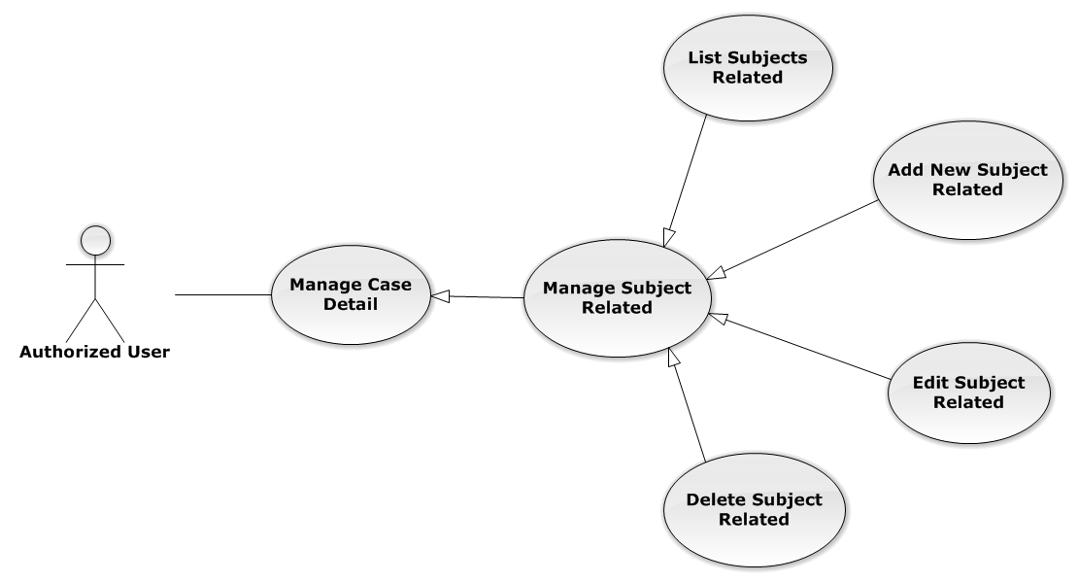

Figure 41: Manage Subject Related Use-Case Diagram

List Subjects Related

List Subjects Related Use-Case Diagram

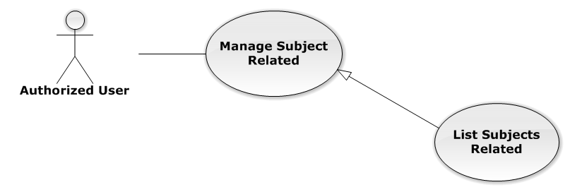

Figure 42: List Subjects Related Use-Case Diagram

List Subjects Related Use-Case Specification

|  |  |  |  |
| --- | --- | --- | --- |
| USE-CASE SPECIFICATION | | | |
| Use-case No. | UC0031 | Use-case Version | 1.0 |
| Use-case Name | List Subjects Related | | |
| Author | Nguyễn Thế Vinh | | |
| Date | 30/01/2014 | Priority | Normal |
| Actor:  Authorized User  Summary:  List all Subjects of current case, each case can have one or more subjects  Goal:  Help to view all Subject related  Triggers:  User click on “Chủ thể” link at right top page  Preconditions:   * Must be logged-in * The page is fully loaded * Must be in “Người liên quan” page   Post Conditions:  Success: Show all Subjects of current case in table  Failure: Do nothing  Main Success Scenario:   |  |  |  | | --- | --- | --- | | *Step* | *User* | *System* | | 1 | Click on “Chủ thể” link | Show all Subjects of current case in table line by line |   Alternative Scenario:  N/A  Exceptions:  N/A  Relationships:  Manage Subject Related  Business Rules:  N/A | | | |

Add New Subject Related

Add New Subject Related Use-Case Diagram

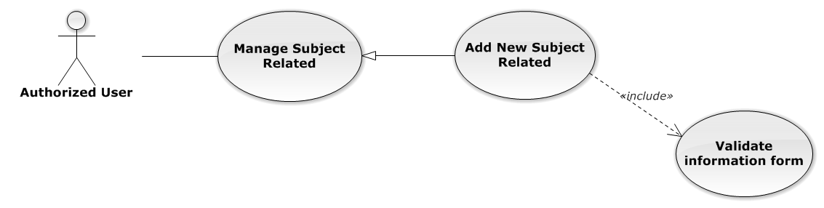

Figure 43: Add New Subject Related Use-Case Diagram

Add New Subject Related Use-Case Specification

|  |  |  |  |
| --- | --- | --- | --- |
| USE-CASE SPECIFICATION | | | |
| Use-case No. | UC0032 | Use-case Version | 1.0 |
| Use-case Name | Add New Subject Related | | |
| Author | Nguyễn Thế Vinh | | |
| Date | 30/01/2014 | Priority | Normal |
| Actor:  Authorized User, who is assigned in current case  Summary:  Staff can create new a subject related into case  Goal:  Helps Staff create new a subject easily  Triggers:  Staff click on “Tạo chủ thể” button at the bottom of table  Preconditions:   * Must be logged-in * The page is fully loaded * Must be in “Chủ thể” page * Click on edit icon beside “Chủ thể liên quan” label before   Post Conditions:  Success:   * Add new a subject into Case * Show message assign successfully: “Thêm chủ thể thành công!”   Failure: System display error message “Thêm chủ thể thất bại!”  Main Success Scenario:   |  |  |  | | --- | --- | --- | | *Step* | *User* | *System* | | 1 | Click on edit icon beside “Chủ thể liên quan” label | “Thêm chủ thể mới” button is display | | 2 | Staff click on “Tạo chủ thể” button | Modal popup is displayed with fields for input information of new subject  [Alternative 1] | | 3 | Input corresponding information in form then click “Thêm mới” button  [Exception 1] | * Modal popup is close * System display successful message “Thêm chủ thể thành công!” * Update list subject on page |   Alternative Scenario:   |  |  |  | | --- | --- | --- | | *#* | *User* | *System* | | 1 | Click on [X] button, “Đóng” button, or click out of modal | Modal popup is close |   Exceptions:   |  |  |  | | --- | --- | --- | | *#* | *User* | *System* | | 1 | Leave empty require fields then click on “Thêm mới” button | Modal popup display validation for needed to input field |   Relationships:  Manage Subject Related  Business Rules:   * Only Administrator or Authorized User is assigned in current case can be use this function when status of case is “Đang thụ lý” and Office that have current case must is active. * After create subject successfully, system will be automatically add new subject into that case | | | |

Edit Subject Related

Edit Subject Related Use-Case Diagram

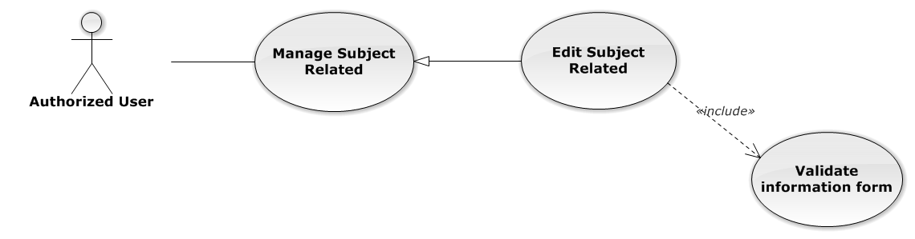

Figure 44: Edit Subject Related Use-Case Diagram

Edit Subject Related Use-Case Specification

|  |  |  |  |
| --- | --- | --- | --- |
| USE-CASE SPECIFICATION | | | |
| Use-case No. | UC0033 | Use-case Version | 1.0 |
| Use-case Name | Edit Subject Related | | |
| Author | Nguyễn Thế Vinh | | |
| Date | 30/01/2014 | Priority | Normal |
| Actor:  Authorized User, who is assigned in current case  Summary:  Staff can edit a available subject related  Goal:  Helps Staff edit a available subject information  Triggers:  Staff click on edit icon at the right table  Preconditions:   * Must be logged-in * The page is fully loaded * Must be in “Chủ thể” page * Click on edit icon beside “Chủ thể liên quan” label before   Post Conditions:  Success:   * Edit a subject information * Show message assign successfully: “Cập nhật chủ thể thành công!”   Failure: System display error message “Cập nhật chủ thể thất bại!”  Main Success Scenario:   |  |  |  | | --- | --- | --- | | *Step* | *User* | *System* | | 1 | Click on edit icon beside “Chủ thể liên quan” label | The icon to edit subject is display | | 2 | Staff click on edit icon | Modal popup is displayed with fields for input new information of subject  [Alternative 1] | | 3 | Input corresponding information in form then click “Lưu chỉnh sửa” button  [Exception 1] | * Modal popup is close * System display successful message “Cập nhật chủ thể thành công!” * Update list subject on page |   Alternative Scenario:   |  |  |  | | --- | --- | --- | | *#* | *User* | *System* | | 1 | Click on [X] button, “Đóng” button, or click out of modal | Modal popup is close |   Exceptions:   |  |  |  | | --- | --- | --- | | *#* | *User* | *System* | | 1 | Leave empty require fields then click on “Lưu chỉnh sửa” button | Modal popup display validation for needed to input field |   Relationships:  Manage Subject Related  Business Rules:  Only Administrator or Authorized User is assigned in current case can be use this function when status of case is “Đang thụ lý” and Office that have current case must is active. | | | |

Delete Subject Related

Delete Subject Related Use-Case Diagram

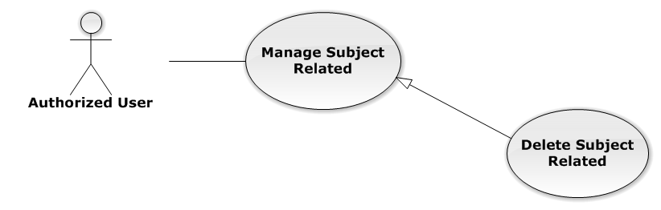

Figure 45: Delete Subject Related Use-Case Diagram

Delete Subject Related Use-Case Specification

|  |  |  |  |
| --- | --- | --- | --- |
| USE-CASE SPECIFICATION | | | |
| Use-case No. | UC0034 | Use-case Version | 1.0 |
| Use-case Name | Delete Subject Related | | |
| Author | Nguyễn Thế Vinh | | |
| Date | 30/01/2014 | Priority | Normal |
| Actor:  Authorized User, who is assigned in current case  Summary:  Staff can delete Subject related in Case  Goal:  Helps Staff delete Subject related  Triggers:  Staff click on delete icon in the end table list  Preconditions:   * Must be logged-in * The page is fully loaded * Must be in “Chủ thể” page * Click on edit icon beside “Chủ thể liên quan” label before   Post Conditions:  Success:   * Delete the subject out of current Case * Show message remove successfully: “Xóa chủ thể thành công!”   Failure: System display error message “Xóa chủ thể hàng thất bại!”  Main Success Scenario:   |  |  |  | | --- | --- | --- | | *Step* | *User* | *System* | | 1 | Click on edit icon beside “Chủ thể liên quan” label | Icon delete is display | | 2 | Click on icon delete corresponding with Subject want to delete | Show a modal popup to confirm | | 3 | Click on “Xác nhận” button  [Alternative 1] | System display message “Xóa chủ thể thành công!” |   Alternative Scenario:   |  |  |  | | --- | --- | --- | | *#* | *User* | *System* | | 1 | Click on “Bỏ qua” button | Modal popup is close and system do not remove the Subject |   Exceptions:  N/A  Relationships:  Manage Subject Related  Business Rules:  Only Administrator or Authorized User is assigned in current case can be use this function when status of case is “Đang thụ lý” and Office that have current case must is active. | | | |

###### Manage Document Related

Reference to DVD: <root>/Documents/LFMS Project Document - Full Report.docx

###### Manage Used Service

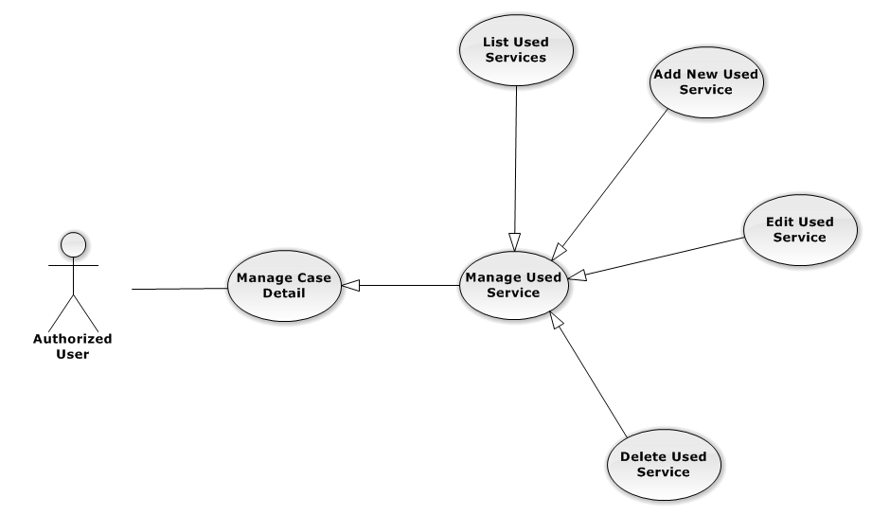

Figure 46: Manage Used Service Use-Case Diagram

List Used Services

List Used Services Use-Case Diagram

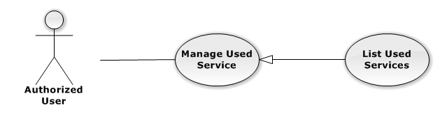

Figure 47: List Used Services Use-Case Diagram

List Used Services Use-Case Specification

|  |  |  |  |
| --- | --- | --- | --- |
| USE-CASE SPECIFICATION | | | |
| Use-case No. | UC0035 | Use-case Version | 1.0 |
| Use-case Name | List Used Services | | |
| Author | Nguyễn Tiến Thành | | |
| Date | 30/01/2014 | Priority | Normal |
| Actor:  Authorized User  Summary:  Show all Used Service of case.  Goal:  Help staff to view all Used Service of case.  Triggers:  User click on “Hóa đơn” link in Case Detail page  Preconditions:   * Must be logged-in * The page is fully loaded * Must be in Case Detail page   Post Conditions:  Success:   * List all Used Service in current case include company name and customer name. * Display total money of list Used Service   Failure: Do nothing  Main Success Scenario:   |  |  |  | | --- | --- | --- | | *Step* | *User* | *System* | | 1 | Click on “Hóa đơn” link | Show all Used Service in current case |   Alternative Scenario:  N/A  Exceptions:  N/A  Relationships:  Manage Used Service  Business Rules:  In the end of Used Service table have fill name “Tổng chi phí” display total money of all Used Service.  In the end of table have fill name “Chưa Thanh Toán” display total money of all Used Service. | | | |

Add New Used Service

Add New Used Service Use-Case Diagram

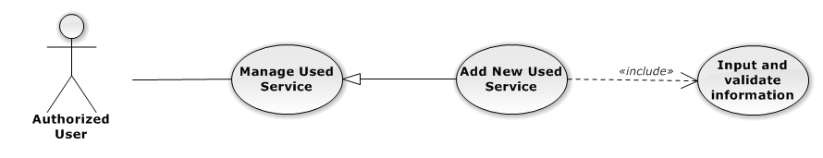

Figure 48: Add New Used Service Use-Case Diagram

Add New Used Service Use-Case Specification

|  |  |  |  |
| --- | --- | --- | --- |
| USE-CASE SPECIFICATION | | | |
| Use-case No. | UC0036 | Use-case Version | 1.0 |
| Use-case Name | Add New Used Service | | |
| Author | Nguyễn Tiến Thành | | |
| Date | 30/01/2014 | Priority | Normal |
| Actor:  Authorized User, who is assigned in current case  Summary:  Staff can add new Used Service into Case  Goal:  Helps Staff create event into Case  Triggers:   * Staff click on “Hóa đơn” link in Case Detail page * Click on edit icon beside “Chi phí dịch vụ” button * Click on “Thêm dịch vụ” button to add new Used Service to current case.   Preconditions:   * Must be logged-in * The page is fully loaded * Must be in Used Service page * Click on edit icon beside “Chi phí dịch vụ” label before   Post Conditions:  Success:   * At new Used Service into current Case * Calculation and display the total money of Used Service to “Tổng Chi Phí” field and “Chưa Thanh Toán” fileld. * Show message successfully: “Thêm dịch vụ thành công!”   Failure: System display error message “Thêm dịch vụ thất bại!", "hãy kiểm tra lại kết nối database!”  Main Success Scenario:   |  |  |  | | --- | --- | --- | | *Step* | *User* | *System* | | 1 | Click on edit icon beside “Chi phí dịch vụ” label, click “Thêm dịch vụ” button | Pop-up input is display.  With two button “Đóng” and “Tạo dịch vụ” is display | | 2 | Input information into fields and click button “Tạo mới”  button  [Alternative 1], [Exception 1], [Exception 2] | System display message “Thêm dịch vụ thành công!” |   Alternative Scenario:   |  |  |  | | --- | --- | --- | | *#* | *User* | *System* | | 1 | Click on “Đóng” button | Input form close back to list all Used Service screen. |   Exceptions:   |  |  |  | | --- | --- | --- | | *#* | *User* | *System* | | 1 | Field “Loại Dịch Vụ”, are blank | Shows error message “Nhập vào tên dịch vụ!”. | | Field “Tên Dịch Vụ”, are blank | Shows error message “Chọn dịch vụ!”. | | Field “Chi Phí”, are blank | Shows error message “Nhập chi phí!”. | | Field “Nội dung”, are blank | Shows error message “Nhập nội dung!”. | | 2 | System cannot insert Used Service to data base. | Shows error message “Thêm thanh toán thất bại!", "Hãy kiểm tra lại kết nối database” |   Relationships:  Manage Used Service  Business Rules:  Only Administrator or Authorized User is assigned in current case can be use this function when status of case is “Đang thụ lý” and Office that have current case must is active. | | | |

Edit Used Service

Edit Used Service Use-Case Diagram

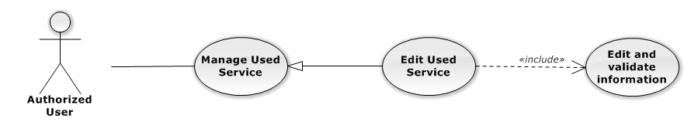

Figure 49: Edit Used Service Use-Case Diagram

Edit Used Service Use-Case Specification

|  |  |  |  |
| --- | --- | --- | --- |
| USE-CASE SPECIFICATION | | | |
| Use-case No. | UC0037 | Use-case Version | 1.0 |
| Use-case Name | Edit Used Service | | |
| Author | Nguyễn Tiến Thành | | |
| Date | 30/01/2014 | Priority | Normal |
| Actor:  Authorized User, who is assigned in current case  Summary:  Staff can update Used Service into Case  Goal:  Helps Staff update Used Service into Case  Triggers:   * Staff click on “Hóa đơn” link in Case Detail page * Click on edit icon beside “Chi phí dịch vụ” button * Click on “Edit” button to update event.   Preconditions:   * Must be logged-in * The page is fully loaded * Must be in Used Service page * Click on edit icon beside “Chi phí dịch vụ” label before   Post Conditions:  Success:   * Update Used Service into current Case * Show message successfully: “Sửa dịch vụ thành công!” * Calculation and display the total money of Used Service to “Tổng Chi Phí” field and “Chưa Thanh Toán” fileld   Failure: System display error message “Sửa dịch vụ thất bại!", "hãy kiểm tra lại kết nối database!”  Main Success Scenario:   |  |  |  | | --- | --- | --- | | *Step* | *User* | *System* | | 1 | Click on edit icon beside “Chi phí dịch vụ” label | List all Used Service in current case, “Edit” and “Delete” icon is display, “Thêm dịch vụ” and “Hoàn thành” button is display | | 2 | Click on the “Edit” button | Pop-up “Sửa chi phí” is display load detail of 1 Used Service, “Đóng” and “Sửa chi phí” button is display | | 3 | Edit information into fields and click button “Sửa chi phí” button  [Alternative 1], [Exception 1], [Exception 2] | System display message “Sửa dịch vụ thành công!” |   Alternative Scenario:   |  |  |  | | --- | --- | --- | | *#* | *User* | *System* | | 1 | Click on “Đóng” button | Input form close back to list all event screen. |   Exceptions:   |  |  |  | | --- | --- | --- | | *#* | *User* | *System* | | 1 | Field “Chi Phí”, are blank | Shows error message “Nhập chi phí!”. | | Field “Nội dung”, are blank | Shows error message “Nhập nội dung!”. | | 2 | System cannot insert event to data base. | Shows error message “Sửa dịch vụ thất bại!", "Hãy kiểm tra lại kết nối database”. |   Relationships:  Manage Used Service  Business Rules:  Only Administrator or Authorized User is assigned in current case can be use this function when status of case is “Đang thụ lý” and Office that have current case must is active. | | | |

Delete Used Service

Delete Used Service Use-Case Diagram

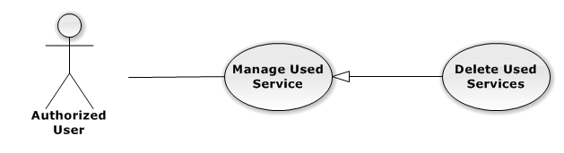

Figure 50: Delete Used Service Use-Case Diagram

Delete Used Service Use-Case Specification

|  |  |  |  |
| --- | --- | --- | --- |
| USE-CASE SPECIFICATION | | | |
| Use-case No. | UC0038 | Use-case Version | 1.0 |
| Use-case Name | Delete Used Service | | |
| Author | Nguyễn Tiến Thành | | |
| Date | 30/01/2014 | Priority | Normal |
| Actor:  Authorized User, who is assigned in current case  Summary:  Staff can remove Used Service in Case  Goal:  Helps Staff remove Used Service in Case  Triggers:  Staff click on delete icon in the end table list  Preconditions:   * Must be logged-in * The page is fully loaded * Must be in Lawyer related page * Click on edit icon beside “Chi phí dịch vụ” label before   Post Conditions:  Success:   * Remove the Event out of current Case * Show message remove successfully: “Xóa dịch vụ thành công!” * Calculation and display the total money of Used Service to “Tổng Chi Phí” field and “Chưa Thanh Toán” fileld   Failure: System display error message “Xóa dịch vụ thất bại!", "Hãy kiểm tra lại kết nối database”  Main Success Scenario:   |  |  |  | | --- | --- | --- | | *Step* | *User* | *System* | | 1 | Click on edit icon beside “Chi phí dịch vụ” label | Icon delete is display | | 2 | Click on icon delete corresponding with Used Service want to remove | Show a modal popup to confirm | | 3 | Click on “Xác nhận” button  [Alternative 1] | System display message “Xóa dịch vụ thành công!” |   Alternative Scenario:   |  |  |  | | --- | --- | --- | | *#* | *User* | *System* | | 1 | Click on “Bỏ qua” button | Modal popup is close and system do not remove the Event |   Exceptions:  N/A  Relationships:  Manage Used Service  Business Rules:  Only Administrator or Authorized User is assigned in current case can be use this function when status of case is “Đang thụ lý” and Office that have current case must is active. | | | |

###### Manage Payment

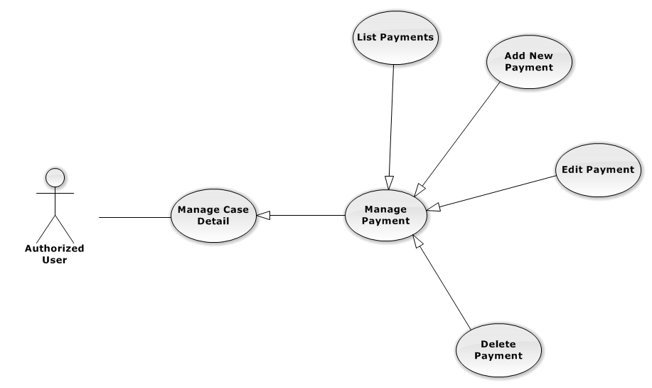

Figure 51: Manage Payment Use-Case Diagram

List Payments

List Payments Use-Case Diagram

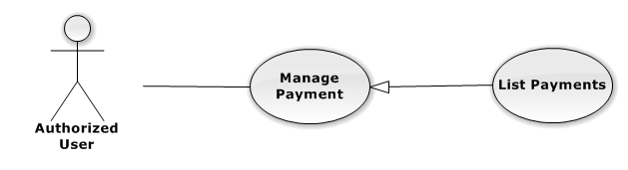

Figure 52: List Payments Use-Case Diagram

List Payments Use-Case Specification

|  |  |  |  |
| --- | --- | --- | --- |
| USE-CASE SPECIFICATION | | | |
| Use-case No. | UC0039 | Use-case Version | 1.0 |
| Use-case Name | List Payments | | |
| Author | Nguyễn Tiến Thành | | |
| Date | 30/01/2014 | Priority | Normal |
| Actor:  Authorized User  Summary:  Show all payment of case.  Goal:  Help staff to view all payment of case.  Triggers:  User click on “Hóa đơn” link in Case Detail page  Preconditions:   * Must be logged-in * The page is fully loaded * Must be in Case Detail page   Post Conditions:  Success:   * List all payment in current case include * Display total money of list payment.   Failure: Do nothing  Main Success Scenario:   |  |  |  | | --- | --- | --- | | *Step* | *User* | *System* | | 1 | Click on “Hóa đơn” link [Alternative 1], [Alternative 2] | Show all payment in current case |   Alternative Scenario:   |  |  |  | | --- | --- | --- | | *#* | *User* | *System* | | 1 | If total Payment > total Used Services | Display total money Unpaid in field “Số dư” | | 2 | If total Payment < total Used Services | Display total money balance in field “Chưa thanh toán” |   Exceptions:  N/A  Relationships:  Manage Payment  Business Rules:  In the end of Used Service table have fill name “Tổng chi phí” display total money of all Used Service. | | | |

Add New Payment

Add New Payment Use-Case Diagram

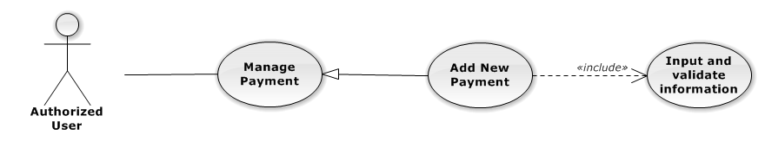

Figure 53: Add New Payment Use-Case Diagram

Add New Payment Use-Case Specification

|  |  |  |  |
| --- | --- | --- | --- |
| USE-CASE SPECIFICATION | | | |
| Use-case No. | UC0040 | Use-case Version | 1.0 |
| Use-case Name | Add New Payment | | |
| Author | Nguyễn Tiến Thành | | |
| Date | 30/01/2014 | Priority | High |
| Actor:  Authorized User, who is assigned in current case  Summary:  Staff can add new payment into Case  Goal:  Helps Staff create payment into Case  Triggers:   * Staff click on “Hóa đơn” link in Case Detail page * Click on edit icon beside “Hóa đơn thanh toán” button * Click on “Thêm thanh toán button to add new payment to current case.   Preconditions:   * Must be logged-in * The page is fully loaded * Must be in payment page * Click on edit icon beside “Hóa đơn thanh toán” label before   Post Conditions:  Success:   * At new Used Service into current Case * Calculation and display the total money of Payment and display total of money unpaid or balancein field “Chưa thanh toán” , “Số dư”. * Show message successfully: “Thêm thanh toán thành công!”   Failure: System display error message “Thêm thanh toán thất bại!", "hãy kiểm tra lại kết nối database!”  Main Success Scenario:   |  |  |  | | --- | --- | --- | | *Step* | *User* | *System* | | 1 | Click on edit icon beside “Hóa đơn thanh toán” label, click “Thêm thanh toán” button | Pop-up input is display. | | 2 | Input information into fields and click button “Tạo thanh toán” button  [Alternative 1], [Exception 1], [Exception 2] | System display message “Thêm thanh toán thành công!” |   Alternative Scenario:   |  |  |  | | --- | --- | --- | | *#* | *User* | *System* | | 1 | Click on “Đóng” button | Input form close back to list all Used Service screen. |   Exceptions:   |  |  |  | | --- | --- | --- | | *#* | *User* | *System* | | 1 | Field “Thanh Toán”, are blank | Shows error message “Nhập số tiền thanh toán!”. | | Field “Nội dung”, are blank | Shows error message “Nhập nội dung!”. | | 2 | System cannot insert payment to data base. | Shows error message “Thêm thanh toán thất bại!", "Hãy kiểm tra lại kết nối database” |   Relationships:  Manage Payment  Business Rules:  Only Administrator or Authorized User is assigned in current case can be use this function when status of case is “Đang thụ lý” and Office that have current case must is active. | | | |

Edit Payment

Edit Payment Use-Case Diagram

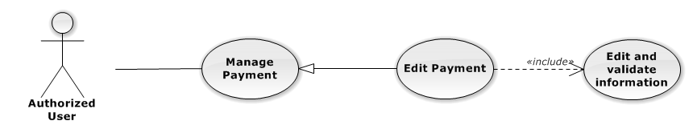

Figure 54: Edit Payment Use-Case Diagram

Edit Payment Use-Case Specification

|  |  |  |  |
| --- | --- | --- | --- |
| USE-CASE SPECIFICATION | | | |
| Use-case No. | UC0041 | Use-case Version | 1.0 |
| Use-case Name | Edit Payment | | |
| Author | Nguyễn Tiến Thành | | |
| Date | 30/01/2014 | Priority | Normal |
| Actor:  Authorized User, who is assigned in current case  Summary:  Staff can update payment service into Case  Goal:  Helps Staff update payment service into Case  Triggers:   * Staff click on “Hóa đơn” link in Case Detail page * Click on edit icon beside “Hóa đơn thanh toán” button * Click on “Edit” button to update event.   Preconditions:   * Must be logged-in * The page is fully loaded * Must be in Used Service page * Click on edit icon beside “Hóa đơn thanh toán” label before   Post Conditions:  Success:   * Update Used Service into current Case * Show message successfully: “Sửa thanh toán thành công!” * Calculation and display the total money of Payment and display total of money unpaid or balancein field “Chưa thanh toán” , “Số dư”.   Failure: System display error message “Sửa thanh toán thất bại!", "hãy kiểm tra lại kết nối database!”  Main Success Scenario:   |  |  |  | | --- | --- | --- | | *Step* | *User* | *System* | | 1 | Click on edit icon beside “Hóa đơn thanh toán” label | List all payment in current case, “Edit” and “Delete” icon is display, “Thêm dịch vụ” and “Hoàn thành” button is display | | 2 | Click on the “Edit” button | Pop-up “Sửa thanh toán” is display load detail of 1 Used Service, “Đóng” and “Sửa chi phí” button is display | | 3 | Edit information into fields and click button “Sửa thanh toán” button  [Alternative 1], [Exception 1] ,[Exception 2] | System display message “Sửa thanh toán thành công!” |   Alternative Scenario:   |  |  |  | | --- | --- | --- | | *#* | *User* | *System* | | 1 | Click on “Đóng” button | Input form close back to list all event screen. |   Exceptions:   |  |  |  | | --- | --- | --- | | *#* | *User* | *System* | | 1 | Field “Thanh Toán”, are blank | Shows error message “Nhập số tiền thanh toán!”. | | Field “Nội dung”, are blank | Shows error message “Nhập nội dung!”. | | 2 | System cannot insert event to data base. | Shows error message “Sửa thanh toán thất bại!", "Hãy kiểm tra lại kết nối database”. |   Relationships:  Manage Payment  Business Rules:  Only Administrator or Authorized User is assigned in current case can be use this function when status of case is “Đang thụ lý” and Office that have current case must is active. | | | |

Delete Payment

Delete Payment Use-Case Diagram

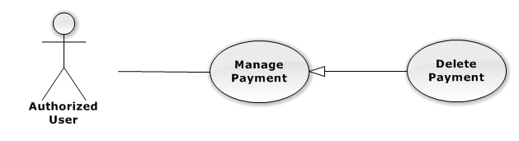

Figure 55: Delete Payment Use-Case Diagram

Delete Payment Use-Case Specification

|  |  |  |  |
| --- | --- | --- | --- |
| USE-CASE SPECIFICATION | | | |
| Use-case No. | UC0042 | Use-case Version | 1.0 |
| Use-case Name | Delete Payment | | |
| Author | Nguyễn Tiến Thành | | |
| Date | 30/01/2014 | Priority | Normal |
| Actor:  Authorized User, who is assigned in current case  Summary:  Staff can remove payment in Case  Goal:  Helps Staff remove payment in Case  Triggers:  Staff click on delete icon in the end table list  Preconditions:   * Must be logged-in * The page is fully loaded * Must be in Lawyer related page * Click on edit icon beside “Hóa đơn thanh toán” label before   Post Conditions:  Success:   * Remove the Event out of current Case * Show message remove successfully: “Xóa thanh toán thành công!” * Calculation and display the total money of payment   Failure: System display error message “Xóa thanh toán thất bại!", "Hãy kiểm tra lại kết nối database”  Main Success Scenario:   |  |  |  | | --- | --- | --- | | *Step* | *User* | *System* | | 1 | Click on edit icon beside “Chi phí dịch vụ” label | Icon delete is display | | 2 | Click on icon delete corresponding with Used Service want to remove | Show a modal popup to confirm | | 3 | Click on “Xác nhận” button  [Alternative 1] | System display message “Xóa thanh toán thành công!” |   Alternative Scenario:   |  |  |  | | --- | --- | --- | | *#* | *User* | *System* | | 1 | Click on “Bỏ qua” button | Modal popup is close and system do not remove the Event |   Exceptions:  N/A  Relationships:  Manage Payment  Business Rules:  Only Administrator or Authorized User is assigned in current case can be use this function when status of case is “Đang thụ lý” and Office that have current case must is active. | | | |

###### Integrate Thư Viện Pháp Luật

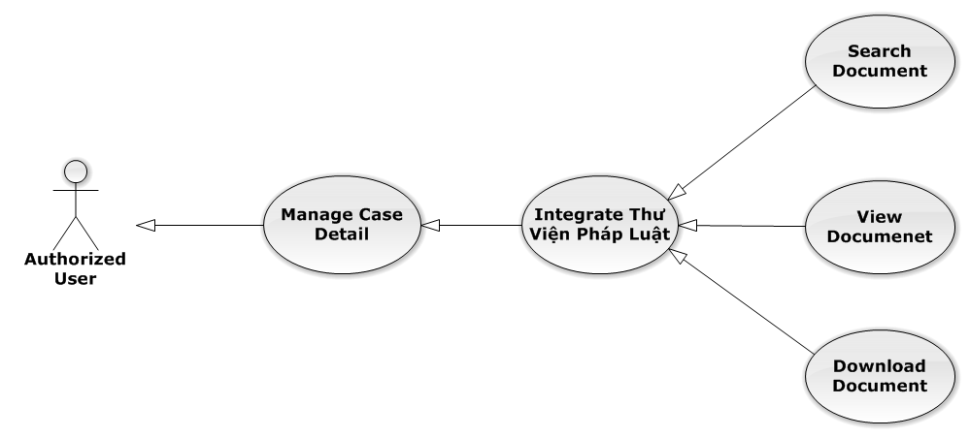

Figure 56: Integrate Thư Viện Pháp Luật Use-Case Diagram

Search Document

Search Document Use-Case Diagram

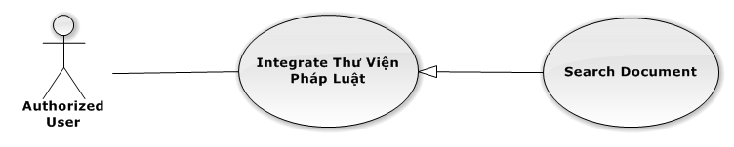

Figure 57: Search Document Use-Case Diagram

Search Document Use-Case Specification

|  |  |  |  |
| --- | --- | --- | --- |
| USE-CASE SPECIFICATION | | | |
| Use-case No. | UC0043 | Use-case Version | 1.0 |
| Use-case Name | Search Document | | |
| Author | Nguyễn Tiến Thành | | |
| Date | 30/01/2014 | Priority | Normal |
| Actor:  Authorized User  Summary:  Staff can search document resource of website <http://thuvienphapluat.vn> by LFMS  Goal:  Helps Staff search document about law.  Triggers:   * Staff click on “Trợ giúp” button Case Detail page * Choose type of document want to search, and input keyword to search. * Click on “Tìm kiếm” button to search document.   Preconditions:   * Must be logged-in * Connect the Internet * The page is fully loaded   Post Conditions:  Success:Display result of search.  Failure: System display error message.  Main Success Scenario:   |  |  |  | | --- | --- | --- | | *Step* | *User* | *System* | | 1 | Click on “Trợ giúp” button | Display Search popup | | 2 | Choose type of document want to search.  Choose constraints to search.  Click “Tìm kiếm” button  [Alternative 1], [Exception 1] | Display the result of search. |   Alternative Scenario:   |  |  |  | | --- | --- | --- | | *#* | *User* | *System* | | 1 | Click on “Đóng” button | Search Popup is closed. |   Exceptions:   |  |  |  | | --- | --- | --- | | *#* | *User* | *System* | | 1 | When can’t connect to website | Shows error message “Không thể login vào thuvienphapluat.vn, hãy kiểm tra kết nối mạng!”. |   Relationships:  Integrate Thư Viện Pháp Luật  Business Rules:  N/A | | | |

View Document

View Document Use-Case Diagram

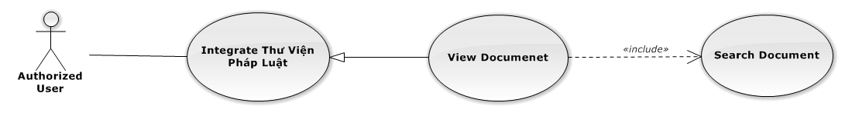

Figure 58: View Document Use-Case Diagram

View Document Use-Case Specification

|  |  |  |  |
| --- | --- | --- | --- |
| USE-CASE SPECIFICATION | | | |
| Use-case No. | UC0044 | Use-case Version | 1.0 |
| Use-case Name | View Document | | |
| Author | Nguyễn Tiến Thành | | |
| Date | 30/01/2014 | Priority | Normal |
| Actor:  Authorized User  Summary:  Staff can view detail of document from the result of search.  Goal:  Helps staff to view detail of document  Triggers:   * Staff click on “Xem trước nội dung” link   Preconditions:   * Must be logged-in * The page is fully loaded * Search document successful * Must be in “Search” popup   Post Conditions:  Success: The popup modal have document detail is displayed  Failure: Display error message “Không thể login vào thuvienphapluat.vn, hãy kiểm tra kết nối mạng”  Main Success Scenario:   |  |  |  | | --- | --- | --- | | *Step* | *User* | *System* | | 1 | Staff click on “Xem trước nội dung” link  [Alternative 1], [Exception 1] | The popup modal have document detail is displayed |   Alternative Scenario:   |  |  |  | | --- | --- | --- | | *#* | *User* | *System* | | 1 | Click “Đóng” button | Modal popup is close |   Exceptions:   |  |  |  | | --- | --- | --- | | *#* | *User* | *System* | | 1 | When can’t connect to website | Shows error message “Không thể login vào thuvienphapluat.vn, hãy kiểm tra kết nối mạng!”. |   Relationships:  Integrate Thư Viện Pháp Luật  Business Rules:  N/A | | | |

Download Document

Download Document Use-Case Diagram

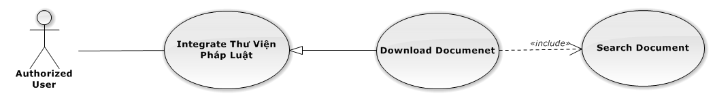

Figure 59: Download Document Use-Case Diagram

Download Document Use-Case Specification

|  |  |  |  |
| --- | --- | --- | --- |
| USE-CASE SPECIFICATION | | | |
| Use-case No. | UC0045 | Use-case Version | 1.0 |
| Use-case Name | Dowwnload Document | | |
| Author | Nguyễn Tiến Thành | | |
| Date | 30/01/2014 | Priority | Normal |
| Actor:  Authorized User, who is assigned in current case  Summary:  Staff can dowload document and add into Case.  Goal:  Helps staff to download document  Triggers:   * Staff click on “Tải về” link   Preconditions:   * Must be logged-in * The page is fully loaded * Search document successful * Must be in “Search” popup   Post Conditions:  Success: The success message is displayed  Failure: Display error message  Main Success Scenario:   |  |  |  | | --- | --- | --- | | *Step* | *User* | *System* | | 1 | Staff click on “Tải về” link  [Alternative 1], [Exception 1] | The popup waiting is display “Hệ thống đang tải văn bản Xin hãy đợi 1 lát ...“  The message result of download is displayed. |   Alternative Scenario:   |  |  |  | | --- | --- | --- | | *#* | *User* | *System* | | 1 | Click “Đóng” button | Modal popup is close |   Exceptions:   |  |  |  | | --- | --- | --- | | *#* | *User* | *System* | | 1 | When can’t connect to website | Shows error message “Không thể login vào thuvienphapluat.vn, hãy kiểm tra kết nối mạng!”. | | When can’t download file | Shows error message “Không thể login vào thuvienphapluat.vn, hãy kiểm tra kết nối mạng!”. |   Relationships:  Integrate Thư Viện Pháp Luật  Business Rules:  Only Administrator or Authorized User is assigned in current case can be use this function when status of case is “Đang thụ lý” and Office that have current case must is active. | | | |

#### Manage Customer Group

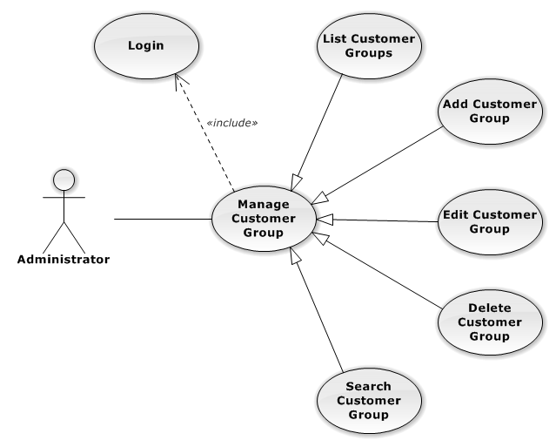

Figure 60: Manage Customer Group Use-Case Diagram

##### List Customer Groups

###### List Customer Groups Use-Case Diagram

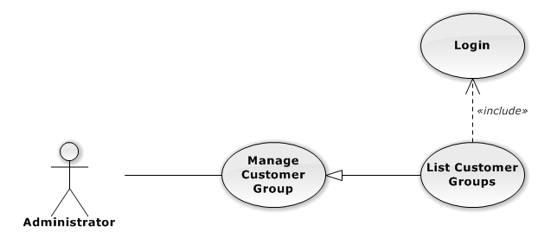

Figure 61: List Customer Groups Use-Case Diagram

###### List Customer Groups Use-Case Specification

|  |  |  |  |
| --- | --- | --- | --- |
| USE CASE SPECIFICATION | | | |
| Use-case No. | UC0046 | Use-case Version | 1.0 |
| Use-case Name | List Customer Groups | | |
| Author | Lê Duy Hoàng | | |
| Date | 30/01/2014 | Priority | Normal |
| Actor:  Administrator  Summary:  List All Customer Group.  Goal:  The purpose of List Customer Group use case is allowing Admin to view all Customer Groups.  Triggers:  User choose “Quản lý Nhóm Khách Hàng” in menu.  Preconditions:  User is authenticated and has role “admin”.  The page is fully loaded.  Post Conditions:  Success: All Customer Groups are listed.  Failure: N/A  Main Success Scenario:   |  |  |  | | --- | --- | --- | | *Step* | *User* | *System* | | 1 | Click “Quản lý Nhóm Khách Hàng” in menu. | All Customer Groups are loaded. |   Alternative Scenario:  N/A  Exceptions:  N/A  Relationships:  Manage Customer Group  Business Rules:  N/A | | | |

##### Add New Customer Group

###### Add New Customer Group Use-Case Diagram

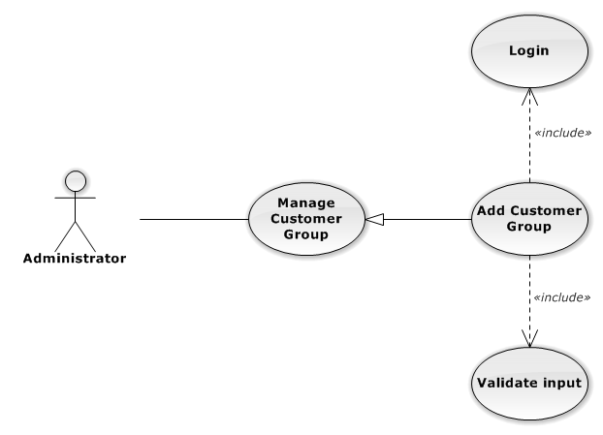

Figure 62: Add New Customer Group Use-Case Diagram

###### Add New Customer Group Use-Case Specification

|  |  |  |  |
| --- | --- | --- | --- |
| USE CASE SPECIFICATION | | | |
| Use-case No. | UC0047 | Use-case Version | 1.0 |
| Use-case Name | Add Customer Group | | |
| Author | Lê Duy Hoàng | | |
| Date | 30/01/2014 | Priority | Normal |
| Actor:  Administrator  Summary:  Add new Customer Group.  Goal:  The purpose of Add Customer Group use case is allowing Admin to add new Customer Group.  Triggers:  User choose “Quản lý Nhóm Khách Hàng” in menu.  Preconditions:  User is authenticated and has role “admin”.  Post Conditions:  Success: New Customer Group is created.  Failure: No Customer Group is created and Error message will be showed.  Main Success Scenario:   |  |  |  | | --- | --- | --- | | *Step* | *User* | *System* | | 1 | Click “Thêm Nhóm Khách Hàng” button. | Show add new customer group pop-up. | | 2 | Enters the Customer Group Name and Description |  | | 3 | Presses “Thêm Nhóm Khách Hàng” button.  [Alternative: 1] | Checks validate, add new Customer Group to database.  Show success message.  [Exception: 1]  [Exception: 2]  [Exception: 3] |   Alternative Scenario:   |  |  |  | | --- | --- | --- | | *#* | *User* | *System* | | 1 | Presses “Đóng”, “X” button or click outside pop-up. | The Add New Customer Group pop-up is close. |   Exceptions:   |  |  |  | | --- | --- | --- | | *#* | *User* | *System* | | 1 | Customer Group Name is missing. | Show error “Nhập tên nhóm khách hang” to user. | | 2 | Add Customer group fail. | The Add New Customer Group is closed and display error message “Tạo nhóm khách hàng thất bại!", "Hãy kiểm tra lại kết nối database." | | 3 | Add Customer group error. | The Add New Customer Group is closed and display error message "Tạo nhóm khách hàng thất bại!", "Có lỗi xảy ra trong quá trình tạo nhóm khách hàng." |   Relationships:  Manage Customer Group  Business Rules:  N/A | | | |

##### Edit Customer Group

###### Edit Customer Group Use-Case Diagram

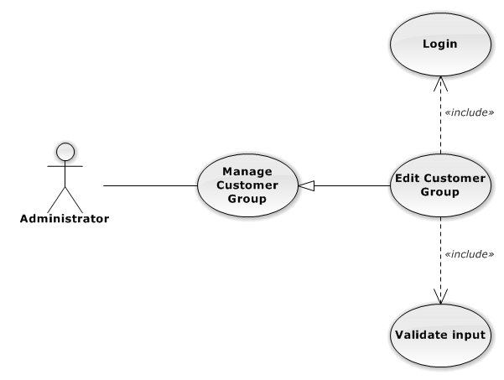

Figure 63: Edit Customer Group Use-Case Diagram

###### Edit Customer Group Use-Case Specification

|  |  |  |  |
| --- | --- | --- | --- |
| USE CASE SPECIFICATION | | | |
| Use-case No. | UC0048 | Use-case Version | 1.0 |
| Use-case Name | Delete Customer Group | | |
| Author | Lê Duy Hoàng | | |
| Date | 30/01/2014 | Priority | Normal |
| Actor:  Administrator  Summary:  Update Customer Group.  Goal:  The purpose of Update Customer Group use case is allowing Admin to update Customer Group.  Triggers:  User choose “Quản lý Nhóm Dịch Vụ” in menu.  Preconditions:  User is authenticated and has role “admin”.  Post Conditions:  Success: The Customer Group id Updated.  Failure: The Customer Group is not updated and Error message will be showed.  Main Success Scenario:   |  |  |  | | --- | --- | --- | | *Step* | *User* | *System* | | 1 | Click Update icon. |  | | 2 | Enters the new Customer Group Name and Description |  | | 3 | Presses “Lưu chỉnh sửa” button.  [Alternative: 1] | Checks validate, update Customer Group to database.  Show success message.  [Exception: 1]  [Exception: 2]  [Exception: 3] |   Alternative Scenario:   |  |  |  | | --- | --- | --- | | *#* | *User* | *System* | | 1 | Presses “Đóng”, “X” button or click outside pop-up. | The Update Customer Group pop-up is close. |   Exceptions:   |  |  |  | | --- | --- | --- | | *#* | *User* | *System* | | 1 | Customer Group Name is missing. | Show error “Nhập tên nhóm khách hàng” to user. | | 2 | Update Customer group fail. | The Update Customer Group is closed and display error message “Chỉnh sửa nhóm khách hàng thất bại!", "Hãy kiểm tra lại kết nối database." | | 3 | Update Customer group error. | The Update Customer Group is closed and display error message "Chỉnh sửa nhóm khách hàng thất bại!", "Có lỗi xảy ra trong quá trình tạo nhóm khách hàng." |   Relationships:  Manage Customer Group  Business Rules:  N/A | | | |

##### Delete Customer Group

###### Delete Customer Group Use-Case Diagram

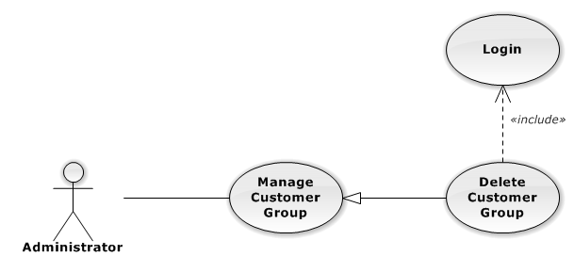

Figure 64: Delete Customer Group Use-Case Diagram

###### Delete Customer Group Use-Case Specification

|  |  |  |  |
| --- | --- | --- | --- |
| USE CASE SPECIFICATION | | | |
| Use-case No. | UC0049 | Use-case Version | 1.0 |
| Use-case Name | Delete Customer Group | | |
| Author | Lê Duy Hoàng | | |
| Date | 30/01/2014 | Priority | Normal |
| Actor:  Administrator  Summary:  Delete Customer Group.  Goal:  The purpose of Delete Customer Group use case is allowing Admin to delete Customer Group.  Triggers:  User choose “Quản lý Nhóm Khách Hàng” in menu.  Preconditions:  User is authenticated and has role “admin”.  Post Conditions:  Success: The Customer Group is deleted.  Failure: The Customer Group is not delete and Error message will be showed.  Main Success Scenario:   |  |  |  | | --- | --- | --- | | *Step* | *User* | *System* | | 1 | Click Delete icon. | Show confirm pop-up | | 2 | Presses “Đồng ý” button.  [Alternative: 1] | Delete Customer Group from database.  Show success message.  [Exception: 1]  [Exception: 2] |   Alternative Scenario:   |  |  |  | | --- | --- | --- | | *#* | *User* | *System* | | 1 | Presses “Đóng”, “X” button or click outside pop-up. | The confirm pop-up is close. |   Exceptions:   |  |  |  | | --- | --- | --- | | *#* | *User* | *System* | | 1 | Delete Customer group fail. | The Add New Customer Group is closed and display error message “Xóa nhóm khách hàng thất bại!", "Hãy kiểm tra lại kết nối database." | | 2 | Delete Customer group error. | The Add New Customer Group is closed and display error message "Xóa nhóm khách hàng thất bại!", "Có lỗi xảy ra trong quá xóa nhóm khách hàng." |   Relationships:  Manage Customer Group  Business Rules:  N/A | | | |

##### Search Customer Group

###### Search Customer Group Use-Case Diagram

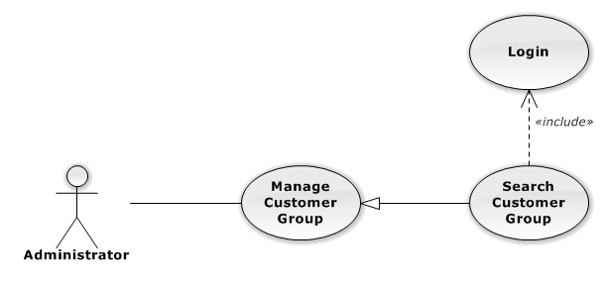

Figure 65: Search Customer Group Use-Case Diagram

###### Search Customer Group Use-Case Specification

|  |  |  |  |
| --- | --- | --- | --- |
| USE CASE SPECIFICATION | | | |
| Use-case No. | UC0050 | Use-case Version | 1.0 |
| Use-case Name | Search Customer Group | | |
| Author | Lê Duy Hoàng | | |
| Date | 30/01/2014 | Priority | Normal |
| Actor:  Administrator  Summary:  Search Customer Group.  Goal:  The purpose of Search Customer Group use case is allowing Admin to search Customer.  Triggers:  User choose “Quản lý Nhóm khách hàng” in menu.  Preconditions:  User is authenticated and has role “admin”.  Post Conditions:  Success: List of Customer Group with search key words is displayed.  Failure: No record is displayed.  Main Success Scenario:   |  |  |  | | --- | --- | --- | | *Step* | *User* | *System* | | 1 | In “Quản lý Nhóm khách hàng” screen, input key word at “Tìm kiếm” textbox. | List of Customer Group with search key words is displayed. |   Alternative Scenario:  N/A  Exceptions:  N/A  Relationships:  Manage Customer Group  Business Rules:  N/A | | | |

#### Manage Customer

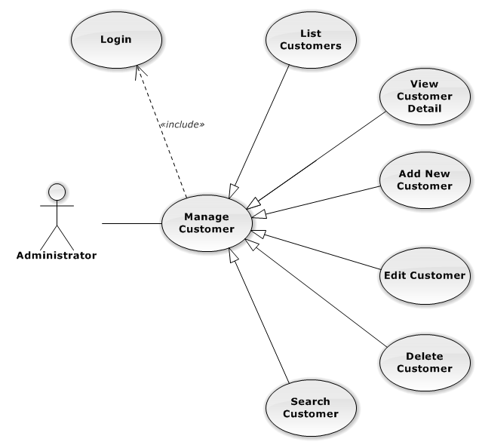

Figure 66: Manage Customer Use-Case Diagram

##### List Customers

###### List Customers Use-Case Diagram

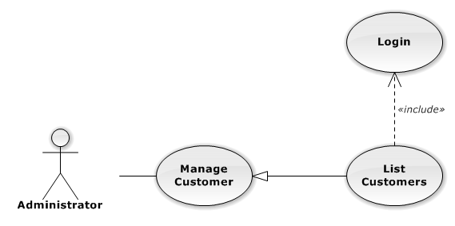

Figure 67: List Customers Use-Case Diagram

###### List Customers Use-Case Specification

|  |  |  |  |
| --- | --- | --- | --- |
| USE CASE SPECIFICATION | | | |
| Use-case No. | UC0051 | Use-case Version | 1.0 |
| Use-case Name | List Customers | | |
| Author | Lê Duy Hoàng | | |
| Date | 30/01/2014 | Priority | Normal |
| Actor:  Administrator  Summary:  List All Customer.  Goal:  The purpose of List Customers use case is allowing Admin to view all Customers.  Triggers:  User choose “Quản lý Khách Hàng” in menu.  Preconditions:  User is authenticated and has role “admin”.  The page is fully loaded.  Post Conditions:  Success: All Customer is listed.  Failure: N/A  Main Success Scenario:   |  |  |  | | --- | --- | --- | | *Step* | *User* | *System* | | 1 | Click “Quản lý Khách Hàng” in menu. | All Customers are loaded. |   Alternative Scenario:  N/A  Exceptions:  N/A  Relationships:  Manage Customer  Business Rules:  N/A | | | |

##### View Customer Detail

###### View Customer Detail Use-Case Diagram

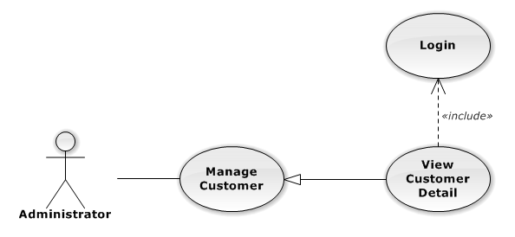

Figure 68: View Customer Detail Use-Case Diagram

###### View Customer Detail Use-Case Specification

|  |  |  |  |
| --- | --- | --- | --- |
| USE CASE SPECIFICATION | | | |
| Use-case No. | UC0052 | Use-case Version | 1.0 |
| Use-case Name | View Customer Detail | | |
| Author | Lê Duy Hoàng | | |
| Date | 30/01/2014 | Priority | Normal |
| Actor:  Administrator  Summary:  View Customer Detail.  Goal:  The purpose of View Customer Detail use case is allowing Admin to view a Customer detail.  Triggers:  User choose “Quản lý Khách Hàng” in menu. Then click “View detail” icon.  Preconditions:  User is authenticated and has role “admin”.  Post Conditions:  Success: Customer Detail is showed.  Failure: Do nothing.  Main Success Scenario:   |  |  |  | | --- | --- | --- | | *Step* | *User* | *System* | | 1 | In Manage Customer page, click “View detail” icon | The Customer Detail is showed. |   Alternative Scenario:  N/A  Exceptions:  N/A  Relationships:  Manage Customer  Business Rules:  N/A | | | |

##### Add New Customer

###### Add New Customer Use-Case Diagram

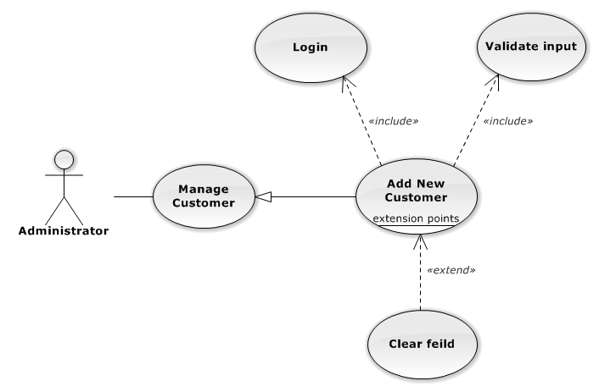

Figure 69: Add New Customer Use-Case Diagram

###### Add New Customer Use-Case Specification

|  |  |  |  |
| --- | --- | --- | --- |
| USE CASE SPECIFICATION | | | |
| Use-case No. | UC0053 | Use-case Version | 1.0 |
| Use-case Name | Add New Customer | | |
| Author | Lê Duy Hoàng | | |
| Date | 30/01/2014 | Priority | Normal |
| Actor:  Administrator  Summary:  Add Customer.  Goal:  The purpose of Add Customer use case is allowing Admin to add new Customer.  Triggers:  User choose “Quản lý Khách Hàng” in menu.  Preconditions:  User is authenticated and has role “admin”.  Post Conditions:  Success: New Customer is created.  Failure: No Customer is created and Error message will be showed.  Main Success Scenario:   |  |  |  | | --- | --- | --- | | *Step* | *User* | *System* | | 1 | Click “Thêm Khách Hàng” button. | Show add Customer pop-up. | | 2 | Enters the Customer detail. |  | | 3 | Presses “Thêm Khách Hàng” button.  [Alternative: 1] | Checks validate, add new Customer to database.  Show success message.  [Exception: 1]  [Exception: 2]  [Exception: 3] |   Alternative Scenario:   |  |  |  | | --- | --- | --- | | *#* | *User* | *System* | | 1 | Presses “Đóng”, “X” button or click outside pop-up. | The Add New Customer pop-up is close. |   Exceptions:   |  |  |  | | --- | --- | --- | | *#* | *User* | *System* | | 1 | Customer Name is missing. | Show error “"Nhập tên khách hàng!" to user. | | Represent-Person is missing. | Show error “"Nhập tên người đại diện!” to user. | | Customer Group is not chosen. | Show error “"Chọn nhóm khách hàng!” to user. | | Address is missing. | Show error “"Nhập địa chỉ!" to user. | | Email format is wrong. | Show error “Email chưa đúng định dạng!" to user. | | Mobile is missing. | Show error “Nhập số điện thoại di động!” to user. | | 2 | Add Customer fail. | The Add New Customer is closed and display error message “Tạo khách hàng thất bại!", "Hãy kiểm tra lại kết nối database." | | 3 | Add Customer error. | The Add New Customer is closed and display error message "Tạo khách hàng thất bại!", "Có lỗi xảy ra trong quá trình tạo khách hàng." |   Relationships:  Manage Customer  Business Rules:  N/A | | | |

##### Edit Customer

###### Edit Customer Use-Case Diagram

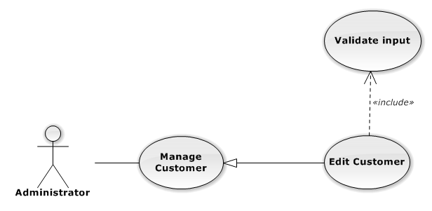

Figure 70: Edit Customer Use-Case Diagram

###### Edit Customer Use-Case Specification

|  |  |  |  |
| --- | --- | --- | --- |
| USE CASE SPECIFICATION | | | |
| Use-case No. | UC0054 | Use-case Version | 1.0 |
| Use-case Name | Edit Customer | | |
| Author | Lê Duy Hoàng | | |
| Date | 30/01/2014 | Priority | Normal |
| Actor:  Administrator  Summary:  Update Customer.  Goal:  The purpose of Update Customer use case is allowing Admin to update Customer.  Triggers:  User choose “Quản lý Khách Hàng” in menu.  Preconditions:  User is authenticated and has role “admin”.  Post Conditions:  Success: The Customer is Updated.  Failure: The Customer is not updated and Error message will be showed.  Main Success Scenario:   |  |  |  | | --- | --- | --- | | *Step* | *User* | *System* | | 1 | Click Update icon. | Show update Customer pop-up. | | 2 | Enters the new Customer’s detail. |  | | 3 | Presses “Lưu chỉnh sửa” button.  [Alternative: 1] | Checks validate, update Customer to database.  Show success message.  [Exception: 1]  [Exception: 2]  [Exception: 3] |   Alternative Scenario:   |  |  |  | | --- | --- | --- | | *#* | *User* | *System* | | 1 | Presses “Đóng”, “X” button or click outside pop-up. | The Update Customer pop-up is close. |   Exceptions:   |  |  |  | | --- | --- | --- | | *#* | *User* | *System* | | 1 | Customer Name is missing. | Show error “"Nhập tên khách hàng!" to user. | | Represent-Person is missing. | Show error “"Nhập tên người đại diện!” to user. | | Customer Group is not chosen. | Show error “"Chọn nhóm khách hàng!” to user. | | Address is missing. | Show error “"Nhập địa chỉ!" to user. | | Email format is wrong. | Show error “Email chưa đúng định dạng!" to user. | | Mobile is missing. | Show error “Nhập số điện thoại di động!” to user. | | 2 | Update Customer fail. | The Update Customer pop-up is closed and display error message “Chỉnh sửa khách hàng thất bại!", "Hãy kiểm tra lại kết nối database." | | 3 | Update Customer error. | The Update Customer pop-up is closed and display error message "Chỉnh sửa khách hàng thất bại!", "Có lỗi xảy ra trong quá trình chỉnh sửa khách hàng." |   Relationships:  Manage Customer  Business Rules:  N/A | | | |

##### Delete Customer

###### Delete Customer Use-Case Diagram

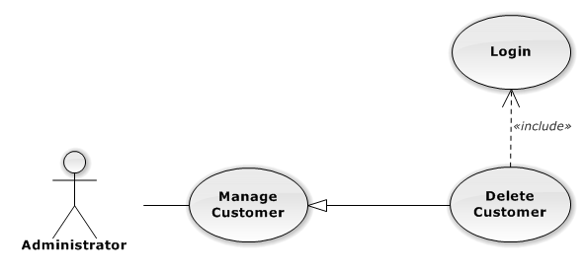

Figure 71: Delete Customer Use-Case Diagram

###### Delete Customer Use-Case Specification

|  |  |  |  |
| --- | --- | --- | --- |
| USE CASE SPECIFICATION | | | |
| Use-case No. | UC0055 | Use-case Version | 1.0 |
| Use-case Name | Delete Customer | | |
| Author | Lê Duy Hoàng | | |
| Date | 30/01/2014 | Priority | Normal |
| Actor:  Administrator  Summary:  Delete Customer.  Goal:  The purpose of Delete Customer use case is allowing Admin to delete Customer.  Triggers:  User choose “Quản lý Khách Hàng” in menu.  Preconditions:  User is authenticated ans has role “admin”.  Post Conditions:  Success: The Customer is deleted.  Failure: The Customer is not delete and Error message will be showed.  Main Success Scenario:   |  |  |  | | --- | --- | --- | | *Step* | *User* | *System* | | 1 | Click Delete icon. | Show confirm pop-up | | 2 | Presses “Đồng ý” button.  [Alternative: 1] | Delete Customer from database.  Show success message.  [Exception: 1]  [Exception: 2] |   Alternative Scenario:   |  |  |  | | --- | --- | --- | | *#* | *User* | *System* | | 1 | Presses “Đóng”, “X” button or click outside pop-up. | The confirm pop-up is close. |   Exceptions:   |  |  |  | | --- | --- | --- | | *#* | *User* | *System* | | 1 | Delete Customer fail. | The confirm pop-up is closed and display error message “Xóa nhóm dịch vụ thất bại!", "Hãy kiểm tra lại kết nối database." | | 2 | Delete Customer error. | The confirm pop-up is closed and display error message “Xóa nhóm dịch vụ thất bại!", "Có lỗi xảy ra trong quá trình xóa khách hàng." |   Relationships:  Manage Customer  Business Rules:  N/A | | | |

##### Search Customer

###### Search Customer Use-Case Diagram

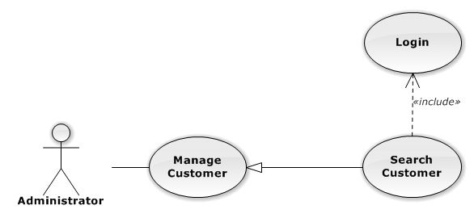

Figure 72: Search Customer Use-Case Diagram

###### Search Customer Use-Case Specification

|  |  |  |  |
| --- | --- | --- | --- |
| USE CASE SPECIFICATION | | | |
| Use-case No. | UC0056 | Use-case Version | 1.0 |
| Use-case Name | Search Customer | | |
| Author | Lê Duy Hoàng | | |
| Date | 30/01/2014 | Priority | Normal |
| Actor:  Administrator  Summary:  Search Customer.  Goal:  The purpose of Search Customer use case is allowing Admin to search Customer.  Triggers:  User choose “Quản lý Khách hàng” in menu.  Preconditions:  User is authenticated and has role “admin”.  Post Conditions:  Success: List of Customer with search key words is displayed.  Failure: No record is displayed.  Main Success Scenario:   |  |  |  | | --- | --- | --- | | *Step* | *User* | *System* | | 1 | In “Quản lý Khách hàng” screen, input key word at “Tìm kiếm” textbox. | List of Customer with search key words is displayed. |   Alternative Scenario:  N/A  Exceptions:  N/A  Relationships:  N/A  Business Rules:  N/A | | | |

#### Manage Staff Group

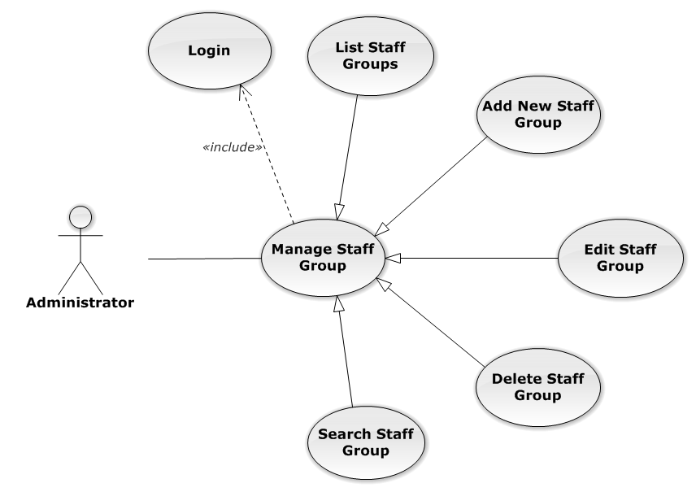

Figure 73: Manage Staff Group Use-Case Diagram

##### List Staff Groups

###### List Staff Groups Use-Case Diagram

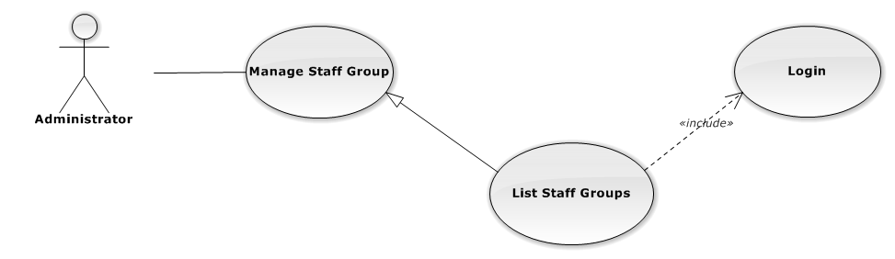

Figure 74: List Staff Groups Use-Case Diagram

###### List Staff Groups Use-Case Specification

|  |  |  |  |
| --- | --- | --- | --- |
| USE-CASE SPECIFICATION | | | |
| Use-case No. | UC0057 | Use-case Version | 1.0 |
| Use-case Name | List Staff Groups | | |
| Author | Nguyễn Thanh Sang | | |
| Date | 30/01/2014 | Priority | Normal |
| Actor:  Administrator  Summary:  Redirect user to “Quản lí nhóm nhân viên” page and list all staff group.  Goal:  To allowing Administrator view any detail information of all staff group.  Triggers:   * User click on User Control Panel and then click on “Quản lí nhân viên” link * On sub menu click on “nhóm nhân viên”.   Preconditions:   * Must be logged-in with “Admin” role. * The page is fully loaded   Post Conditions:  Success: System redirects user to “Quản lí nhóm nhân viên” page.  Failure: Do nothing.  Main Success Scenario:   |  |  |  | | --- | --- | --- | | *Step* | *User* | *System* | | 1 | Click on “Quản lí nhóm nhân viên” link | Redirect to “Quản lí nhóm nhân viên” page  Show all staff group. |   Alternative Scenario:  N/A  Exceptions:  N/A  Relationships:  Manage Staff Group  Business Rules:  Only Staff with role =”Admin” can be use this function. | | | |

##### Add New Staff Group

###### Add New Staff Group Use-Case Diagram

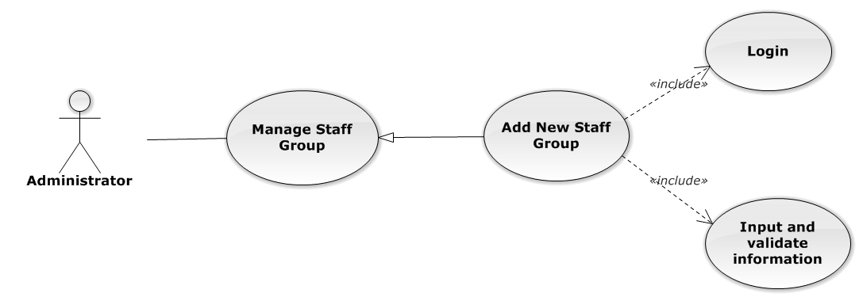

Figure 75: Add New Staff Group Use-Case Diagram

###### Add New Staff Group Use-Case Specification

|  |  |  |  |
| --- | --- | --- | --- |
| USE CASE SPECIFICATION | | | |
| Use-case No. | UC0058 | Use-case Version | 1.0 |
| Use-case Name | Add New Staff Group | | |
| Author | Nguyễn Thanh Sang | | |
| Date | 24/03/2014 | Priority | Normal |
| Actor:  Administrator.  Summary:  Administrator can insert new staff group in the system.  **Goal:**  Add new staff group.  Triggers:  At “Quản lí nhóm nhân viên” page click “Thêm nhóm nhân viên” button, fill information and click button “Thêm mới”.  Preconditions:   * Logged-in as “Admin” role. * The page is fully loaded   Post Conditions:  Success: New staff group is inserted into database, message show “Tạo nhóm nhân viên mới thành công!” and display on “Quản lí nhân viên” screen.  Failure: Show message “Tạo nhóm nhân viên mới thất bại!”  Main Success Scenario:   |  |  |  | | --- | --- | --- | | *Step* | *User* | *System* | | 1 | Administrator click on “Thêm nhóm nhân viên” button at “Quản lí Nhóm nhân viên” page. | Modal popup is displayed with fields for input information of new staff group. | |  | Fill information into fields and click button “Thêm mới”  [Alternative 1]  [Exception 1], [Exception 2], [Exception 3] | Modal popup is close  System display successful message “Tạo nhóm nhân viên mới thành công!”  Update list staff group on page |   Alternative Scenario:   |  |  |  | | --- | --- | --- | | *#* | *User* | *System* | | 1 | Click on [X] button, “Đóng” button, or click out of modal | Modal popup is close |   Exceptions:   |  |  |  | | --- | --- | --- | | *#* | *User* | *System* | | 1 | Field “Tên nhóm nhân viên” are blank | Shows error message “Nhập tên nhóm nhân viên!”. | | Field “Chi tiết nhóm nhân viên”, are blank | Shows error message “Nhập chi tiết chi tiết nhân viên!” | | 2 | System cannot insert staff group to data base. | Shows error message “Tạo nhóm nhân viên thất bại!” | | 3 | System fail insert staff group to data base. | Shows error message “Tạo nhóm nhân viên thất bại!", "Hãy kiểm tra lại kết nối database!”. |   Relationships:  Manage Staff Group  Business Rules:  Only Staff with role=”Admin” can be use this function. | | | |

##### Edit Staff Group

###### Edit Staff Group Use-Case Diagram

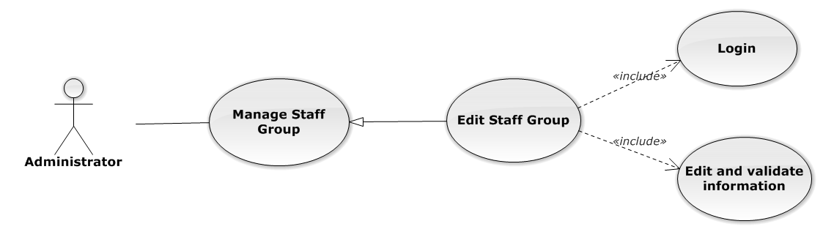

Figure 76: Edit Staff Group Use-Case Diagram

###### Edit Staff Group Use-Case Specification

|  |  |  |  |
| --- | --- | --- | --- |
| USE CASE SPECIFICATION | | | |
| Use-case No. | UC0059 | Use-case Version | 1.0 |
| Use-case Name | Edit Staff Group | | |
| Author | Nguyễn Thanh Sang | | |
| Date | 24/03/2014 | Priority | Normal |
| Actor:  Administrator.  Summary:  Administrator can update information of staff group.  **Goal:**  Administrator can update information of staff group and save to database system.  Triggers:   * Administrator goes to “Chi tiết nhóm nhân viên” Popup and click “Chỉnh Sửa” button and modify information, after that click button “Lưu Chỉnh Sửa”. * Administrator goes to “Nhóm nhân viên” screen, click “Chỉnh Sửa” button and modify information, after that click button “Lưu Chỉnh Sửa”.   Preconditions:   * User has logged-in as “Admin” role. * The page is fully loaded   Post Conditions:  Success:  Information of staff group is updated and saves to database, message show “Cập nhật chi tiết nhóm nhân viên thành công!” and display information after update on “Quản lý nhóm nhân viên” screen.  Failure:  Show message “Cập nhật chi tiết nhóm nhân viên thất bại!”  Main Success Scenario:   |  |  |  | | --- | --- | --- | | *Step* | *User* | *System* | | 1 | Manager click on “Chỉnh sửa” button at “Quản lí nhóm nhân viên” screen. | Modal popup is displayed with fields for detil information of staff group. | | 2 | Edit information into fields and click button “Lưu chỉnh sửa”  [Alternative 1]  [Exception 1], [Exception 1], [Exception 3] | Modal popup is close  System display successful message “Cập nhật chi tiết nhóm nhân viên thành công!”  Update list staff group on page |   Alternative Scenario:   |  |  |  | | --- | --- | --- | | *#* | *User* | *System* | | 1 | Click on [X] button, “Đóng” button, or click out of modal | Modal popup is close |   Exceptions:   |  |  |  | | --- | --- | --- | | *#* | *User* | *System* | | 1 | Field “Tên nhóm nhân viên” are blank | Shows error message “Nhập tên nhóm nhân viên!”. | | Field “Chi tiết nhóm nhân viên”, are blank | Shows error message “Nhập chi tiết chi tiết nhân viên!”. | | 2 | System cannot update staff to data base. | Shows error message “Cập nhật chi tiết nhóm nhân viên thất bại!”. | | 3 | System fail insert staff to data base. | Shows error message “Cập nhật chi tiết nhóm nhân viên thất bại!", "Hãy kiểm tra lại kết nối database!”. |   Relationships:  Manage Staff Group  Business Rules:  Only Staff with role=”Admin” can be use this function. | | | |

##### Delete Staff Group

###### Delete Staff Group Use-Case Diagram

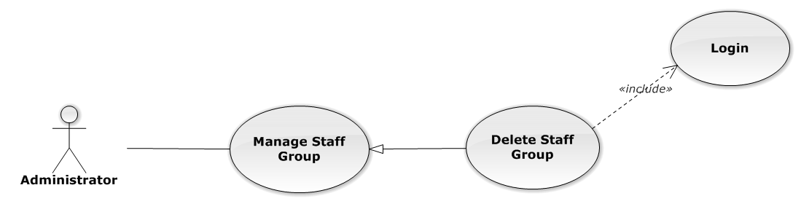

Figure 77: Delete Staff Group Use-Case Diagram

###### Delete Staff Group Use-Case Specification

|  |  |  |  |
| --- | --- | --- | --- |
| USE CASE SPECIFICATION | | | |
| Use-case No. | UC0060 | Use-case Version | 1.0 |
| Use-case Name | Delete Staff Group | | |
| Author | Nguyễn Thanh Sang | | |
| Date | 24/03/2014 | Priority | Normal |
| Actor:  Administrator.  Summary:  Administrator can delete staff group.  **Goal:**  Helps Administrator delete staff group if it didn’t use in Staff manager and save to database system.  Triggers:  Administrator goes to “Quản lí nhóm nhân viên ”page click button “Xóa”. After that click on “Bỏ qua” or“Xác nhận” button to confirm delete staff group.  Preconditions:   * User has logged-in as Admin role. * The page is fully loaded   Post Conditions:  Success:  Delete staff group and save to database system, display message “Xóa nhóm nhân viên thành công!”  Failure:  Show message “Xóa nhóm nhân viên thất bại!","Nhóm nhân viên này hiện đang được sử dụng!”.  Main Success Scenario:   |  |  |  | | --- | --- | --- | | *Step* | *User* | *System* | | 1 | Supper admin click on “Xóa” button at “Quản lí nhóm nhân viên” screen. | Show Pop-up confirm “Bạn có muốn thực hiện thao tác này” with two button “Xác nhận” and “Bỏ qua” | | 2 | User click “Bỏ qua” button | Staff group not delete, comeback to “Chi tiết nhóm nhân viên” screen. | | 3 | User click “ Xác nhận” button  [Exception 1], [Exception 2] | Show message “Xóa nhóm nhân viên thành công!” |   Alternative Scenario:  N/A  Exceptions:   |  |  |  | | --- | --- | --- | | *#* | *User* | *System* | | 1 | Delete staff group fail because staff group is use. | Shows error message “Xóa nhóm nhân viên thất bại!","Nhóm nhân viên này hiện đang được sử dụng!” | | 2 | Delete staff group error because staff group is use. | Shows error message “Xóa nhóm nhân viên thất bại!", "Có lỗi xảy ra trong quá trình xóa nhóm nhân viên”. |   Relationships:  Manage Staff Group  Business Rules:  Only Staff with role=”Admin” can be use this function. | | | |

##### Search Staff Group

###### Search Staff Group Use-Case Diagram

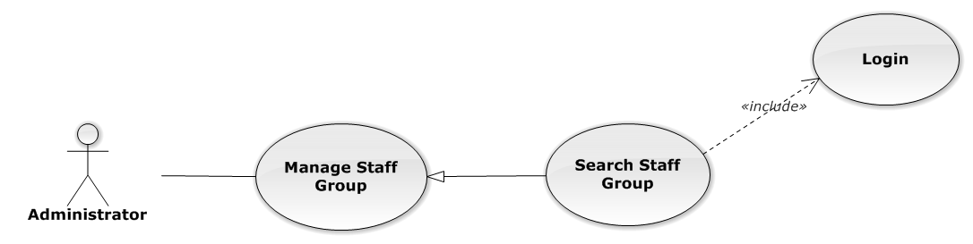

Figure 78: Search Staff Group Use-Case Diagram

###### Search Staff Group Use-Case Specification

|  |  |  |  |
| --- | --- | --- | --- |
| USE CASE SPECIFICATION | | | |
| Use-case No. | UC0061 | Use-case Version | 1.0 |
| Use-case Name | Search Staff Group | | |
| Author | Nguyễn Thanh Sang | | |
| Date | 24/03/2014 | Priority | Normal |
| Actor:  Administrator.  Summary:  Administrator search staff in list of staff group.  **Goal:**  Helps Administrator search staff group.  Triggers:   * Administrator wants to search staff group. * Administrator goes to “Quản lý nhóm nhân viên” screen, input word into “Tìm Kiếm” textbox.   Preconditions:   * User has logged-in as Admin role. * The page is fully loaded   Post Conditions:  Success:  List of staff group map with word search is displayed.  Failure:  Do nothing  Main Success Scenario:   |  |  |  | | --- | --- | --- | | *Step* | *User* | *System* | | 1 | In “Quản lý nhóm nhân viên” screen, input key word at “Tìm kiếm” textbox. | List of staff group mapping with word search is display. |   Alternative Scenario:  N/A  Exceptions:  N/A  Relationships:  Manage Staff Group  Business Rules:  Only Staff with role=”Admin” can be use this function. | | | |

#### Manage Staff

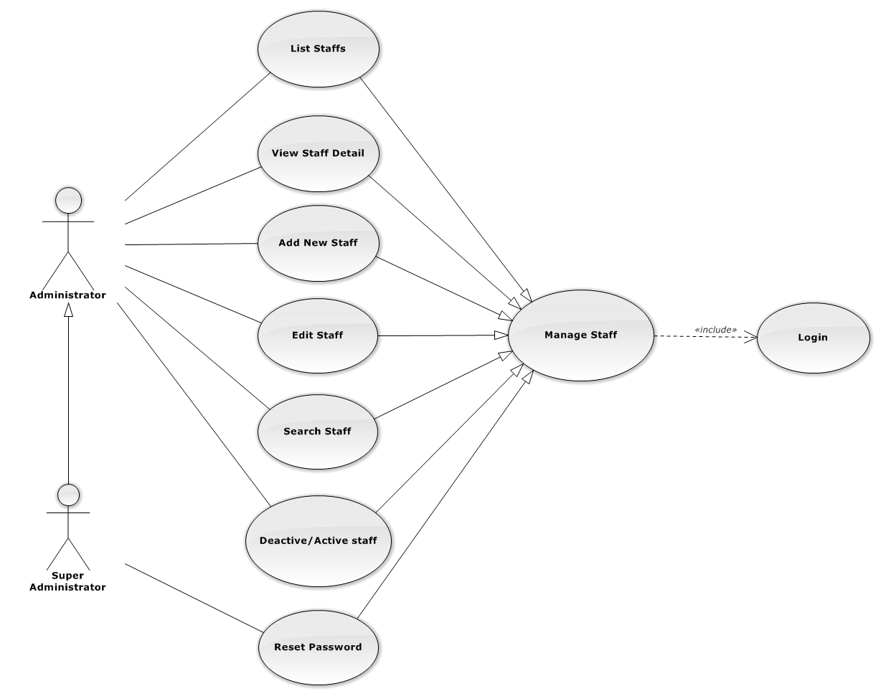

Figure 79: Manage Staff Use-Case Diagram

##### List Staffs

###### List Staffs Use-Case Diagram

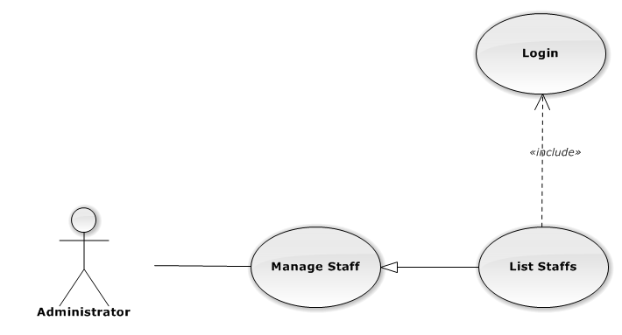

Figure 80: List Staffs Use-Case Diagram

###### List Staffs Use-Case Specification

|  |  |  |  |
| --- | --- | --- | --- |
| USE-CASE SPECIFICATION | | | |
| Use-case No. | UC0062 | Use-case Version | 1.0 |
| Use-case Name | List Staffs | | |
| Author | Nguyễn Thanh Sang | | |
| Date | 30/01/2014 | Priority | Normal |
| Actor:  Administrator  Summary:  Redirect user to “Quản lí nhân viên” page and list all staff.  Goal:  To allowing Administrator view any detail information of all staff.  Triggers:  User click on User Control Panel and then click on “Quản lí nhân viên” link  Preconditions:   * Must be logged-in with “Admin” role. * The page is fully loaded   Post Conditions:  Success: System redirects user to “Quản lí nhân viên” page.  Failure: Do nothing.  Main Success Scenario:   |  |  |  | | --- | --- | --- | | *Step* | *User* | *System* | | 1 | Click on “Quản lí nhân viên” link | Redirect to “Quản lí nhân viên” page. Show all staff. |   Alternative Scenario:  N/A  Exceptions:  N/A  Relationships:  Manage Staff  Business Rules:  Only Staff login with role “Admin” can be use this function. | | | |

##### View Staff Detail

###### View Staff Detail Use-Case Diagram

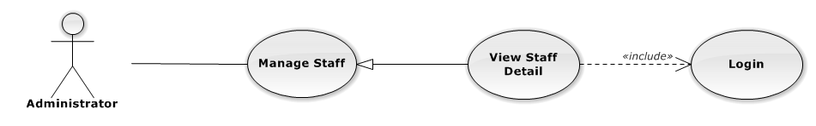

Figure 81: View Staff Detail Use-Case Diagram

###### View Staff Detail Use-Case Specification

|  |  |  |  |
| --- | --- | --- | --- |
| USE-CASE SPECIFICATION | | | |
| Use-case No. | UC0063 | Use-case Version | 1.0 |
| Use-case Name | View Staff Detail | | |
| Author | Nguyễn Thanh Sang | | |
| Date | 30/01/2014 | Priority | Normal |
| Actor:  Administrator  Summary:  Administrator can view detail of staff information  Goal:  Helps Administrator view staff information  Triggers:   * On User Control Panel click on “Quản lí nhân viên**”,** * Click click on “Chi tiết” button * Click on image staff.   Preconditions:   * Must be logged-in with “Admin” role * The page is fully loaded   Post Conditions:  Success: The detail staff information is displayed  Failure: Do nothing  Main Success Scenario:   |  |  |  | | --- | --- | --- | | *Step* | *User* | *System* | | 1 | Staff click on “chi tiết” button or click on image link  [Alternative 1] ,[Alternative 2]  [Alternative 3] ,[Alternative 4] | The detail staff information is displayed. |   Alternative Scenario:   |  |  |  | | --- | --- | --- | | *#* | *User* | *System* | | 1 | Click on [X] button, “Đóng” button, or click out of modal | Modal popup is close | | 2 | If staff login with Id=”1”, Click on “Chỉnh sửa” button | Administrator can update information of office (ref 3.2.2.2.4. Update staff) | | 3 | If staff login with Id=”1”, Click on “Hoạt động lại” or “Ngừng hoạt động” link | Administrator can Deactivate/Activate staff (ref 3.2.2.2.5. Deactivate/Activate staff) | | 4 | If staff login with Id=”1”, Click on “Đặt lại mật khẩu” link | Administrator can reset password staff (ref 3.2.2.2.7. Reset Password staff) |   Exceptions:  N/A  Relationships:  Manage Staff  Business Rules:  Only Staff login with role “Admin” can be use this function. | | | |

##### Add New Staff

###### Add New Staff Use-Case Diagram

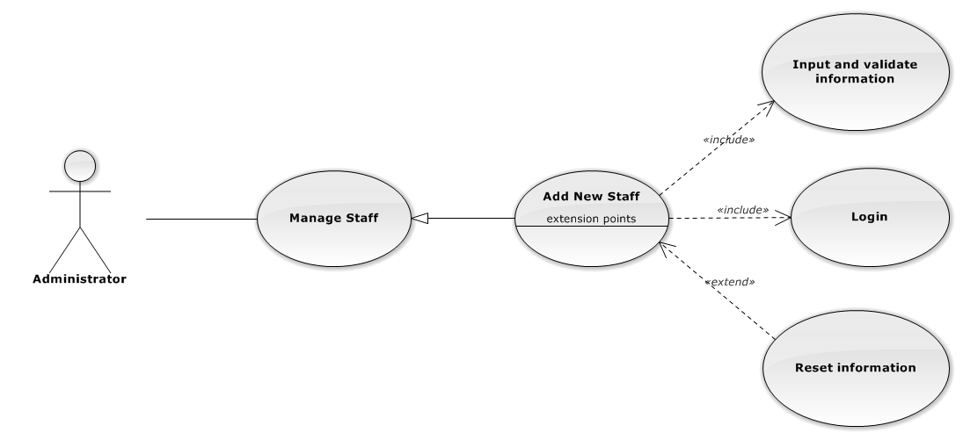

Figure 82: Add New Staff Use-Case Diagram

###### Add New Staff Use-Case Specification

|  |  |  |  |
| --- | --- | --- | --- |
| USE CASE SPECIFICATION | | | |
| Use-case No. | UC0064 | Use-case Version | 1.0 |
| Use-case Name | Add New Staff | | |
| Author | Nguyễn Thanh Sang | | |
| Date | 24/03/2014 | Priority | High |
| Actor:  Administrator.  Summary:  Administrator can insert new staff into the system.  **Goal:**  Add new staff.  Triggers:  At “Quản lí nhân viên” page, Administrator click on “Thêm nhân viên” button and fill information after that click button “Thêm mới” button.  Preconditions:   * User has logged-in as “Admin” role. * The page is fully loaded   Post Conditions:  Success:   * Add new case successful and message show “Thêm nhân viên thành công”. * Add current staff’s office to data system. * New staff’s status is “Đang hoạt động”. * Add current with username and default password is “123456” to data system.   Failure:  Show message “Thêm nhân viên thất bại, hãy kiểm tra lại kết nối database”.  Main Success Scenario:   |  |  |  | | --- | --- | --- | | *Step* | *User* | *System* | | 1 | Administrator click on “Thêm nhân viên” button at “Quản lí nhân viên” page. | Modal popup is displayed with fields for input information of new staff. | | 2 | Fill information into fields and click button “Thêm mới”  [Alternative 1]  [Exception 1], [Exception 2], [Exception 3], [Exception 4] | Modal popup is closed.  System display successful message “Thêm nhân viên thành công!”  Update list staff on page |   Alternative Scenario:   |  |  |  | | --- | --- | --- | | *#* | *User* | *System* | | 1 | Click “Làm trống” button | All input field reset to blank. |   Exceptions:   |  |  |  | | --- | --- | --- | | *#* | *User* | *System* | | 1 | Field “Tên nhân viên” are blank | Shows error message “Nhập tên nhân viên!”. | | Field “Tên đăng nhập”, are blank | Shows error message “Nhập vào tên đăng nhập!”. | | Field “Nhóm nhân viên” are blank | Shows error message “Chọn nhóm cho nhân viên!”. | | Field “Ngày sinh” are blank | Shows error message “Chọn ngày sinh của nhân viên!”. | | Field “Điện thoại di động” are blank | Shows error message “Nhập vào số điện thoại nhân viên!”. | | Field “Email” are blank | Shows error message “Hãy nhập Email của nhân viên!”. | | Input “Email” not follow the rule | Shows error message “Hãy nhập địa chỉ email đúng!”. | | Field “Địa chỉ liên hệ” are blank | Shows error message “Nhập địa chỉ của nhân viên!”. | | Field “Thuộc văn phòng ” are blank | Shows error message “Chọn một văn phòng!”. | | Field “Vai trò nhân viên” are blank | Shows error message “Chọn vai trò cho nhân viên!”. | | Field “CMND” are blank | Shows error message “Nhập vào số chứng minh nhân dân!”. | | Field “Ngày cấp CMND” are blank | Shows error message “Chọn ngày cấp chứng minh nhân dân!“. | | Field “Nơi cấp CMND” are blank | Shows error message “Nhập vào nơi cấp chứng minh nhân dân!”. | | Input “Tên đăng nhập” not follow the rule | Shows error message “Tên đăng nhập không được chứa ký tự đặc biệt!”. | | 2 | Input “Tên đăng nhập” is existed in Database | Shows error message “Tên đăng nhập nhân viên đã tồn tại!”. | | 3 | System cannot insert staff to data base. | Shows error message “Tạo nhân viên thất bại!” | | 4 | System error insert staff to data base. | Shows error message “Tạo nhân viên thất bại!", "Hãy kiểm tra lại kết nối database!”. |   Relationships:  Manage Staff.  Manage Staff Group  Business Rules:  Only Staff login with role “Admin” can be use this function. | | | |

##### Edit Staff

###### Edit Staff Use-Case Diagram

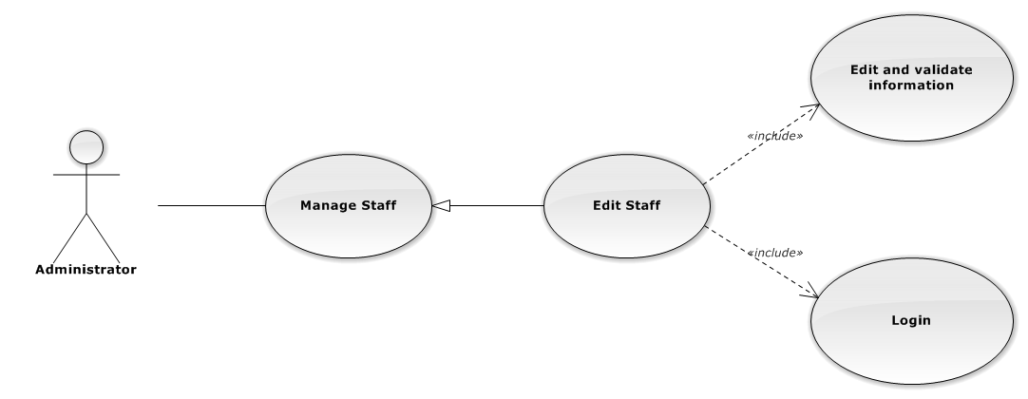

Figure 83: Edit Staff Use-Case Diagram

###### Edit Staff Use-Case Specification

|  |  |  |  |
| --- | --- | --- | --- |
| USE CASE SPECIFICATION | | | |
| Use-case No. | UC0065 | Use-case Version | 1.0 |
| Use-case Name | Edit Staff | | |
| Author | Nguyễn Thanh Sang | | |
| Date | 24/03/2014 | Priority | Normal |
| Actor:  Administrator.  Summary:  Administrator can update information of staff.  **Goal:**  Administrator can update information of staff and save to database system.  Triggers:   * Administrator goes to “Quản lý nhân viên” screen, click button “Chỉnh Sửa” button and modify information, after that click button “Lưu Chỉnh Sửa”. * Manager goes to “Chi tiết nhân viên” Popup screen, click on “Chỉnh Sửa” button and modify information, after that click button “Lưu Chỉnh Sửa”.   Preconditions:   * Logged-in as “Admin” role. * The page is fully loaded   Post Conditions:  Success:   * Information of Office is updated and saves to database * Message show “Cập nhật chi tiết nhân viên thành công” and display information after update on “Quản lý nhân viên” screen.   Failure:  Show message “Cập nhật chi tiết nhân viên thất bại!", "Hãy kiểm tra lại kết nối database.”  Main Success Scenario:   |  |  |  | | --- | --- | --- | | *Step* | *User* | *System* | | 1 | Manager click on “Chỉnh sửa” button at “Quản lí nhân viên” screen. | Modal popup is displayed with fields for detail information of new staff. | | 2 | Edit information into fields and click button “Lưu chỉnh sửa”  [Alternative 1]  [Exception 1], [Exception 2], [Exception 3] | Modal popup is close  System display successful message “Cập nhật chi tiết nhân viên thành công!”  Update list staff on page |   Alternative Scenario:   |  |  |  | | --- | --- | --- | | *#* | *User* | *System* | | 1 | Click on [X] button, “Đóng” button, or click out of modal | Modal popup is close |   Exceptions:   |  |  |  | | --- | --- | --- | | *#* | *User* | *System* | | 1 | Field “Tên nhân viên” are blank | Shows error message “Nhập tên nhân viên!”. | | Field “Tên đăng nhập”, are blank | Shows error message “Nhập vào tên đăng nhập!”. | | Field “Nhóm nhân viên” are blank | Shows error message “Chọn nhóm cho nhân viên!”. | | Field “Ngày sinh” are blank | Shows error message “Chọn ngày sinh của nhân viên!”. | | Field “Điện thoại di động” are blank | Shows error message “Nhập vào số điện thoại nhân viên!”. | | Field “Email” are blank | Shows error message “Hãy nhập Email của nhân viên!” | | Input “Email” not a regular expression | Shows error message “Hãy nhập địa chỉ email đúng!” | | Field “Địa chỉ liên hệ” are blank | Shows error message “Nhập địa chỉ của nhân viên!”. | | Field “Thuộc văn phòng ” are blank | Shows error message “Chọn một văn phòng!”. | | Field “Vai trò nhân viên” are blank | Shows error message “Chọn vai trò cho nhân viên!”. | | Field “CMND” are blank | Shows error message “Nhập vào số chứng minh nhân dân!” | | Field “Ngày cấp CMND” are blank | Shows error message “Chọn ngày cấp chứng minh nhân dân!” | | Field “Nơi cấp CMND” are blank | Shows error message “Nhập vào nơi cấp chứng minh nhân dân!” | | 2 | System cannot insert staff to data base. | Shows error message “Cập nhật chi tiết nhân viên thất bại!” | | 3 | System error insert staff to data base. | Shows error message “Cập nhật chi tiết nhân viên thất bại!", "Hãy kiểm tra lại kết nối database!” |   Relationships:  Manage Staff  Business Rules:  Only Staff login with role “Admin” can be use this function. | | | |

##### Deactivate/Activate staff

###### Deactivate/Activate staff Use-CaseDiagram

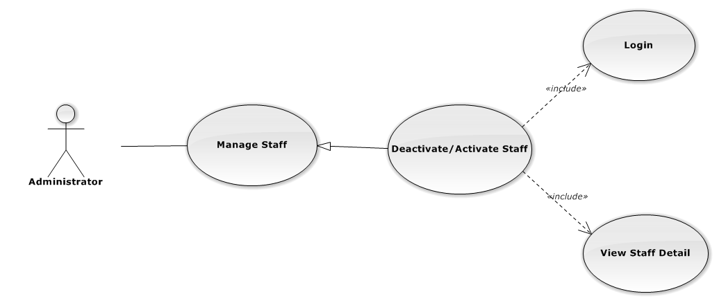

Figure 84: Deactivate/Activate Staff Use-Case Diagram

###### Deactivate/Activate staff Use-Case Specification

|  |  |  |  |
| --- | --- | --- | --- |
| USE CASE SPECIFICATION | | | |
| Use-case No. | UC0066 | Use-case Version | 1.0 |
| Use-case Name | Deactivate/Activate staff | | |
| Author | Nguyễn Thanh Sang | | |
| Date | 24/03/2014 | Priority | Normal |
| Actor:  Administrator.  Summary:  Administrator can change status of Staff.  **Goal:**  Helps Administrator update Status of staff and save to database system.  Triggers:  Administrator goes “Chi tiết nhân viên” Pop-Up screen , Click button “Ngừng hoạt động” or “Hoạt động lại”. After that click on “Bỏ qua” or “Xác nhận” button to confirm change status Staff.  Preconditions:   * Logged-in as “Admin” role * The page is fully loaded   Post Conditions:  Success:  Information of Staff is updated and saves to database, message show “[…] đã hoạt động lại!” or “[…] đã ngừng hoạt động!” and display information after update on “Quản lý nhân viên” screen.  Failure:  Show message “Thay đổi hoạt động nhân viên thất bại!", "Hãy kiểm tra lại kết nối database”.  Main Success Scenario:   |  |  |  | | --- | --- | --- | | *Step* | *User* | *System* | | 1 | Supper admin click on “Chỉnh sửa” button at “Quản lí nhân viên” screen. | Show “Chi tiết nhân viên” Pop-up information. | | 2 | On “Chi tiết văn phòng” Pop-up click button “Ngừng hoạt động ” if Staff have status “Đang hoạt động” or Click button “Hoạt động lại” if staff have status "Ngừng hoạt động”.  [Alternative 1] | Display message box confirm “Bạn có muốn thực hiện thao tác này” with two button “Xác nhận” and “Bỏ qua” | | 3 | User click “Bỏ qua” button | Status of staff not change comeback to “Chi tiết nhân viên” Pop-up screen. | | 4 | User click “ Xác nhận” button  [Exception 1] ,[Exception 2] | Status of staff is change and comeback to “Quản lí nhân viên”screen |   Alternative Scenario:  Alternative:   |  |  |  | | --- | --- | --- | | *#* | *User* | *System* | | 1 | Click on [X] button, “Đóng” button, or click out of modal | Modal popup is close |   Exceptions:   |  |  |  | | --- | --- | --- | | *#* | *User* | *System* | | 1 | System fail change status of staff | Shows error message “Thay đổi hoạt động nhân viên thất bại!", "Có lỗi xảy ra trong quá trình xóa nhân viên.”. | | 2 | System error change status of staff. | Shows error message “Thay đổi hoạt động nhân viên thất bại!", "Hãy kiểm tra lại kết nối database”. |   Relationships:  Manage Staff  Business Rules:  Only Staff login with role “Admin” can be use this function. | | | |

##### Search Staff

###### Search Staff Use-Case Diagram

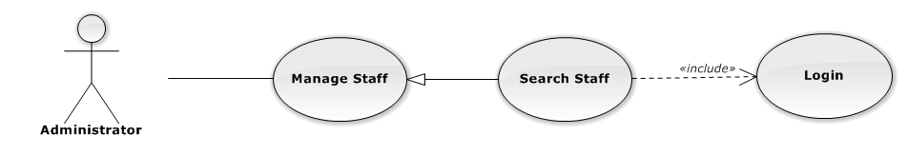

Figure 85: Search Staff Use-Case Diagram

###### Search Staff Use-Case Specification

|  |  |  |  |
| --- | --- | --- | --- |
| USE CASE SPECIFICATION | | | |
| Use-case No. | UC0067 | Use-case Version | 1.0 |
| Use-case Name | Search Staff | | |
| Author | Nguyễn Thanh Sang | | |
| Date | 24/03/2014 | Priority | Normal |
| Actor:  Administrator.  Summary:  Administrator search staff in list of staff  **Goal:**  Helps Administrator search staff.  Triggers:   * Administrator wants to search staff. * Administrator input key word is StaffName. When the key up, system will be automatic search.   Preconditions:   * Logged-in as “Admin” role. * The page is fully loaded   Post Conditions:  Success: List of staff map with word search is displayed.  Failure: Do nothing.  Main Success Scenario:   |  |  |  | | --- | --- | --- | | *Step* | *User* | *System* | | 1 | In “Quản lý nhân viên” screen, input key word at “Tìm kiếm” textbox. | List of staff mapping with word search is display. |   Alternative Scenario:  N/A  Exceptions:  N/A  Relationships:  Manage Staff  Business Rules:  Only Staff with role=”Admin” can be use this function. | | | |

##### Reset Password

###### Reset Password Use-Case Diagram

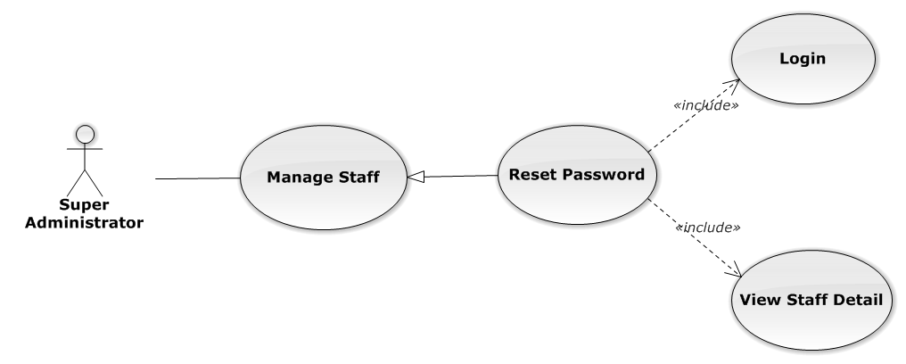

Figure 86: Reset Password Use-Case Diagram

###### Reset Password Use-Case Specification

|  |  |  |  |
| --- | --- | --- | --- |
| USE CASE SPECIFICATION | | | |
| Use-case No. | UC0068 | Use-case Version | 1.0 |
| Use-case Name | Reset Password | | |
| Author | Nguyễn Thanh Sang | | |
| Date | 24/03/2014 | Priority | Normal |
| Actor:  Supper Administrator.  Summary:  Supper Administrator can reset password of all staff to default.  **Goal:**  Helps Supper Administrator reset password to default is “123456”.  Triggers:  Supper Supper Administrator wants to reset password staff.  Supper Administrator goes to “Staff detail” screen, and click to button “Đặt lại mật khẩu”  Preconditions:   * Logged-in to system. * The page is fully loaded   Post Conditions:  Success: Default password “123456” is save to database, message show “Khôi phục mật khẩu thành công  Failure:   * The user is presented with an error message on screen. * Show message “Khôi phục mật mật khẩu thất bại!”.   Main Success Scenario:   |  |  |  | | --- | --- | --- | | *Step* | *User* | *System* | | 1 | Supper admin click on “Chi tiết” button at “Quản lí nhân viên” screen. | Show “Chi tiết nhân viên” Pop-up information. | | 2 | On “Chi tiết văn phòng” Pop-up click button “Đặt lại mật khẩu”  [Alternative 1] | Display message box confirm “Bạn muốn khôi phục mật khẩu nhân viên này về mặc định?” with two button “Xác nhận” and “Bỏ qua” | | 3 | User click “Bỏ qua” button | Password of staff not change comeback to “Chi tiết nhân viên” Pop-up screen. | | 4 | User click “ Xác nhận” button  [Exception 1], [Exception 2] | Password of staff is reset to default “123456” and comeback to “Quản lí nhân viên” screen |   Alternative Scenario:   |  |  |  | | --- | --- | --- | | *#* | *User* | *System* | | 1 | Click on [X] button, “Đóng” button, or click out of modal | Modal popup is close |   Exceptions:   |  |  |  | | --- | --- | --- | | *#* | *User* | *System* | | 1 | System cannot reset password staff. | Shows error message “Khôi phục mật mật khẩu thất bại!” | | 2 | System fail reset password staff. | Shows error message “"Khôi phục mật khẩu thất bại", "Hãy kiểm tra lại kết nối database.”. |   Relationships:  Manage Staff  Business Rules:  Only Staff with id=”1” (Super Administrator) can be use this function. | | | |

#### Manage Service Type

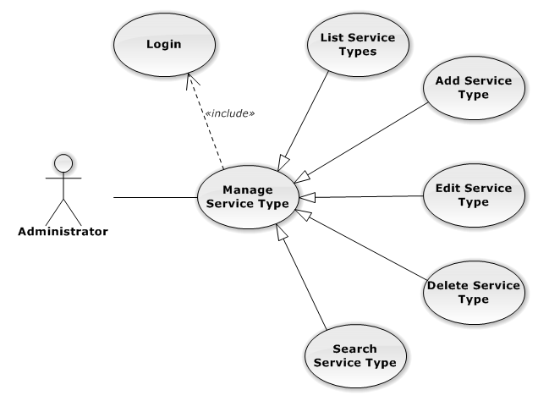

Figure 87: Manage Service Type Use-Case Diagram

##### List Service Types

###### List Service Types Use-Case Diagram

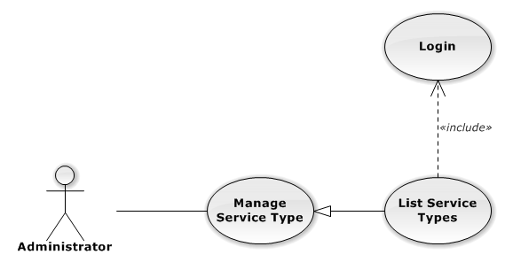

Figure 88: List Service Types Use-Case Diagram

###### List Service Types Use-Case Specification

|  |  |  |  |
| --- | --- | --- | --- |
| USE CASE SPECIFICATION | | | |
| Use-case No. | UC0069 | Use-case Version | 1.0 |
| Use-case Name | List Service Types | | |
| Author | Lê Duy Hoàng | | |
| Date | 30/01/2014 | Priority | Normal |
| Actor:  Administrator  Summary:  List All Service Type.  Goal:  The purpose of List Service Type use case is allowing Admin to view all Services Type.  Triggers:  User choose “Quản lý Loại Dịch Vụ” in menu.  Preconditions:  User is authenticated and has role “admin”.  The page is fully loaded.  Post Conditions:  Success: All Services Type is listed.  Failure: Do nothing.  Main Success Scenario:   |  |  |  | | --- | --- | --- | | *Step* | *User* | *System* | | 1 | Click “Quản lý Loại Dịch Vụ” in menu. | All Service Types are loaded. |   Alternative Scenario:  N/A  Exceptions:  N/A  Relationships:  Manage Service Type  Business Rules:  N/A | | | |

##### Add New Service Type

###### Add New Service Type Use-Case Diagram

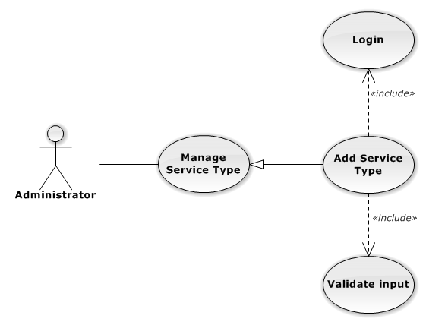

Figure 89: Add New Service Type Use-Case Diagram

###### Add New Service Type Use-Case Specification

|  |  |  |  |
| --- | --- | --- | --- |
| USE CASE SPECIFICATION | | | |
| Use-case No. | UC0070 | Use-case Version | 1.0 |
| Use-case Name | Add New Service Type | | |
| Author | Lê Duy Hoàng | | |
| Date | 30/01/2014 | Priority | Normal |
| Actor:  Administrator  Summary:  Add Service Type.  Goal:  The purpose of Add Service Type use case is allowing Admin to add Service Type.  Triggers:  User choose “Quản lý Nhóm Dịch Vụ” in menu. Then click “Thêm loại dịch vụ” button.  Preconditions:  User is authenticated and has role “admin”.  Post Conditions:  Success: New Service Type is created.  Failure: No Service Type is created and Error message will be showed.  Main Success Scenario:   |  |  |  | | --- | --- | --- | | *Step* | *User* | *System* | | 1 | Click “Thêm loại dịch vụ” button. | Show add Service type pop-up. | | 2 | Enters the Service Type Name and Description |  | | 3 | Presses “Thêm mới” button.  [Alternative: 1] | Checks validate, add new Service Type to database.  Show success message.  [Exception: 1]  [Exception: 2]  [Exception: 3] |   Alternative Scenario:   |  |  |  | | --- | --- | --- | | *#* | *User* | *System* | | 1 | Presses “Đóng”, “X” button or click outside pop-up. | The Add New Service Type pop-up is close. |   Exceptions:   |  |  |  | | --- | --- | --- | | *#* | *User* | *System* | | 1 | Service Type Name is missing. | Show error “Nhập tên loại dịch vụ” | | 2 | Add Service type fail. | The Add New Service Type is closed and display error message “Tạo loại dịch vụ thất bại!", "Hãy kiểm tra lại kết nối database." | | 1 | Add Service type error. | The Add New Service Type is closed and display error message "Tạo loại dịch vụ thất bại!", "Có lỗi xảy ra trong quá trình tạo loại dịch vụ." |   Relationships:  Manage Service Type  Business Rules:  N/A | | | |

##### Edit Service Type

###### Edit Service Type Use-Case Diagram

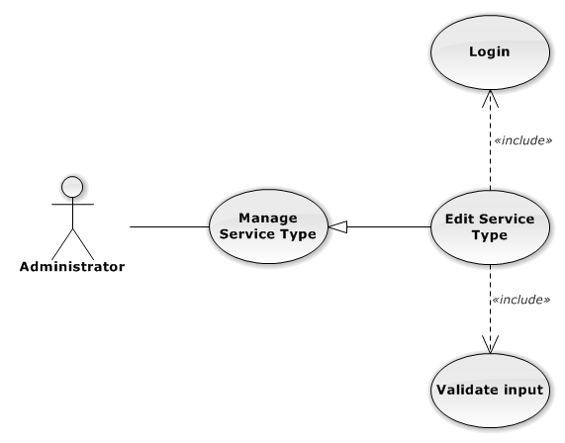

Figure 90: Edit Service Type Use-Case Diagram

###### Edit Service Type Use-Case Specification

|  |  |  |  |
| --- | --- | --- | --- |
| USE CASE SPECIFICATION | | | |
| Use-case No. | UC0071 | Use-case Version | 1.0 |
| Use-case Name | Edit Service Type | | |
| Author | Lê Duy Hoàng | | |
| Date | 30/01/2014 | Priority | Normal |
| Actor:  Administrator  Summary:  Update Service Type.  Goal:  The purpose of Update Service Type use case is allowing Admin to update Service Type.  Triggers:  User choose “Quản lý Loại Dịch Vụ” in menu. Then click update icon.  Preconditions:  User is authenticated and has role “admin”.  Post Conditions:  Success: The Service Type is Updated.  Failure: The Service Type is not updated and Error message will be showed.  Main Success Scenario:   |  |  |  | | --- | --- | --- | | *Step* | *User* | *System* | | 1 | Click Update icon. | Show update Service type pop-up. | | 2 | Enters the new Service Type Name and Description |  | | 3 | Presses “Lưu chỉnh sửa” button.  [Alternative: 1] | Checks validate, update Service Type to database.  Show success message.  [Exception: 1]  [Exception: 2]  [Exception: 3] |   Alternative Scenario:   |  |  |  | | --- | --- | --- | | *#* | *User* | *System* | | 1 | Presses “Đóng”, “X” button or click outside pop-up. | The Update Service Type pop-up is close. |   Exceptions:   |  |  |  | | --- | --- | --- | | *#* | *User* | *System* | | 1 | Service Type Name is missing. | Show error “Nhập tên loại dịch vụ!” to user. | | 2 | Update Service type fail. | The Add New Service Type is closed and display error message “Chỉnh sửa loại dịch vụ thất bại!", "Hãy kiểm tra lại kết nối database." | | 3 | Update Service type error. | The Add New Service Type is closed and display error message "Chỉnh sửa loại dịch vụ thất bại!", "Có lỗi xảy ra trong quá trình tạo loại dịch vụ." |   Relationships:  Manage Service Type  Business Rules:  N/A | | | |

##### Delete Service Type

###### Delete Service Type Use-Case Diagram

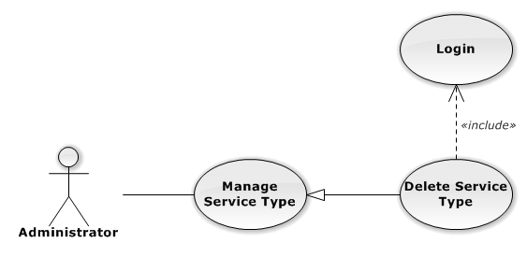

Figure 91: Delete Service Type Use-Case Diagram

###### Delete Service Type Use-Case Specification

|  |  |  |  |
| --- | --- | --- | --- |
| USE CASE SPECIFICATION | | | |
| Use-case No. | UC0072 | Use-case Version | 1.0 |
| Use-case Name | Delete Service Type | | |
| Author | Lê Duy Hoàng | | |
| Date | 30/01/2014 | Priority | Normal |
| Actor:  Administrator  Summary:  Delete Service Type.  Goal:  The purpose of Delete Service Type use case is allowing Admin to delete Service Type.  Triggers:  User choose “Quản lý Dịch Vụ” in menu.  Preconditions:  User is authenticated and has role “admin”.  Post Conditions:  Success: The Service Type is deleted.  Failure: The Service Type is not delete and Error message will be showed.  Main Success Scenario:   |  |  |  | | --- | --- | --- | | *Step* | *User* | *System* | | 1 | Click Delete icon. | Show confirm pop-up | | 2 | Presses “Đồng ý” button.  [Alternative: 1] | Delete Service Type from database.  Show success message.  [Exception: 1]  [Exception: 2] |   Alternative Scenario:   |  |  |  | | --- | --- | --- | | *#* | *User* | *System* | | 1 | Presses “Hủy bỏ”, “X” button. | The confirm pop-up is close. |   Exceptions:   |  |  |  | | --- | --- | --- | | *#* | *User* | *System* | | 1 | Delete Service type fail. | The Add New Service Type is closed and display error message “Xóa loại dịch vụ thất bại!", "Hãy kiểm tra lại kết nối database." | | 2 | Delete Service type error. | The Add New Service is closed and display error message "Xóa loại dịch vụ thất bại!", "Có lỗi xảy ra trong quá xóa loại dịch vụ." |   Relationships:  Manage Service Type  Business Rules:  N/A | | | |

##### Search Service Type

###### Search Service Type Use-Case Diagram

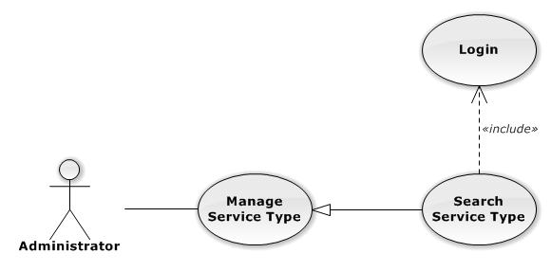

Figure 92: Search Service Type Use-Case Diagram

###### Search Service Type Use-Case Specification

|  |  |  |  |
| --- | --- | --- | --- |
| USE CASE SPECIFICATION | | | |
| Use-case No. | UC0073 | Use-case Version | 1.0 |
| Use-case Name | Search Service Type | | |
| Author | Lê Duy Hoàng | | |
| Date | 30/01/2014 | Priority | Normal |
| Actor:  Administrator  Summary:  Search Service Type.  Goal:  The purpose of Search Service Type use case is allowing Admin to search Service Type.  Triggers:  User choose “Quản lý Dịch Vụ” in menu.  Preconditions:  User is authenticated and has role “admin”.  Post Conditions:  Success: List of Service Type with search key words is displayed.  Failure: No record is displayed.  Main Success Scenario:   |  |  |  | | --- | --- | --- | | *Step* | *User* | *System* | | 1 | In “Quản lý loại dịch vụ” screen, input key word at “Tìm kiếm” textbox. | List of Service Type with search key words is displayed. |   Alternative Scenario:  N/A  Exceptions:  N/A  Relationships:  Manage Service Type  Business Rules:  N/A | | | |

#### Manage Service

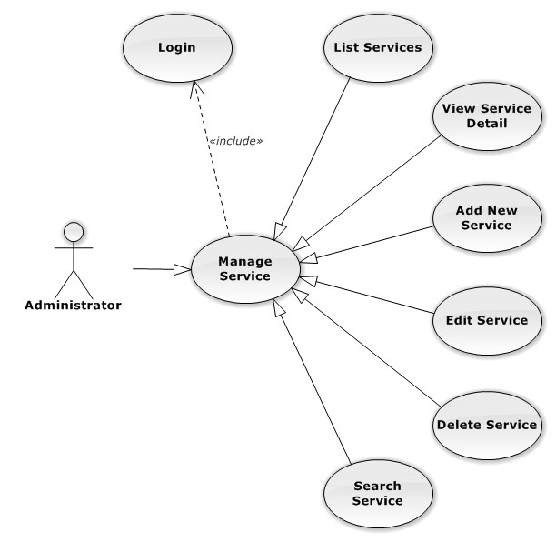

Figure 93: Manage Service Use-Case Diagram

##### List Services

###### List Services Use-Case Diagram

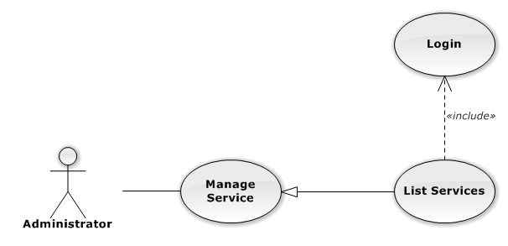

Figure 94: List Services Use-Case Diagram

###### List Services Use-Case Specification

|  |  |  |  |
| --- | --- | --- | --- |
| USE CASE SPECIFICATION | | | |
| Use-case No. | UC0074 | Use-case Version | 1.0 |
| Use-case Name | List Services | | |
| Author | Lê Duy Hoàng | | |
| Date | 30/01/2014 | Priority | Normal |
| Actor:  Administrator  Summary:  List All Service.  Goal:  The purpose of List Service use case is allowing Admin to view all Services.  Triggers:  User choose “Quản lý Dịch Vụ” in menu.  Preconditions:  User is authenticated and has role “admin”.  The page is fully loaded.  Post Conditions:  Success: All Services is listed.  Failure: Do nothing.  Main Success Scenario:   |  |  |  | | --- | --- | --- | | *Step* | *User* | *System* | | 1 | Click “Quản lý Dịch Vụ” in menu. | All Services are loaded. |   Alternative Scenario:  N/A  Exceptions:  N/A  Relationships:  Manage Service  Business Rules:  N/A | | | |

##### View Service Detail

###### View Service Detail Use-Case Diagram

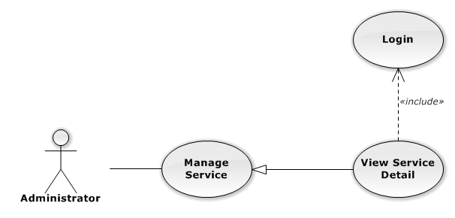

Figure 95: View Service Detail Use-Case Diagram

###### View Service Detail Use-Case Specification

|  |  |  |  |
| --- | --- | --- | --- |
| USE CASE SPECIFICATION | | | |
| Use-case No. | UC0075 | Use-case Version | 1.0 |
| Use-case Name | View Service Detail | | |
| Author | Lê Duy Hoàng | | |
| Date | 30/01/2014 | Priority | Normal |
| Actor:  Administrator  Summary:  View Service Detail.  Goal:  The purpose of View Service Detail use case is allowing Admin to view a Service detail.  Triggers:  User choose “Quản lý Dịch Vụ” in menu. Then click “View detail” icon.  Preconditions:  User is authenticated and has role “admin”.  Post Conditions:  Success: Service Detail is showed.  Failure: Do nothing.  Main Success Scenario:   |  |  |  | | --- | --- | --- | | *Step* | *User* | *System* | | 1 | In Manage Service page, click “View detail” icon | The Service Detail is showed. |   Alternative Scenario:  N/A  Exceptions:  N/A  Relationships:  Manage Service  Business Rules:  N/A | | | |

##### Add New Service

###### Add New Service Use-Case Diagram

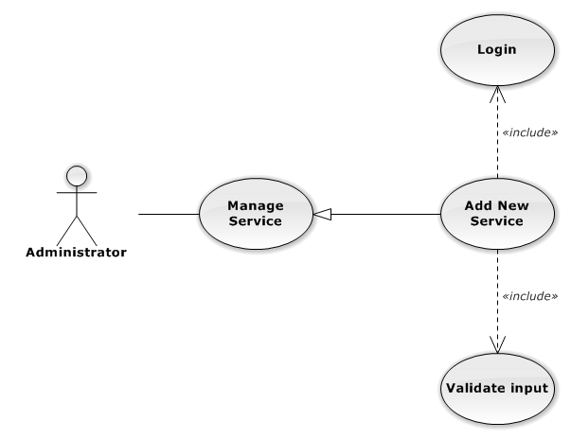

Figure 96: Add New Service Use-Case Diagram

###### Add New Service Use-Case Specification

|  |  |  |  |
| --- | --- | --- | --- |
| USE CASE-n SPECIFICATION | | | |
| Use-case No. | UC0076 | Use-case Version | 1.0 |
| Use-case Name | Add New Service | | |
| Author | Lê Duy Hoàng | | |
| Date | 30/01/2014 | Priority | Normal |
| Actor:  Administrator  Summary:  Add new Service.  Goal:  The purpose of Add Service use case is allowing Admin to add new Service.  Triggers:  User choose “Quản lý Dịch Vụ” in menu. Then click “Thêm dịch vụ mới” button.  Preconditions:  User is authenticated and has role “admin”.  Post Conditions:  Success: New Service is created.  Failure: No Service is created and Error message will be showed.  Main Success Scenario:   |  |  |  | | --- | --- | --- | | *Step* | *User* | *System* | | 1 | Click “Thêm dịch vụ mới” button. | Show add Service pop-up. | | 2 | Enters the Service Name and Description |  | | 3 | Presses “Thêm mới” button.  [Alternative: 1] | Checks validate, add new Service to database.  Show success message.  [Exception: 1]  [Exception: 2]  [Exception: 3] |   Alternative Scenario:   |  |  |  | | --- | --- | --- | | *#* | *User* | *System* | | 1 | Presses “Đóng”, “X” button or click outside pop-up. | The Add New Service pop-up is close. |   Exceptions:   |  |  |  | | --- | --- | --- | | *#* | *User* | *System* | | 1 | Service Name is missing. | Show error “Nhập tên dịch vụ!” to user. | | Service Group is not chosen. | Show error “Chọn loại dịch vụ!” to user. | | 2 | Add Service fail. | The Add New Service is closed and display error message “Tạo dịch vụ thất bại!", "Hãy kiểm tra lại kết nối database." | | 3 | Add Service error. | The Add New Service is closed and display error message "Tạo dịch vụ thất bại!", "Có lỗi xảy ra trong quá trình tạo dịch vụ." |   Relationships:  Manage Service  Business Rules:  N/A | | | |

##### Edit Service

###### Edit Service Use-Case Diagram

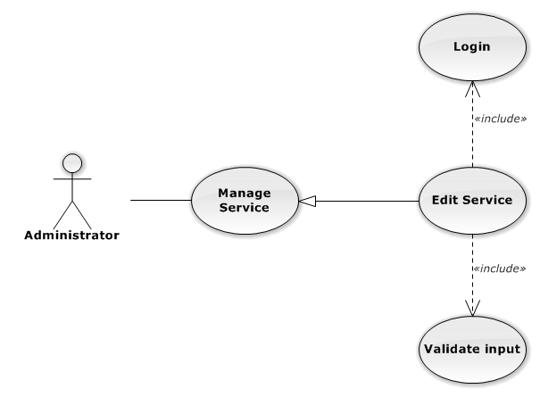

Figure 97: Edit Service Use-Case Diagram

###### Edit Service Use-Case Specification

|  |  |  |  |
| --- | --- | --- | --- |
| USE CASE SPECIFICATION | | | |
| Use-case No. | UC0077 | Use-case Version | 1.0 |
| Use-case Name | Edit Service | | |
| Author | Lê Duy Hoàng | | |
| Date | 30/01/2014 | Priority | Normal |
| Actor:  Administrator  Summary:  Update Service.  Goal:  The purpose of Update Service use case is allowing Admin to update Service.  Triggers:  User choose “Quản lý Dịch Vụ” in menu. Then click update icon.  Preconditions:  User is authenticated and has role “admin”.  Post Conditions:  Success: The Service is Updated.  Failure: The Service is not updated and Error message will be showed.  Main Success Scenario:   |  |  |  | | --- | --- | --- | | *Step* | *User* | *System* | | 1 | Click Update icon. | Show update Service pop-up. | | 2 | Enters the new Service Name and Description |  | | 3 | Presses “Lưu chỉnh sửa” button.  [Alternative: 1] | Checks validate, update Service to database.  Show success message.  [Exception: 1]  [Exception: 2]  [Exception: 3] |   Alternative Scenario:   |  |  |  | | --- | --- | --- | | *#* | *User* | *System* | | 1 | Presses “Đóng”, “X” button or click outside pop-up. | The Update Service pop-up is close. |   Exceptions:   |  |  |  | | --- | --- | --- | | *#* | *User* | *System* | | 1 | Service Name is missing. | Show error “Nhập tên dịch vụ!” to user. | | 2 | Update Service fail. | The Add New Service is closed and display error message “Chỉnh sửa dịch vụ thất bại!", "Hãy kiểm tra lại kết nối database." | | 1 | Update Service error. | The Add New Service is closed and display error message "Chỉnh sửa dịch vụ thất bại!", "Có lỗi xảy ra trong quá trình chỉnh sửa dịch vụ." |   Relationships:  Manage Service  Business Rules:  N/A | | | |

##### Delete Service

###### Delete Service Use-Case Diagram

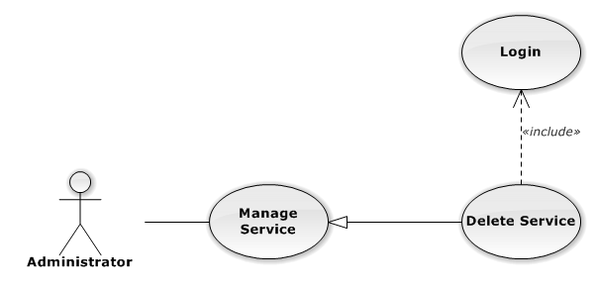

Figure 98: Delete Service Use-Case Diagram

###### Delete Service Use-Case Specification

|  |  |  |  |
| --- | --- | --- | --- |
| USE CASE SPECIFICATION | | | |
| Use-case No. | UC0078 | Use-case Version | 1.0 |
| Use-case Name | Delete Service | | |
| Author | Lê Duy Hoàng | | |
| Date | 30/01/2014 | Priority | Normal |
| Actor:  Administrator  Summary:  Delete Service.  Goal:  The purpose of Delete Service use case is allowing Admin to delete Service.  Triggers:  User choose “Quản lý Dịch Vụ” in menu. Then click delete icon.  Preconditions:  User is authenticated and has role “admin”.  Post Conditions:  Success: The Service is deleted.  Failure: The Service is not delete and Error message will be showed.  Main Success Scenario:   |  |  |  | | --- | --- | --- | | *Step* | *User* | *System* | | 1 | Click Delete icon. | Show confirm pop-up | | 2 | Presses “Xác nhận” button.  [Alternative: 1] | Delete Service from database.  Show success message.  [Exception: 1]  [Exception: 2] |   Alternative Scenario:   |  |  |  | | --- | --- | --- | | *#* | *User* | *System* | | 1 | Presses “Bỏ qua” or “X” button. | The confirm pop-up is close. |   Exceptions:   |  |  |  | | --- | --- | --- | | *#* | *User* | *System* | | 1 | Delete Service fail. | The Add New Service is closed and display error message “Xóa dịch vụ thất bại!", "Hãy kiểm tra lại kết nối database." | | 2 | Delete Service error. | The Add New Service is closed and display error message "Xóa dịch vụ thất bại!", "Có lỗi xảy ra trong quá xóa dịch vụ." |   Relationships:  Manage Service  Business Rules:  N/A | | | |

##### Search Service

###### Search Service Use-Case Diagram

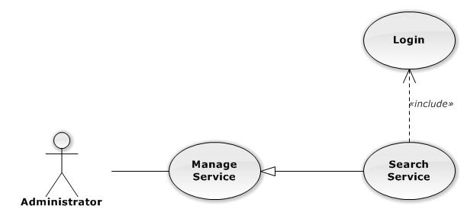

Figure 99: Search Service Use-Case Diagram

###### Search Service Use-Case Specification

|  |  |  |  |
| --- | --- | --- | --- |
| USE CASE SPECIFICATION | | | |
| Use-case No. | UC0079 | Use-case Version | 1.0 |
| Use-case Name | Search Service | | |
| Author | Lê Duy Hoàng | | |
| Date | 30/01/2014 | Priority | Normal |
| Actor:  Administrator  Summary:  Search Service.  Goal:  The purpose of Search Service use case is allowing Admin to search Service.  Triggers:  User choose “Quản lý Dịch Vụ” in menu.  Preconditions:  User is authenticated and has role “admin”.  Post Conditions:  Success: List of Service with search key words is displayed.  Failure: No record is displayed.  Main Success Scenario:   |  |  |  | | --- | --- | --- | | *Step* | *User* | *System* | | 1 | In “Quản lý dịch vụ” screen, input key word at “Tìm kiếm” textbox. | List of Service with search key words is displayed. |   Alternative Scenario:  N/A  Exceptions:  N/A  Relationships:  Manage Service  Business Rules:  N/A | | | |

#### Manage Office

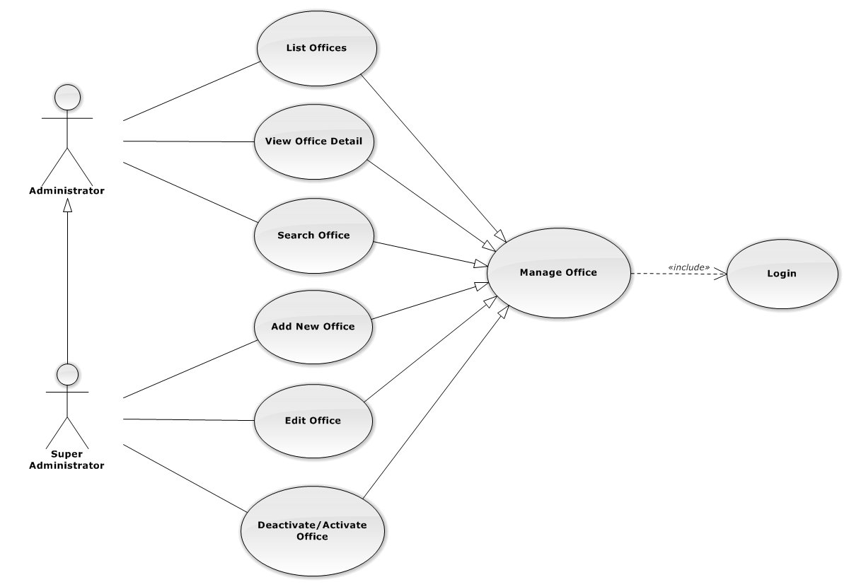

Figure 100: Manage Office Use-Case Diagram

##### List Offices

###### List Offices Use-Case Diagram

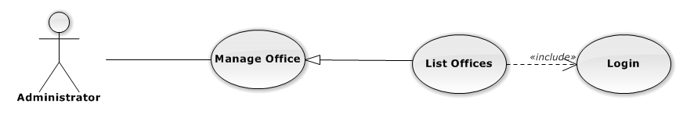

Figure 101: List Offices Use-Case Diagram

###### List Offices Use-Case Specification

|  |  |  |  |
| --- | --- | --- | --- |
| USE-CASE SPECIFICATION | | | |
| Use-case No. | UC0080 | Use-case Version | 1.0 |
| Use-case Name | List Offices | | |
| Author | Nguyễn Thanh Sang | | |
| Date | 30/01/2014 | Priority | Normal |
| Actor:  Administrator  Summary:  Redirect user to “Quản lí văn phòng” page and list all offfice.  Goal:  To allowing Administrator view any detail information of all Office.  Triggers:   * User click on User Control Panel and then click on “Quản lí văn phòng” link   Preconditions:   * Must be logged-in with “Admin” role. * The page is fully loaded   Post Conditions:  Success: System redirects user to “Quản lí văn phòng” page.  Failure: Do nothing.  Main Success Scenario:   |  |  |  | | --- | --- | --- | | *Step* | *User* | *System* | | 1 | Click on “Quản lí văn phòng” link | Redirect to “Quản lí văn phòng” page.Show all Office |   Alternative Scenario:  N/A  Exceptions:  N/A  Relationships:  Management Office  Business Rules:  Only Staff with role =”Admin” can be use this function. | | | |

##### View Office Detail

###### View Office Detail Use-Case Diagram

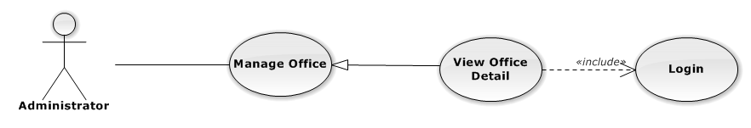

Figure 102: View Office Detail Use-Case Diagram

###### View Office Detail Use-Case Specification

|  |  |  |  |
| --- | --- | --- | --- |
| USE-CASE SPECIFICATION | | | |
| Use-case No. | UC0081 | Use-case Version | 1.0 |
| Use-case Name | View Office Detail | | |
| Author | Nguyễn Thanh Sang | | |
| Date | 30/01/2014 | Priority | Normal |
| Actor:  Administrator  Summary:  Staff can view detail of office information  Goal:  Helps staff to view offfice information  Triggers:   * On User Control Panel click on “Quản lí văn phòng**”,** * Click click on “Chi tiết” button * Click on name’s office link.   Preconditions:   * Must be logged-in * The page is fully loaded   Post Conditions:  Success: The detail offfice information is displayed  Failure: Do nothing  Main Success Scenario:   |  |  |  | | --- | --- | --- | | *Step* | *User* | *System* | | 1 | Staff click on “chi tiết” button or click on name’s offfce link  [Alternative 1], [Alternative 2], [Alternative 3] | The detail offfice information is displayed |   Alternative Scenario:   |  |  |  | | --- | --- | --- | | *#* | *User* | *System* | | 1 | Click on [X] button, “Đóng” button, or click out of modal | Modal popup is close | | 2 | If staff login with Id=”1”, Click on “Chỉnh sửa” button | Staff can update information of office (ref 3.2.2.2.4. Update office) | | 3 | If staff login with Id=”1”, Click on “Hoạt động lại” or “Ngừng hoạt động” link | Staff can Deactivate/Activate office (ref 3.2.2.2.5. Deactivate/Activate office) |   Exceptions:  N/A  Relationships:  Management office.  Business Rules:  Only Staff login with role “Admin” can be use this function. | | | |

##### Add New Office

###### Add New Office Use-Case Diagram

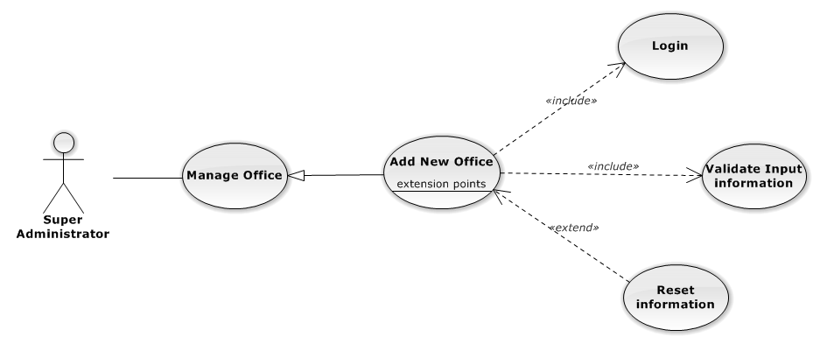

Figure 103: Add New Office Use-Case Diagram

###### Add New Office Use-Case Specification

|  |  |  |  |
| --- | --- | --- | --- |
| USE CASE SPECIFICATION | | | |
| Use-case No. | UC0082 | Use-case Version | 1.0 |
| Use-case Name | Add New Office | | |
| Author | Nguyễn Thanh Sang | | |
| Date | 24/03/2014 | Priority | Normal |
| Actor:  Supper Administrator.  Summary:  Insert new office in the system.  **Goal:**  Add new office.  Triggers:  On User Control Panel click on “Quản lí nhân viên” link, at “Quản lí nhân viên” page click on “Thêm văn phòng” button.  Preconditions:   * Logged-in to system. * The page is fully loaded   Post Conditions:  Success:   * New office is inserted into database, message show “Thêm văn phòng thành công” and display on “Quản lí văn phòng” screen. * New office’s status is “Đang hoạt động”.   Failure:  Show error message “Thêm văn phòng thất bại, hãy kiểm tra lại kết nối database”.  Main Success Scenario:   |  |  |  | | --- | --- | --- | | *Step* | *User* | *System* | | 1 | Administrator click on “Thêm văn phòng” button at “Quản lí văn phòng”page. | Modal popup is displayed with fields for input information of new office. | | 2 | Fill information into fields and click button “Thêm mới”  [Alternative 1]  [Exception 2], [Exception 3] | Modal popup is close  System display successful message “Thêm văn phòng thành công!”  Update list office on page |   Alternative Scenario:   |  |  |  | | --- | --- | --- | | *#* | *User* | *System* | | 1 | Click “Làm trống” button | All input field reset to blank. |   Exceptions:   |  |  |  | | --- | --- | --- | | *Step* | *User* | *System* | | 1 | Field “Tên văn phòng” are blank | Shows error message “Nhập tên văn phòng!” | | Field “Địa chỉ văn phòng”, are blank | Shows error message “Nhập địa chỉ văn phòng!” | | Field “Người quản lí” are blank | Shows error message “Nhập tên người quản lí văn phòng!” | | Field “Ðiện thoại” are blank | Shows error message “Nhập số điện thoại văn phòng!” | | Field “Email” are blank | Shows error message “Hãy nhập Email của văn phòng!” | | Input “Email” not follow the rule | Shows error message “Hãy nhập địa chỉ email đúng!” | | 2 | System cannot insert office to data base. | Shows error message “Thêm văn phòng thất bại!” | | 3 | System error insert office to data base. | Shows error message “Thêm văn phòng thất bại!", "Hãy kiểm tra lại kết nối data base”. |   Relationships:  Manage Office  Business Rules:  Only Staff with id=”1” (Supper Administrator)can be use this function. | | | |

##### Edit Office

###### Edit Office Use-Case Diagram

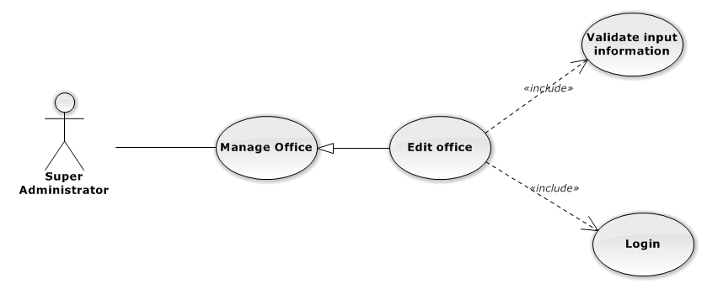

Figure 104: Edit Office Use-Case Diagram

###### Edit Office Use-Case Specification

|  |  |  |  |
| --- | --- | --- | --- |
| USE CASE SPECIFICATION | | | |
| Use-case No. | UC0083 | Use-case Version | 1.0 |
| Use-case Name | Edit Office | | |
| Author | Nguyễn Thanh Sang | | |
| Date | 24/03/2014 | Priority | Normal |
| Actor:  Supper Administrator.  Summary:  Supper Administrator can update information of office.  **Goal:**  Helps Supper Administrator update information of office and save to database system.  Triggers:   * Supper Administrator goes to “Quản lý văn phòng” screen, click button “Chỉnh Sửa” and modify information, after that click button “Lưu Chỉnh Sửa”. * Supper Administrator goes to “Chi tiết nhân viên” Popup screen, click on “Chỉnh Sửa” button and modify information, after that click button “Lưu Chỉnh Sửa”.   Preconditions:   * Logged-in to system. * The page is fully loaded   Post Conditions:  Success:  Information of office is updated and saves to database, message show “Cập nhật chi tiết văn phòng thành công” and display information after update on “Quản lý văn phòng” screen.  Failure:  Show error message “Cập nhật chi tiết văn phòng thất bại!”  Main Success Scenario:   |  |  |  | | --- | --- | --- | | *Step* | *User* | *System* | | 1 | Administrator click on “Chỉnh sửa” button at “Quản lí văn phòng” screen. | Modal popup is displayed with fields for input information of new office. | | 2 | Edit information into fields and click button “Lưu chỉnh sửa”  [Alternative 1]  [Exception 1], [Exception 2], [Exception 3] | Modal popup is close  System display successful message “Cập nhật chi tiết văn phòng thành công!”  Update list office on page |   Alternative Scenario:   |  |  |  | | --- | --- | --- | | *#* | *User* | *System* | | 1 | Click on [X] button, “Đóng” button, or click out of modal | Modal popup is close. |   Exceptions:   |  |  |  | | --- | --- | --- | | *Step* | *User* | *System* | | 1 | Field “Tên văn phòng” are blank | Shows error message “Nhập tên văn phòng!” | | Field “Địa chỉ văn phòng”, are blank | Shows error message “Nhập địa chỉ văn phòng!” | | Field “Người quản lí” are blank | Shows error message “Nhập tên người quản lí văn phòng!” | | Field “Ðiện thoại” are blank | Shows error message “Nhập số điện thoại văn phòng!” | | Field “Email” are blank | Shows error message “Hãy nhập Email của văn phòng!” | | Input “Email” not follow the rule | Shows error message “Hãy nhập địa chỉ email đúng!” | | 2 | System cannot update office to data base. | Shows error message “Cập nhật chi tiết văn phòng thất bại!” | | 3 | System error update office to data base. | Shows error message “Cập nhật chi tiết văn phòng thất bại! ", "Hãy kiểm tra lại kết nối database”. |   Relationships:  Manage Office  Business Rules:  Only Staff with id=”1”( Supper Administrator) can be use this function. | | | |

##### Deactivate/Activate Office

###### Deactivate/Activate Office Use-Case Diagram

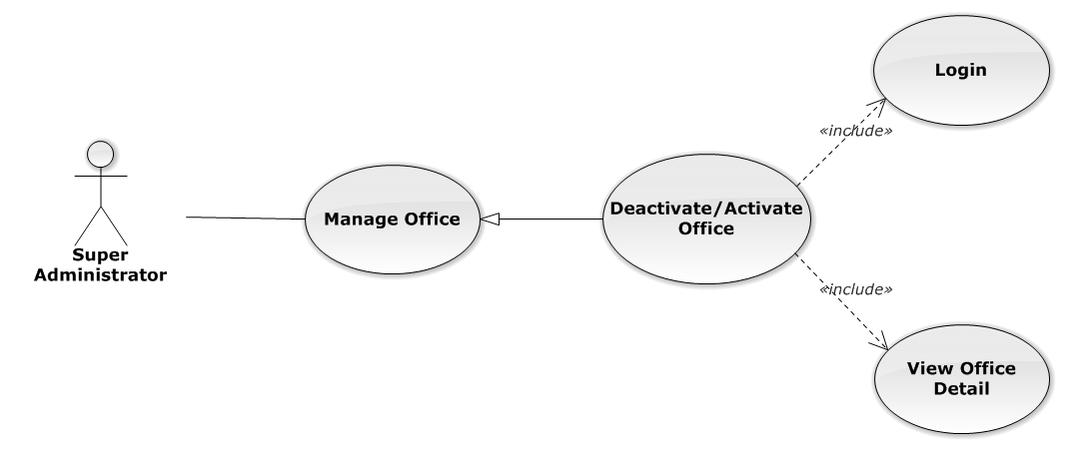

Figure 105: Deactivate/Activate Office Use-Case Diagram

###### Deactivate/Activate Office Use-Case Specification

|  |  |  |  |
| --- | --- | --- | --- |
| USE CASE SPECIFICATION | | | |
| Use-case No. | UC0084 | Use-case Version | 1.0 |
| Use-case Name | Deactivate/Activate office | | |
| Author | Nguyễn Thanh Sang | | |
| Date | 24/03/2014 | Priority | Normal |
| Actor:  Supper Administrator.  Summary:  Supper Administrator can change status of Office to De active or Active.  **Goal:**  Helps Supper Administrator update Status of Office and save to database system.  Triggers:   * Supper Administrator wants to update Status of office. * Supper Administrator goes “Chi tiết văn phòng” screen Pop-Up, Click button “Ngừng hoạt động văn phòng” or “Hoạt động lại”. After that click on “Bỏ qua” or “Xác nhận” button to confirm change status Office.   Preconditions:   * Logged-in to system. * The page is fully loaded   Post Conditions:  Success:  Information of Office is updated and saves to database, message show “Văn phòng đã hoạt động lại!” or “Văn phòng đã ngừng hoạt động!” and display information after update on “Quản lý văn phòng” screen.  Failure:  Show error message “Chỉnh hoạt động văn phòng thất bại!  Main Success Scenario:   |  |  |  | | --- | --- | --- | | *Step* | *User* | *System* | | 1 | Administrator click on “Chỉnh sửa” button at “Quản lí văn phòng” screen. | Show “Chi tiết văn phòng” Pop-up information. | | 2 | On “Chi tiết văn phòng” Pop-up click button “Ngừng hoạt động văn phòng” if Office have status “Đang hoạt động” or Click button “Hoạt động lại” if Office have status "Ngừng hoạt động”.  [Alternative 1] | Display message box confirm “Bạn có muốn thực hiện thao tác này” with two button “Xác nhận” and “Bỏ qua” | | 3 | User click “Bỏ qua” button | Status of Office not change comeback to “Chi tiết văn phòng” Pop-up screen. | | 4 | User click “ Xác nhận” button  [Exception 1], [Exception 2] | Status of Office is change and comeback to “Quản lí văn phòng” screen |   Alternative Scenario:   |  |  |  | | --- | --- | --- | | *#* | *User* | *System* | | 1 | Click on [X] button, “Đóng” button, or click out of modal | Modal popup is close |   Exceptions:   |  |  |  | | --- | --- | --- | | *#* | *User* | *System* | | 1 | System error update status office to data base. | Shows error message “Chỉnh hoạt động văn phòng thất bại!", "Hãy kiểm tra lại kết nối database!”. | | 2 | System error update status office to data base. | Shows error message “Chỉnh hoạt động văn phòng thất bại!", "Có lỗi xảy ra trong quá trình xóa văn phòng!”. |   Relationships:  Manage Office  Business Rules:  Only Staff with id=”1”( Supper Administrator) can be use this function. | | | |

##### Search Office

###### Search Office Use-Case Diagram

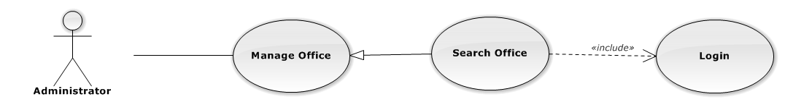

Figure 106: Search Office Use-Case Diagram

###### Search Office Use-Case Specification

|  |  |  |  |
| --- | --- | --- | --- |
| USE CASE SPECIFICATION | | | |
| Use-case No. | UC0085 | Use-case Version | 1.0 |
| Use-case Name | Search Office | | |
| Author | Nguyễn Thanh Sang | | |
| Date | 24/03/2014 | Priority | Normal |
| Actor:  Administrator.  Summary:  Administrator search Office in list of office  **Goal:**  Helps Administrator search Office.  Triggers:   * Manager wants to search office. * Manager goes to “Quản lý văn phòng” screen, input word into “Tìm Kiếm” textbox.   Preconditions:   * Logged-in as “Admin” role. * The page is fully loaded   Post Conditions:  Success: List of Office map with word search is displayed.  Failure: Do nothing  Main Success Scenario:   |  |  |  | | --- | --- | --- | | *Step* | *User* | *System* | | 1 | In “Quản lý văn phòng” screen, input key word at “Tìm kiếm” textbox. | List of office mapping with word search is display. |   Alternative Scenario:  N/A  Exceptions:  N/A  Relationships:  Manage Office  Business Rules:  N/A | | | |

#### Manage Salary

##### Manage Assurance

###### List Assurance

List Assurance Use-Case Diagrame

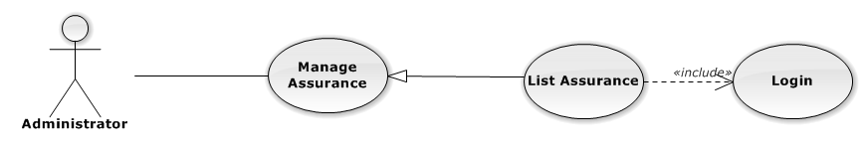

Figure 107: List Assurance Use-Case Diagram

List Assurance Use-Case Specification

|  |  |  |  |
| --- | --- | --- | --- |
| USE-CASE SPECIFICATION | | | |
| Use-case No. | UC0086 | Use-case Version | 1.0 |
| Use-case Name | List Assurance | | |
| Author | Nguyễn Thanh Sang | | |
| Date | 16/05/2014 | Priority | Normal |
| Actor:  Administrator  Summary:  Redirect user to “Quản lí bảo hiểm” page and list all assurance.  Goal:  To allowing Administrator view any detail information of all Assurance.  Triggers:   * User click on User Control Panel and then click on “Quản lí lương nhân viên” link * On sub menu click on “Bảo hiểm”.   Preconditions:   * Must be logged-in with “Admin” role. * The page is fully loaded   Post Conditions:  Success: System redirects user to “Quản lí bảo hiểm” page.  Failure: Do nothing.  Main Success Scenario:   |  |  |  | | --- | --- | --- | | *Step* | *User* | *System* | | 1 | Click on “Bảo hiểm” link | Redirect to “Quản lí bảo hiểm” page.Show all Assurance |   Alternative Scenario:  N/A  Exceptions:  N/A  Relationships:  Management Assurance  Business Rules:  Only Staff with role =”Admin” can be use this function. | | | |

###### Add New Assurance

Add New Assurance Use-Case Diagram

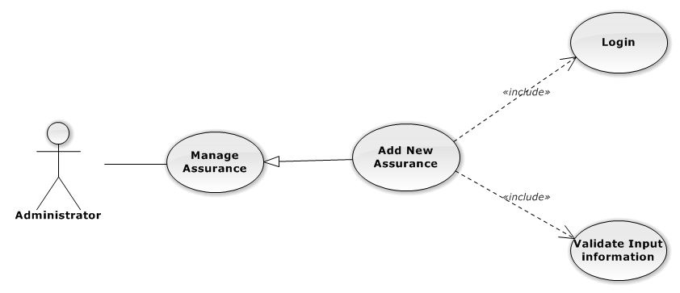

Figure 108: Manage Office Use-Case Diagram

Add New Assurance Use-Case Specification

|  |  |  |  |
| --- | --- | --- | --- |
| USE CASE SPECIFICATION | | | |
| Use-case No. | UC0087 | Use-case Version | 1.0 |
| Use-case Name | Add New Assurance | | |
| Author | Nguyễn Thanh Sang | | |
| Date | 16/05/2014 | Priority | Normal |
| Actor:  Supper Administrator.  Summary:  Insert new Assurance in the system.  **Goal:**  Add new Assurance.  Triggers:  On User Control Panel click on “Quản lí bảo hiểm” link, at “Quản lí bảo hiểm” page click on “Thêm bảo hiểm” button.  Preconditions:   * Logged-in to system. * The page is fully loaded   Post Conditions:  Success:   * New Assurance is inserted into database, message show “Thêm bảo hiểm thành công” and display on “Quản lí bảo hiểm” screen. * New assurance ‘s status is “Đang áp dụng”.   Failure:  Show error message “Thêm bảo hiểm thất bại, hãy kiểm tra lại kết nối database”.  Main Success Scenario:   |  |  |  | | --- | --- | --- | | *Step* | *User* | *System* | | 1 | Administrator click on “Thêm bảo hiểm” button at “Quản lí bảo hiểm”page. | Modal popup is displayed with fields for input information of new assurance. | | 2 | Fill information into fields and click button “Thêm mới”  [Alternative 1]  [Exception 1], [Exception 2] , [Exception 3] | Modal popup is close  System display successful message “Thêm bảo hiểm thành công!”  Update list assurance on page |   Alternative Scenario:   |  |  |  | | --- | --- | --- | | *#* | *User* | *System* | | 1 | Click on [X] button, “Đóng” button, or click out of modal | Modal popup is close |   Exceptions:   |  |  |  | | --- | --- | --- | | *Step* | *User* | *System* | | 1 | Field “Tên bảo hiểm” are blank | Shows error message “Nhập tên bảo hiểm!” | | Field “Chỉ số”, are blank | Shows error message “Nhập phần trăm (%) bảo hiểm!” | | 2 | Input “Chỉ số”, are not a number | Shows error message “Hãy nhập số chính xác!” | | 3 | System error insert assurance to data base. | Shows error message “Thêm bảo hiểm thất bại!", "Hãy kiểm tra lại kết nối data base”. |   Relationships:  Manage Assurance  Business Rules:  Only Staff with role=”Admin” can be use this function. | | | |

###### Edit Assurance

Edit Assurance Use-Case Diagram

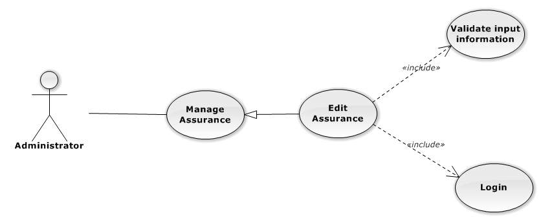

Figure 109: Manage Office Use-Case Diagram

Edit Assurance Use-Case Specification

|  |  |  |  |
| --- | --- | --- | --- |
| USE CASE SPECIFICATION | | | |
| Use-case No. | UC0088 | Use-case Version | 1.0 |
| Use-case Name | Edit Assurance | | |
| Author | Nguyễn Thanh Sang | | |
| Date | 24/03/2014 | Priority | Normal |
| Actor:  Administrator.  Summary:  Administrator can update information of assurance.  **Goal:**  Helps Supper Administrator update information of assurance and save to database system.  Triggers:   * Administrator goes to “Quản lý bảo hiểm” screen, click button “Chỉnh Sửa” and modify information, after that click button “Lưu Chỉnh Sửa”.   Preconditions:   * Logged-in to system. * The page is fully loaded   Post Conditions:  Success:  Information of Assurance is updated and saves to database, message show “Cập nhật chi tiết bảo hiểm thành công” and display information after update on “Quản lý bảo hiểm” screen.  Failure:  Show error message “Cập nhật chi tiết bảo hiểm thất bại!”  Main Success Scenario:   |  |  |  | | --- | --- | --- | | *Step* | *User* | *System* | | 1 | Administrator click on “Chỉnh sửa” button at “Quản lí bảo hiểm” screen. | Modal popup is displayed with fields for input information of new Assurance. | | 2 | Edit information into fields and click button “Lưu chỉnh sửa”  [Alternative 1]  [Exception 1], [Exception 2], [Exception 3] | Modal popup is close  System display successful message “Cập nhật chi tiết bảo hiểm thành công!”  Update list Assurance on page |   Alternative Scenario:   |  |  |  | | --- | --- | --- | | *#* | *User* | *System* | | 1 | Click on [X] button, “Đóng” button, or click out of modal | Modal popup is close. |   Exceptions:   |  |  |  | | --- | --- | --- | | *Step* | *User* | *System* | | 1 | Field “Tên bảo hiểm” are blank | Shows error message “Nhập tên bảo hiểm!” | | Field “Chỉ số”, are blank | Shows error message “Nhập phần trăm (%) bảo hiểm!” | | 2 | Input “Chỉ số”, are not a number | Shows error message “Hãy nhập số chính xác!” | | 3 | System error insert assurance to data base. | Shows error message “Thêm bảo hiểm thất bại!", "Hãy kiểm tra lại kết nối data base”. |   Relationships:  Manage Assurance  Business Rules:  Only Staff with with role=”Admin” can be use this function. | | | |

###### Deactivate/Activate Assurance

Deactivate/Activate Assurance Use-Case Diagram

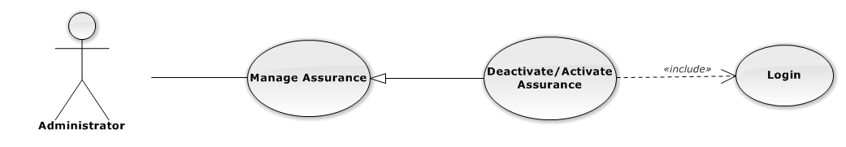

Figure 110: Manage Assurance Use-Case Diagram

Deactivate/Activate Assurance Use-Case Specification

|  |  |  |  |
| --- | --- | --- | --- |
| USE CASE SPECIFICATION | | | |
| Use-case No. | UC0089 | Use-case Version | 1.0 |
| Use-case Name | Deactivate/Activate Assurance | | |
| Author | Nguyễn Thanh Sang | | |
| Date | 24/03/2014 | Priority | Normal |
| Actor:  Administrator.  Summary:  Administrator can change status of assurance to Deactive or Active.  **Goal:**  Helps Administrator update status of assurance and save to database system.  Triggers:  Administrator goes “Chi tiết bảo hiểm” screen Pop-Up, Click button “Ngừng hoạt động bảo hiểm” or “Hoạt động lại”. After that click on “Bỏ qua” or “Xác nhận” button to confirm change status Assurance.  Preconditions:   * Logged-in to system. * The page is fully loaded   Post Conditions:  Success:  Information of Assurance is updated and saves to database, message show “Bảo hiểm đã áp dụng lại!” or “Bảo hiểm đã ngừng áp dụng!” and display information after update on “Quản lý bảo hiểm” screen.  Failure:  Show error message “Chỉnh hoạt động bảo hiểm thất bại!  Main Success Scenario:   |  |  |  | | --- | --- | --- | | *Step* | *User* | *System* | | 1 | Administrator click on “Chỉnh sửa” button at “Quản lí bảo hiểm” screen. | Show “Chi tiết bảo hiểm” Pop-up information. | | 2 | On “Chi tiết bảo hiểm” Pop-up click button “Ngừng áp dụng” if Assurance have status “Đang áp dụng” or Click button “Áp dụng lại” if Assurance have status "Ngừng áp dụng”.  [Alternative 1] | Display message box confirm “Bạn có muốn thực hiện thao tác này” with two button “Xác nhận” and “Bỏ qua” | | 3 | User click “Bỏ qua” button | Status of Assurance not change comeback to “Chi tiết bảo hiểm” Pop-up screen. | | 4 | User click “ Xác nhận” button  [Exception 1], [Exception 2] | Status of Assurance is change and comeback to “Quản lí bảo hiểm” screen |   Alternative Scenario:   |  |  |  | | --- | --- | --- | | *#* | *User* | *System* | | 1 | Click on [X] button, “Đóng” button, or click out of modal | Modal popup is close |   Exceptions:   |  |  |  | | --- | --- | --- | | *#* | *User* | *System* | | 1 | System error update status Assurance to data base. | Shows error message “Chỉnh bảo hiểm thất bại!", "Hãy kiểm tra lại kết nối database!”. | | 2 | System error update status assurance to data base. | Shows error message “Chỉnh bảo hiểm thất bại!", "Có lỗi xảy ra trong quá trình xóa bảo hiểm!”. |   Relationships:  Manage Assurance  Business Rules:  Only Staff with role=”Admin” can be use this function. | | | |

##### Manage Tax

###### List Tax

List Tax Use-Case Diagrame

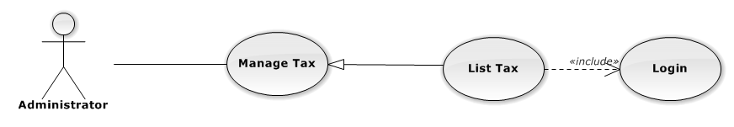

Figure 111: List Tax Use-Case Diagram

List Tax Use-Case Specification

|  |  |  |  |
| --- | --- | --- | --- |
| USE-CASE SPECIFICATION | | | |
| Use-case No. | UC0090 | Use-case Version | 1.0 |
| Use-case Name | List Tax | | |
| Author | Nguyễn Thanh Sang | | |
| Date | 16/05/2014 | Priority | Normal |
| Actor:  Administrator  Summary:  Redirect user to “Quản lí Thuế” page and list all tax.  Goal:  To allowing Administrator view any detail information of all Tax.  Triggers:   * User click on User Control Panel and then click on “Quản lí lương lương nhân viên” link * On sub menu click on “Thuế”.   Preconditions:   * Must be logged-in with “Admin” role. * The page is fully loaded   Post Conditions:  Success: System redirects user to “Quản lí Thuế” page.  Failure: Do nothing.  Main Success Scenario:   |  |  |  | | --- | --- | --- | | *Step* | *User* | *System* | | 1 | Click on “Thuế” link | Redirect to “Quản lí Thuế” page.Show all Tax |   Alternative Scenario:  N/A  Exceptions:  N/A  Relationships:  Management Tax  Business Rules:  Only Staff with role =”Admin” can be use this function. | | | |

###### Add New Tax

Add New Tax Use-Case Diagram

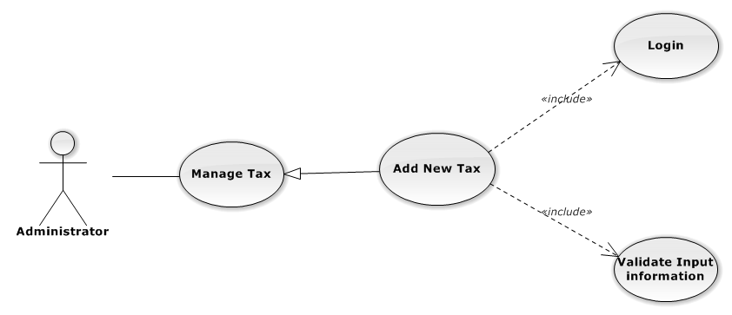

Figure 112: Manage Office Use-Case Diagram

Add New Tax Use-Case Specification

|  |  |  |  |
| --- | --- | --- | --- |
| USE CASE SPECIFICATION | | | |
| Use-case No. | UC0091 | Use-case Version | 1.0 |
| Use-case Name | Add New Tax | | |
| Author | Nguyễn Thanh Sang | | |
| Date | 16/05/2014 | Priority | Normal |
| Actor:  Supper Administrator.  Summary:  Insert new Tax in the system.  **Goal:**  Add new Tax.  Triggers:  On User Control Panel click on “Quản lí lương nhân viên” link, at “Quản lí Thuế” page click on “Thêm Thuế” button.  Preconditions:   * Logged-in to system. * The page is fully loaded   Post Conditions:  Success:   * New Tax is inserted into database, message show “Thêm Thuế thành công” and display on “Quản lí Thuế” screen. * New Tax ‘s status is “Đang áp dụng”.   Failure:  Show error message “Thêm Thuế thất bại, hãy kiểm tra lại kết nối database”.  Main Success Scenario:   |  |  |  | | --- | --- | --- | | *Step* | *User* | *System* | | 1 | Administrator click on “Thêm Thuế” button at “Quản lí Thuế”page. | Modal popup is displayed with fields for input information of new Tax. | | 2 | Fill information into fields and click button “Thêm mới”  [Alternative 1]  [Exception 1], [Exception 2] , [Exception 3] | Modal popup is close  System display successful message “Thêm Thuế thành công!”  Update list Tax on page |   Alternative Scenario:   |  |  |  | | --- | --- | --- | | *#* | *User* | *System* | | 1 | Click on [X] button, “Đóng” button, or click out of modal | Modal popup is close |   Exceptions:   |  |  |  | | --- | --- | --- | | *Step* | *User* | *System* | | 1 | Field “Tên Thuế” are blank | Shows error message “Nhập tên thuế!” | | Field “Thuế suất”, are blank | Shows error message “Nhập phần trăm tính thuế %!” | | Field “Từ”, are blank | Shows error message “Nhập khoảng tiền bắt đầu tính thuế!” | | Field “Đến”, are blank | Shows error message “Nhập khoảng tiền kết thúc tính thuế!” | | Field “Chỉ số”, are blank | Shows error message “Nhập chỉ số tính thuế!” | | 2 | Input “Chỉ số”, are not a number | Shows error message “Hãy nhập số chính xác!” | | Input “Từ”, are not a number | Shows error message “Hãy nhập số chính xác!” | | Input “Đến”, are not a number | Shows error message “Hãy nhập số chính xác!” | | Input “Thuế suất”, are not a number | Shows error message “Hãy nhập số chính xác!” | | 3 | System error insert Tax to data base. | Shows error message “Thêm Thuế thất bại!", "Hãy kiểm tra lại kết nối data base”. |   Relationships:  Manage Tax  Business Rules:  Only Staff with role=”Admin” can be use this function. | | | |

###### Edit Tax

Edit Tax Use-Case Diagram

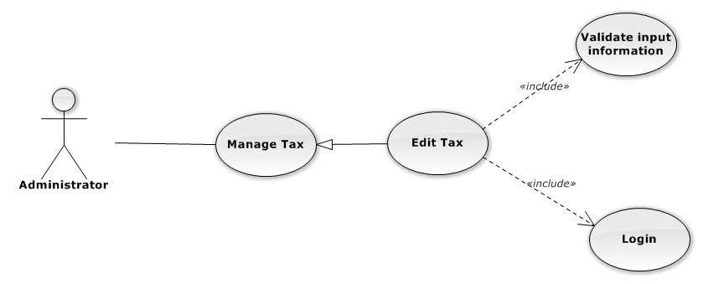

Figure 113: Manage Office Use-Case Diagram

Edit Tax Use-Case Specification

|  |  |  |  |
| --- | --- | --- | --- |
| USE CASE SPECIFICATION | | | |
| Use-case No. | UC0092 | Use-case Version | 1.0 |
| Use-case Name | Edit Tax | | |
| Author | Nguyễn Thanh Sang | | |
| Date | 24/03/2014 | Priority | Normal |
| Actor:  Administrator.  Summary:  Administrator can update information of Tax.  **Goal:**  Helps Administrator update information of Tax and save to database system.  Triggers:   * Administrator goes to “Quản lý Thuế” screen, click button “Chỉnh Sửa” and modify information, after that click button “Lưu Chỉnh Sửa”.   Preconditions:   * Logged-in to system. * The page is fully loaded   Post Conditions:  Success:  Information of Tax is updated and saves to database, message show “Cập nhật chi tiết Thuế thành công” and display information after update on “Quản lý Thuế” screen.  Failure:  Show error message “Cập nhật chi tiết Thuế thất bại!”  Main Success Scenario:   |  |  |  | | --- | --- | --- | | *Step* | *User* | *System* | | 1 | Administrator click on “Chỉnh sửa” button at “Quản lí Thuế” screen. | Modal popup is displayed with fields for input information of new Tax. | | 2 | Edit information into fields and click button “Lưu chỉnh sửa”  [Alternative 1]  [Exception 1], [Exception 2], [Exception 3] | Modal popup is close  System display successful message “Cập nhật chi tiết Thuế thành công!”  Update list Tax on page |   Alternative Scenario:   |  |  |  | | --- | --- | --- | | *#* | *User* | *System* | | 1 | Click on [X] button, “Đóng” button, or click out of modal | Modal popup is close. |   Exceptions:   |  |  |  | | --- | --- | --- | | *Step* | *User* | *System* | | 1 | Field “Tên Thuế” are blank | Shows error message “Nhập tên thuế!” | | Field “Thuế suất”, are blank | Shows error message “Nhập phần trăm tính thuế %!” | | Field “Từ”, are blank | Shows error message “Nhập khoảng tiền bắt đầu tính thuế!” | | Field “Đến”, are blank | Shows error message “Nhập khoảng tiền kết thúc tính thuế!” | | Field “Chỉ số”, are blank | Shows error message “Nhập chỉ số tính thuế!” | | 2 | Input “Chỉ số”, are not a number | Shows error message “Hãy nhập số chính xác!” | | Input “Từ”, are not a number | Shows error message “Hãy nhập số chính xác!” | | Input “Đến”, are not a number | Shows error message “Hãy nhập số chính xác!” | | Input “Thuế suất”, are not a number | Shows error message “Hãy nhập số chính xác!” | | 3 | System error insert Tax to data base. | Shows error message “Thêm Thuế thất bại!", "Hãy kiểm tra lại kết nối data base”. |   Relationships:  Manage Tax  Business Rules:  Only Staff with with role=”Admin” can be use this function. | | | |

###### Deactivate/Activate Tax

Deactivate/Activate Tax Use-Case Diagram

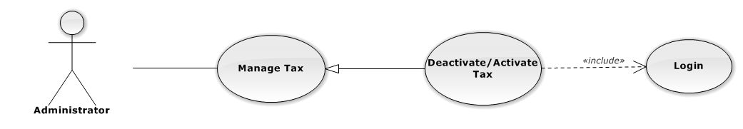

Figure 114: Manage Tax Use-Case Diagram

Deactivate/Activate Tax Use-Case Specification

|  |  |  |  |
| --- | --- | --- | --- |
| USE CASE SPECIFICATION | | | |
| Use-case No. | UC0093 | Use-case Version | 1.0 |
| Use-case Name | Deactivate/Activate Tax | | |
| Author | Nguyễn Thanh Sang | | |
| Date | 24/03/2014 | Priority | Normal |
| Actor:  Administrator.  Summary:  Administrator can change status of Tax to Deactive or Active.  **Goal:**  Helps Administrator update status of Tax and save to database system.  Triggers:  Administrator goes “Chi tiết Thuế” screen Pop-Up, Click button “Ngừng áp dụng” or “Áp dụng lại”. After that click on “Bỏ qua” or “Xác nhận” button to confirm change status Tax.  Preconditions:   * Logged-in to system. * The page is fully loaded   Post Conditions:  Success:  Information of Tax is updated and saves to database, message show “Thuế đã áp dụng lại!” or “Thuế đã ngừng áp dụng!” and display information after update on “Quản lý Thuế” screen.  Failure:  Show error message “Chỉnh hoạt động Thuế thất bại!  Main Success Scenario:   |  |  |  | | --- | --- | --- | | *Step* | *User* | *System* | | 1 | Administrator click on “Chỉnh sửa” button at “Quản lí Thuế” screen. | Show “Chi tiết Thuế” Pop-up information. | | 2 | On “Chi tiết Thuế” Pop-up click button “Ngừng áp dụng” if Tax have status “Đang áp dụng” or Click button “Áp dụng lại” if Tax have status "Ngừng áp dụng”.  [Alternative 1] | Display message box confirm “Bạn có muốn thực hiện thao tác này” with two button “Xác nhận” and “Bỏ qua” | | 3 | User click “Bỏ qua” button | Status of Tax not change comeback to “Chi tiết Thuế” Pop-up screen. | | 4 | User click “ Xác nhận” button  [Exception 1], [Exception 2] | Status of Tax is change and comeback to “Quản lí Thuế” screen |   Alternative Scenario:   |  |  |  | | --- | --- | --- | | *#* | *User* | *System* | | 1 | Click on [X] button, “Đóng” button, or click out of modal | Modal popup is close |   Exceptions:   |  |  |  | | --- | --- | --- | | *#* | *User* | *System* | | 1 | System error update status Tax to data base. | Shows error message “Chỉnh Thuế thất bại!", "Hãy kiểm tra lại kết nối database!”. | | 2 | System error update status Tax to data base. | Shows error message “Chỉnh Thuế thất bại!", "Có lỗi xảy ra trong quá trình xóa Thuế!”. |   Relationships:  Manage Tax  Business Rules:  Only Staff with role=”Admin” can be use this function. | | | |

##### Manage Benefit

###### List Benefit

List Benefit Use-Case Diagrame



Figure 115: List Benefit Use-Case Diagram

List Benefit Use-Case Specification

|  |  |  |  |
| --- | --- | --- | --- |
| USE-CASE SPECIFICATION | | | |
| Use-case No. | UC0094 | Use-case Version | 1.0 |
| Use-case Name | List Benefit | | |
| Author | Nguyễn Thanh Sang | | |
| Date | 16/05/2014 | Priority | Normal |
| Actor:  Administrator  Summary:  Redirect user to “Quản lí Trợ cấp” page and list all benefit.  Goal:  To allowing Administrator view any detail information of all benefit.  Triggers:   * User click on User Control Panel and then click on “Quản lí lương nhân viên” link * On sub menu click on “Trợ cấp”.   Preconditions:   * Must be logged-in with “Admin” role. * The page is fully loaded   Post Conditions:  Success: System redirects user to “Quản lí Trợ cấp” page.  Failure: Do nothing.  Main Success Scenario:   |  |  |  | | --- | --- | --- | | *Step* | *User* | *System* | | 1 | Click on “Trợ cấp” link | Redirect to “Quản lí Trợ cấp” page.Show all Benefit |   Alternative Scenario:  N/A  Exceptions:  N/A  Relationships:  Management Benefit  Business Rules:  Only Staff with role =”Admin” can be use this function. | | | |

###### Add New Benefit

Add New Benefit Use-Case Diagram



Figure 116: Manage Office Use-Case Diagram

Add New Benefit Use-Case Specification

|  |  |  |  |
| --- | --- | --- | --- |
| USE CASE SPECIFICATION | | | |
| Use-case No. | UC0095 | Use-case Version | 1.0 |
| Use-case Name | Add New Benefit | | |
| Author | Nguyễn Thanh Sang | | |
| Date | 16/05/2014 | Priority | Normal |
| Actor:  Administrator.  Summary:  Insert new Benefit in the system.  **Goal:**  Add new Benefit.  Triggers:  At “Quản lí Trợ cấp” page click on “Thêm Trợ cấp” button.  Preconditions:   * Logged-in to system. * The page is fully loaded   Post Conditions:  Success:   * New benefit is inserted into database, message show “Thêm Trợ cấp thành công” and display on “Quản lí Trợ cấp” screen. * New Benefit ‘s status is “Đang áp dụng”.   Failure:  Show error message “Thêm Trợ cấp thất bại, hãy kiểm tra lại kết nối database”.  Main Success Scenario:   |  |  |  | | --- | --- | --- | | *Step* | *User* | *System* | | 1 | Administrator click on “Thêm Trợ cấp” button at “Quản lí Trợ cấp”page. | Modal popup is displayed with fields for input information of new benefit. | | 2 | Fill information into fields and click button “Thêm mới”  [Alternative 1]  [Exception 1], [Exception 2] , [Exception 3] | Modal popup is close  System display successful message “Thêm Trợ cấp thành công!”  Update list benefit on page |   Alternative Scenario:   |  |  |  | | --- | --- | --- | | *#* | *User* | *System* | | 1 | Click on [X] button, “Đóng” button, or click out of modal | Modal popup is close |   Exceptions:   |  |  |  | | --- | --- | --- | | *Step* | *User* | *System* | | 1 | Field “Tên Trợ cấp” are blank | Shows error message “Nhập tên Trợ cấp!” | | Field “Số tiền”, are blank | Shows error message “Nhập số tiền trợ cấp!” | | 2 | Input “Số tiền”, are not a number | Shows error message “Hãy nhập số tiền chính xác!” | | 3 | System error insert Benefit to data base. | Shows error message “Thêm Trợ cấp thất bại!", "Hãy kiểm tra lại kết nối data base”. |   Relationships:  Manage Benefit  Business Rules:  Only Staff with role=”Admin” can be use this function. | | | |

###### Edit Benefit

Edit Benefit Use-Case Diagram



Figure 117: Manage Office Use-Case Diagram

Edit Benefit Use-Case Specification

|  |  |  |  |
| --- | --- | --- | --- |
| USE CASE SPECIFICATION | | | |
| Use-case No. | UC0096 | Use-case Version | 1.0 |
| Use-case Name | Edit Benefit | | |
| Author | Nguyễn Thanh Sang | | |
| Date | 24/03/2014 | Priority | Normal |
| Actor:  Administrator.  Summary:  Administrator can update information of benefit.  **Goal:**  Helps Administrator update information of benefit and save to database system.  Triggers:   * Administrator goes to “Quản lý Trợ cấp” screen, click button “Chỉnh Sửa” and modify information, after that click button “Lưu Chỉnh Sửa”.   Preconditions:   * Logged-in to system. * The page is fully loaded   Post Conditions:  Success:  Information of Benefit is updated and saves to database, message show “Cập nhật chi tiết Trợ cấp thành công” and display information after update on “Quản lý Trợ cấp” screen.  Failure:  Show error message “Cập nhật chi tiết Trợ cấp thất bại!”  Main Success Scenario:   |  |  |  | | --- | --- | --- | | *Step* | *User* | *System* | | 1 | Administrator click on “Chỉnh sửa” button at “Quản lí Trợ cấp” screen. | Modal popup is displayed with fields for input information of new Benefit. | | 2 | Edit information into fields and click button “Lưu chỉnh sửa”  [Alternative 1]  [Exception 1], [Exception 2], [Exception 3] | Modal popup is close  System display successful message “Cập nhật chi tiết Trợ cấp thành công!”  Update list Benefit on page |   Alternative Scenario:   |  |  |  | | --- | --- | --- | | *#* | *User* | *System* | | 1 | Click on [X] button, “Đóng” button, or click out of modal | Modal popup is close. |   Exceptions:   |  |  |  | | --- | --- | --- | | *Step* | *User* | *System* | | 1 | Field “Tên Trợ cấp” are blank | Shows error message “Nhập tên Trợ cấp!” | | Field “Số tiền”, are blank | Shows error message “Nhập số tiền trợ cấp!” | | 2 | Input “Số tiền”, are not a number | Shows error message “Hãy nhập số tiền chính xác!” | | 3 | System error insert Benefit to data base. | Shows error message “Thêm Trợ cấp thất bại!", "Hãy kiểm tra lại kết nối data base”. |   Relationships:  Manage Benefit  Business Rules:  Only Staff with with role=”Admin” can be use this function. | | | |

###### Deactivate/Activate Benefit

Deactivate/Activate Benefit Use-Case Diagram



Figure 118: Manage Benefit Use-Case Diagram

Deactivate/Activate Benefit Use-Case Specification

|  |  |  |  |
| --- | --- | --- | --- |
| USE CASE SPECIFICATION | | | |
| Use-case No. | UC0097 | Use-case Version | 1.0 |
| Use-case Name | Deactivate/Activate Benefit | | |
| Author | Nguyễn Thanh Sang | | |
| Date | 24/03/2014 | Priority | Normal |
| Actor:  Administrator.  Summary:  Administrator can change status of Benefit to Deactive or Active.  **Goal:**  Helps Administrator update status of Benefit and save to database system.  Triggers:  Administrator goes “Chi tiết Trợ cấp” screen Pop-Up, Click button “Ngừng hoạt động Trợ cấp” or “Hoạt động lại”. After that click on “Bỏ qua” or “Xác nhận” button to confirm change status Benefit.  Preconditions:   * Logged-in to system. * The page is fully loaded   Post Conditions:  Success:  Information of Benefit is updated and saves to database, message show “Trợ cấp đã áp dụng lại!” or “Trợ cấp đã ngừng áp dụng!” and display information after update on “Quản lý Trợ cấp” screen.  Failure:  Show error message “Chỉnh hoạt động trợ cấp thất bại!  Main Success Scenario:   |  |  |  | | --- | --- | --- | | *Step* | *User* | *System* | | 1 | Administrator click on “Chỉnh sửa” button at “Quản lí Trợ cấp” screen. | Show “Chi tiết Trợ cấp” Pop-up information. | | 2 | On “Chi tiết Trợ cấp” Pop-up click button “Ngừng áp dụng” if Benefit have status “Đang áp dụng” or Click button “Áp dụng lại” if Benefit have status "Ngừng áp dụng”.  [Alternative 1] | Display message box confirm “Bạn có muốn thực hiện thao tác này” with two button “Xác nhận” and “Bỏ qua” | | 3 | User click “Bỏ qua” button | Status of Benefit not change comeback to “Chi tiết Trợ cấp” Pop-up screen. | | 4 | User click “ Xác nhận” button  [Exception 1], [Exception 2] | Status of Benefit is change and comeback to “Quản lí Trợ cấp” screen |   Alternative Scenario:   |  |  |  | | --- | --- | --- | | *#* | *User* | *System* | | 1 | Click on [X] button, “Đóng” button, or click out of modal | Modal popup is close |   Exceptions:   |  |  |  | | --- | --- | --- | | *#* | *User* | *System* | | 1 | System error update status Benefit to data base. | Shows error message “Chỉnh Trợ cấp thất bại!", "Hãy kiểm tra lại kết nối database!”. | | 2 | System error update status Benefit to data base. | Shows error message “Chỉnh Trợ cấp thất bại!", "Có lỗi xảy ra trong quá trình xóa Trợ cấp!”. |   Relationships:  Manage Benefit  Business Rules:  Only Staff with role=”Admin” can be use this function. | | | |

##### Manage Impress

###### List Impress

List Impress Use-Case Diagrame

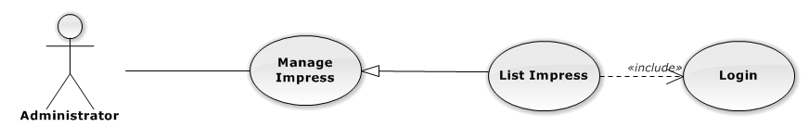

Figure 119: List Impress Use-Case Diagram

List Impress Use-Case Specification

|  |  |  |  |
| --- | --- | --- | --- |
| USE-CASE SPECIFICATION | | | |
| Use-case No. | UC0098 | Use-case Version | 1.0 |
| Use-case Name | List Impress | | |
| Author | Nguyễn Thanh Sang | | |
| Date | 16/05/2014 | Priority | Normal |
| Actor:  Administrator  Summary:  Redirect user to “Quản lí Tạm ứng” page and list all impress.  Goal:  To allowing Administrator view any detail information of all impress.  Triggers:   * User click on User Control Panel and then click on “Quản lí lương nhân viên” link * On sub menu click on “Tạm ứng”.   Preconditions:   * Must be logged-in with “Admin” role. * The page is fully loaded   Post Conditions:  Success: System redirects user to “Quản lí Tạm ứng” page.  Failure: Do nothing.  Main Success Scenario:   |  |  |  | | --- | --- | --- | | *Step* | *User* | *System* | | 1 | Click on “Tạm ứng” link | Redirect to “Quản lí Tạm ứng” page.Show all Impress |   Alternative Scenario:  N/A  Exceptions:  N/A  Relationships:  Management Impress  Business Rules:  Only Staff with role =”Admin” can be use this function. | | | |

###### Add New Impress

Add New Impress Use-Case Diagram

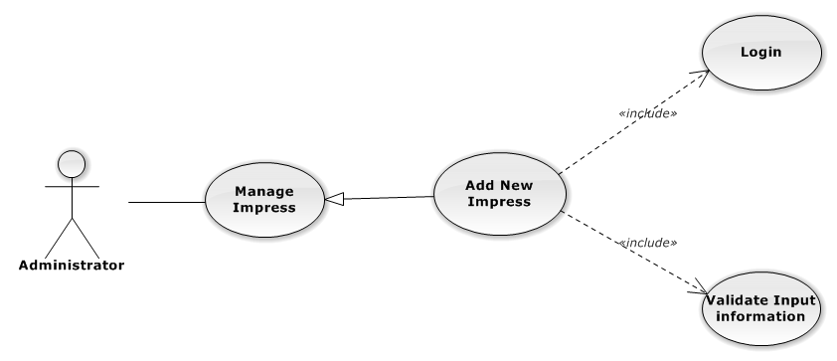

Figure 120: Manage Office Use-Case Diagram

Add New Impress Use-Case Specification

|  |  |  |  |
| --- | --- | --- | --- |
| USE CASE SPECIFICATION | | | |
| Use-case No. | UC0099 | Use-case Version | 1.0 |
| Use-case Name | Add New Impress | | |
| Author | Nguyễn Thanh Sang | | |
| Date | 16/05/2014 | Priority | Normal |
| Actor:  Administrator.  Summary:  Insert new Impress in the system.  **Goal:**  Add new Impress.  Triggers:  At “Quản lí Tạm ứng” page click on “Thêm Tạm ứng” button.  Preconditions:   * Logged-in to system. * The page is fully loaded   Post Conditions:  Success:  New Impress is inserted into database, message show “Thêm Tạm ứng thành công” and display on “Quản lí Tạm ứng” screen.  Failure:  Show error message “Thêm Tạm ứng thất bại, hãy kiểm tra lại kết nối database”.  Main Success Scenario:   |  |  |  | | --- | --- | --- | | *Step* | *User* | *System* | | 1 | Administrator click on “Thêm Tạm ứng” button at “Quản lí Tạm ứng”page. | Modal popup is displayed with fields for input information of new impress. | | 2 | Fill information into fields and click button “Thêm mới”  [Alternative 1]  [Exception 1], [Exception 2] , [Exception 3] | Modal popup is close  System display successful message “Thêm Tạm ứng thành công!”  Update list Impress on page |   Alternative Scenario:   |  |  |  | | --- | --- | --- | | *#* | *User* | *System* | | 1 | Click on [X] button, “Đóng” button, or click out of modal | Modal popup is close |   Exceptions:   |  |  |  | | --- | --- | --- | | *Step* | *User* | *System* | | 1 | Field “Tên nhân viên” are blank | Shows error message “Chọn một nhân viên!” | | Field “Ngày ứng tiền”, are blank | Shows error message “Hãy chọn ngày ứng tiền của nhân viên!” | | Field “Ngày ứng tiền”, are blank | Shows error message “Nhập số tiền tạm ứng! | | 2 | Input “Ngày ứng tiền”, with month are not a current month | Shows error message “Chỉ được chọn tháng hiện tại!” | | Input “Số tiền” are not a number | Shows error message “Hãy nhập số chính xác!” | | 3 | System error insert Impress to data base. | Shows error message “Thêm Tạm ứng thất bại!", "Hãy kiểm tra lại kết nối data base”. |   Relationships:  Manage Impress  Business Rules:  Only Staff with role=”Admin” can be use this function. | | | |

###### Edit Impress

Edit Impress Use-Case Diagram

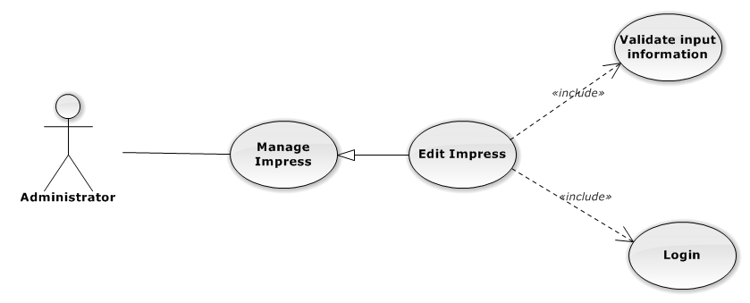

Figure 121: Manage Office Use-Case Diagram

Edit Impress Use-Case Specification

|  |  |  |  |
| --- | --- | --- | --- |
| USE CASE SPECIFICATION | | | |
| Use-case No. | UC0100 | Use-case Version | 1.0 |
| Use-case Name | Edit Impress | | |
| Author | Nguyễn Thanh Sang | | |
| Date | 24/03/2014 | Priority | Normal |
| Actor:  Administrator.  Summary:  Administrator can update information of impress.  **Goal:**  Helps Administrator update information of impress and save to database system.  Triggers:   * Administrator goes to “Quản lý Tạm ứng” screen, click button “Chỉnh Sửa” and modify information, after that click button “Lưu Chỉnh Sửa”.   Preconditions:   * Logged-in to system. * The page is fully loaded   Post Conditions:  Success:  Information of Impress is updated and saves to database, message show “Cập nhật chi tiết Tạm ứng thành công” and display information after update on “Quản lý Tạm ứng” screen.  Failure:  Show error message “Cập nhật chi tiết Tạm ứng thất bại!”  Main Success Scenario:   |  |  |  | | --- | --- | --- | | *Step* | *User* | *System* | | 1 | Administrator click on “Chỉnh sửa” button at “Quản lí Tạm ứng” screen. | Modal popup is displayed with fields for input information of new Impress. | | 2 | Edit information into fields and click button “Lưu chỉnh sửa”  [Alternative 1]  [Exception 1], [Exception 2], [Exception 3] | Modal popup is close  System display successful message “Cập nhật chi tiết Tạm ứng thành công!”  Update list Impress on page |   Alternative Scenario:   |  |  |  | | --- | --- | --- | | *#* | *User* | *System* | | 1 | Click on [X] button, “Đóng” button, or click out of modal | Modal popup is close. |   Exceptions:   |  |  |  | | --- | --- | --- | | *Step* | *User* | *System* | | 1 | Field “Tên nhân viên” are blank | Shows error message “Chọn một nhân viên!” | | Field “Ngày ứng tiền”, are blank | Shows error message “Hãy chọn ngày ứng tiền của nhân viên!” | | 2 | Input “Ngày ứng tiền”, with month are not a current month | Shows error message “Chỉ được chọn tháng hiện tại!” | | Input “Số tiền” are not a number | Shows error message “Hãy nhập số chính xác!” | | 3 | System error insert Impress to data base. | Shows error message “Thêm Tạm ứng thất bại!", "Hãy kiểm tra lại kết nối data base”. |   Relationships:  Manage Impress  Business Rules:  Only Staff with with role=”Admin” can be use this function. | | | |

###### Delete Impress

Delete Impress Use-Case Diagram

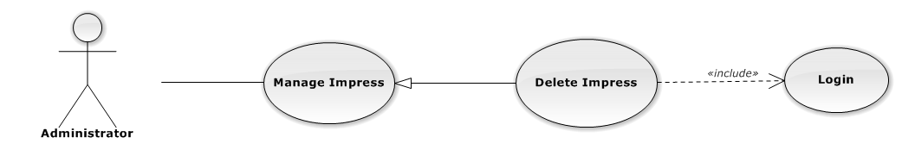

Figure 122: Manage Impress Use-Case Diagram

Delete Impress Use-Case Specification

|  |  |  |  |
| --- | --- | --- | --- |
| USE CASE SPECIFICATION | | | |
| Use-case No. | UC0101 | Use-case Version | 1.0 |
| Use-case Name | Delete Impress | | |
| Author | Nguyễn Thanh Sang | | |
| Date | 24/03/2014 | Priority | Normal |
| Actor:  Administrator.  Summary:  Administrator can delete Impress.  **Goal:**  Helps Administrator delete Impress and save to database system.  Triggers:  Administrator goes to “Quản lí tạm ứng ”page click button “Xóa”. After that click on “Bỏ qua” or“Xác nhận” button to confirm delete impress.  Preconditions:   * User has logged-in as Admin role. * The page is fully loaded   Post Conditions:  Success:  Delete Impress and remove on database system, display message “Xóa tạm ứng của nhân viên thành công!”  Failure:  Show message “Xóa tạm ứng của nhân viên thất bại!", "Tạm ứng này hiện đang được sử dụng!”.  Main Success Scenario:   |  |  |  | | --- | --- | --- | | *Step* | *User* | *System* | | 1 | Supper admin click on “Xóa” button at “Quản lí tạm ứng” screen. | Show Pop-up confirm “Bạn có muốn thực hiện thao tác này” with two button “Xác nhận” and “Bỏ qua” | | 2 | User click “Bỏ qua” button | Impress not delete, comeback to “Quản lí tạm ứng” screen. | | 3 | User click “ Xác nhận” button  [Exception 1], [Exception 2] | Show message “Xóa tạm ứng của nhân viên thành công!” |   Alternative Scenario:  N/A  Exceptions:   |  |  |  | | --- | --- | --- | | *#* | *User* | *System* | | 1 | Delete Impress fail because Impress is use. | Shows error message “Xóa tạm ứng của nhân viên thất bại!", "Tạm ứng này hiện đang được sử dụng!” | | 2 | Delete Impress error because Impress is use. | Shows error message “Xóa tạm ứng của nhân viên thất bại!", "Có lỗi xảy ra trong quá trình xóa!”. |   Relationships:  Manage Impress  Business Rules:  Only Staff with role=”Admin” can be use this function. | | | |

##### Manage TimeSheet

###### List TimeSheet

List TimeSheet Use-Case Diagrame

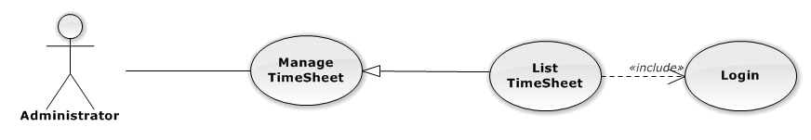

Figure 123: List TimeSheet Use-Case Diagram

List TimeSheet Use-Case Specification

|  |  |  |  |
| --- | --- | --- | --- |
| USE-CASE SPECIFICATION | | | |
| Use-case No. | UC0102 | Use-case Version | 1.0 |
| Use-case Name | List TimeSheet | | |
| Author | Nguyễn Thanh Sang | | |
| Date | 16/05/2014 | Priority | Normal |
| Actor:  Administrator  Summary:  Redirect user to “Quản lí nghỉ phép” page and list all timeSheet.  Goal:  To allowing Administrator view any detail information of all timeSheet.  Triggers:   * User click on User Control Panel and then click on “Quản lí lương nhân viên” link * On sub menu click on “Nghỉ phép”.   Preconditions:   * Must be logged-in with “Admin” role. * The page is fully loaded   Post Conditions:  Success: System redirects user to “Quản lí nghỉ phép” page.  Failure: Do nothing.  Main Success Scenario:   |  |  |  | | --- | --- | --- | | *Step* | *User* | *System* | | 1 | Click on “Nghỉ phép” link | Redirect to “Quản lí nghỉ phép” page.Show all TimeSheet |   Alternative Scenario:  N/A  Exceptions:  N/A  Relationships:  Management TimeSheet  Business Rules:  Only Staff with role =”Admin” can be use this function. | | | |

###### Add New TimeSheet

Add New TimeSheet Use-Case Diagram

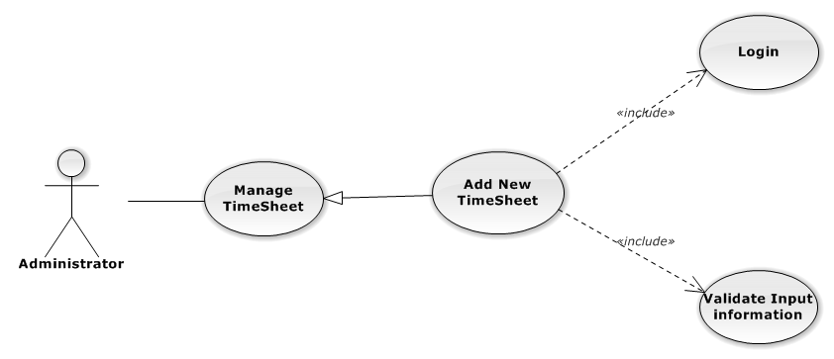

Figure 124: Manage Office Use-Case Diagram

Add New TimeSheet Use-Case Specification

|  |  |  |  |
| --- | --- | --- | --- |
| USE CASE SPECIFICATION | | | |
| Use-case No. | UC0103 | Use-case Version | 1.0 |
| Use-case Name | Add New TimeSheet | | |
| Author | Nguyễn Thanh Sang | | |
| Date | 16/05/2014 | Priority | Normal |
| Actor:  Administrator.  Summary:  Insert new TimeSheet in the system.  **Goal:**  Add new TimeSheet.  Triggers:  At “Quản lí Nghỉ phép” page click on “Thêm Nghỉ phép” button.  Preconditions:   * Logged-in to system. * The page is fully loaded   Post Conditions:  Success:  New TimeSheet is inserted into database, message show “Thêm Nghỉ phép thành công” and display on “Quản lí Nghỉ phép” screen.  Failure:  Show error message “Thêm Nghỉ phép thất bại, hãy kiểm tra lại kết nối database”.  Main Success Scenario:   |  |  |  | | --- | --- | --- | | *Step* | *User* | *System* | | 1 | Administrator click on “Thêm Nghỉ phép” button at “Quản lí Nghỉ phép”page. | Modal popup is displayed with fields for input information of new TimeSheet. | | 2 | Fill information into fields and click button “Thêm mới”  [Alternative 1]  [Exception 1], [Exception 2] , [Exception 3] | Modal popup is close  System display successful message “Thêm Nghỉ phép thành công!”  Update list TimeSheet on page |   Alternative Scenario:   |  |  |  | | --- | --- | --- | | *#* | *User* | *System* | | 1 | Click on [X] button, “Đóng” button, or click out of modal | Modal popup is close |   Exceptions:   |  |  |  | | --- | --- | --- | | *Step* | *User* | *System* | | 1 | Field “Tên nhân viên” are blank | Shows error message “Chọn một nhân viên!” | | Field “Ngày nghỉ”, are blank | Shows error message “”Chọn ngày nghỉ của nhân viên! | |  | Field “Số giờ nghỉ”, are blank | Shows error message “”Nhập vào số giờ nghỉ!” | | 2 | Input “Ngày nghỉ”, with month are not a current month | Shows error message “Chỉ được chọn tháng hiện tại!” | | Input “Số giờ nghỉ” are larger than 8 hour. | Shows error message “Một ngày nghỉ tối đa chỉ 8h!” | | 3 | System error insert TimeSheet to data base. | Shows error message “Thêm Nghỉ phép thất bại!", "Hãy kiểm tra lại kết nối data base”. |   Relationships:  Manage TimeSheet  Business Rules:  Only Staff with role=”Admin” can be use this function. | | | |

###### Edit TimeSheet

Edit TimeSheet Use-Case Diagram

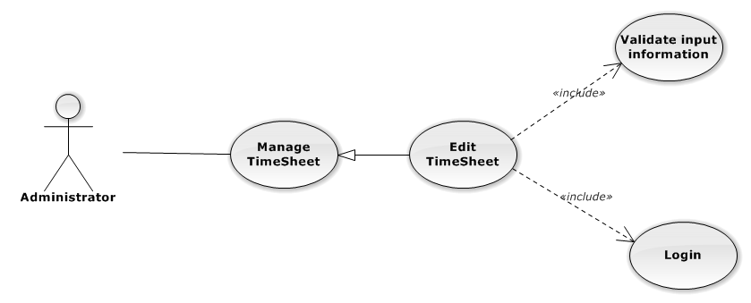

Figure 125: Manage Office Use-Case Diagram

Edit TimeSheet Use-Case Specification

|  |  |  |  |
| --- | --- | --- | --- |
| USE CASE SPECIFICATION | | | |
| Use-case No. | UC0104 | Use-case Version | 1.0 |
| Use-case Name | Edit TimeSheet | | |
| Author | Nguyễn Thanh Sang | | |
| Date | 24/03/2014 | Priority | Normal |
| Actor:  Administrator.  Summary:  Administrator can update information of TimeSheet.  **Goal:**  Helps Administrator update information of TimeSheet and save to database system.  Triggers:   * Administrator goes to “Quản lý Nghỉ phép” screen, click button “Chỉnh Sửa” and modify information, after that click button “Lưu Chỉnh Sửa”.   Preconditions:   * Logged-in to system. * The page is fully loaded   Post Conditions:  Success:  Information of TimeSheet is updated and saves to database, message show “Cập nhật chi tiết Nghỉ phép thành công” and display information after update on “Quản lý Nghỉ phép” screen.  Failure:  Show error message “Cập nhật chi tiết Nghỉ phép thất bại!”  Main Success Scenario:   |  |  |  | | --- | --- | --- | | *Step* | *User* | *System* | | 1 | Administrator click on “Chỉnh sửa” button at “Quản lí Nghỉ phép” screen. | Modal popup is displayed with fields for input information of new TimeSheet. | | 2 | Edit information into fields and click button “Lưu chỉnh sửa”  [Alternative 1]  [Exception 1], [Exception 2], [Exception 3] | Modal popup is close  System display successful message “Cập nhật chi tiết Nghỉ phép thành công!”  Update list TimeSheet on page |   Alternative Scenario:   |  |  |  | | --- | --- | --- | | *#* | *User* | *System* | | 1 | Click on [X] button, “Đóng” button, or click out of modal | Modal popup is close. |   Exceptions:   |  |  |  | | --- | --- | --- | | *Step* | *User* | *System* | | 1 | Field “Tên nhân viên” are blank | Shows error message “Chọn một nhân viên!” | | Field “Ngày nghỉ”, are blank | Shows error message “”Chọn ngày nghỉ của nhân viên! | |  | Field “Số giờ nghỉ”, are blank | Shows error message “”Nhập vào số giờ nghỉ!” | |  | Input “Ngày nghỉ”, with month are not a current month | Shows error message “Chỉ được chọn tháng hiện tại!” | | 3 | Input “Số giờ nghỉ” are larger than 8 hour. | Shows error message “Một ngày nghỉ tối đa chỉ 8h!” | |  | System error insert TimeSheet to data base. | Shows error message “Thêm Nghỉ phép thất bại!", "Hãy kiểm tra lại kết nối data base”. |   Relationships:  Manage TimeSheet  Business Rules:  Only Staff with with role=”Admin” can be use this function. | | | |

###### Delete TimeSheet

Delete TimeSheet Use-Case Diagram

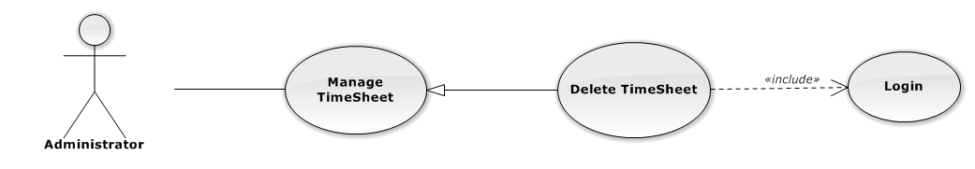

Figure 126: Manage TimeSheet Use-Case Diagram

Delete TimeSheet Use-Case Specification

|  |  |  |  |
| --- | --- | --- | --- |
| USE CASE SPECIFICATION | | | |
| Use-case No. | UC0105 | Use-case Version | 1.0 |
| Use-case Name | Delete TimeSheet | | |
| Author | Nguyễn Thanh Sang | | |
| Date | 24/03/2014 | Priority | Normal |
| Actor:  Administrator.  Summary:  Administrator can delete TimeSheet.  **Goal:**  Helps Administrator delete TimeSheet and save to database system.  Triggers:  Administrator goes to “Quản lí Nghỉ phép ”page click button “Xóa”. After that click on “Bỏ qua” or“Xác nhận” button to confirm delete TimeSheet.  Preconditions:   * User has logged-in as Admin role. * The page is fully loaded   Post Conditions:  Success:  Delete TimeSheet and remove on database system, display message “Xóa Nghỉ phép của nhân viên thành công!”  Failure:  Show message “Xóa Nghỉ phép của nhân viên thất bại!", "Nghỉ phép này hiện đang được sử dụng!”.  Main Success Scenario:   |  |  |  | | --- | --- | --- | | *Step* | *User* | *System* | | 1 | Supper admin click on “Xóa” button at “Quản lí Nghỉ phép” screen. | Show Pop-up confirm “Bạn có muốn thực hiện thao tác này” with two button “Xác nhận” and “Bỏ qua” | | 2 | User click “Bỏ qua” button | TimeSheet not delete, comeback to “Quản lí Nghỉ phép” screen. | | 3 | User click “ Xác nhận” button  [Exception 1], [Exception 2] | Show message “Xóa Nghỉ phép của nhân viên thành công!” |   Alternative Scenario:  N/A  Exceptions:   |  |  |  | | --- | --- | --- | | *#* | *User* | *System* | | 1 | Delete TimeSheet fail because TimeSheet is use. | Shows error message “Xóa Nghỉ phép của nhân viên thất bại!", "Nghỉ phép này hiện đang được sử dụng!” | | 2 | Delete TimeSheet error because TimeSheet is use. | Shows error message “Xóa Nghỉ phép của nhân viên thất bại!", "Có lỗi xảy ra trong quá trình xóa!”. |   Relationships:  Manage TimeSheet  Business Rules:  Only Staff with role=”Admin” can be use this function. | | | |

##### Manage Reward

###### List Reward

List Reward Use-Case Diagrame

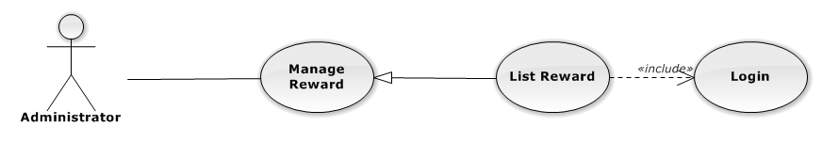

Figure 127: List Reward Use-Case Diagram

List Reward Use-Case Specification

|  |  |  |  |
| --- | --- | --- | --- |
| USE-CASE SPECIFICATION | | | |
| Use-case No. | UC0106 | Use-case Version | 1.0 |
| Use-case Name | List Reward | | |
| Author | Nguyễn Thanh Sang | | |
| Date | 16/05/2014 | Priority | Normal |
| Actor:  Administrator  Summary:  Redirect user to “Quản lí tiền thưởng” page and list all Reward.  Goal:  To allowing Administrator view any detail information of all Reward.  Triggers:   * User click on User Control Panel and then click on “Quản lí lương nhân viên” link * On sub menu click on “Tiền thưởng”.   Preconditions:   * Must be logged-in with “Admin” role. * The page is fully loaded   Post Conditions:  Success: System redirects user to “Quản lí Tiền thưởng” page.  Failure: Do nothing.  Main Success Scenario:   |  |  |  | | --- | --- | --- | | *Step* | *User* | *System* | | 1 | Click on “Tiền thưởng” link | Redirect to “Quản lí Tiền thưởng” page.Show all Reward |   Alternative Scenario:  N/A  Exceptions:  N/A  Relationships:  Management Reward  Business Rules:  Only Staff with role =”Admin” can be use this function. | | | |

###### Add New Reward

Add New Reward Use-Case Diagram

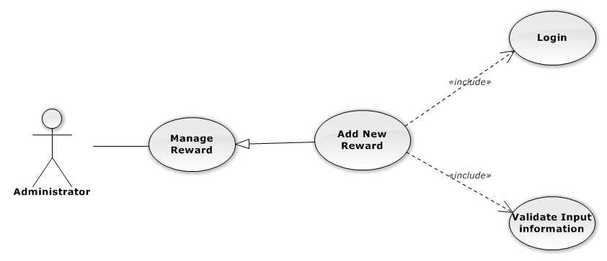

Figure 128: Manage Office Use-Case Diagram

Add New Reward Use-Case Specification

|  |  |  |  |
| --- | --- | --- | --- |
| USE CASE SPECIFICATION | | | |
| Use-case No. | UC0107 | Use-case Version | 1.0 |
| Use-case Name | Add New Reward | | |
| Author | Nguyễn Thanh Sang | | |
| Date | 16/05/2014 | Priority | Normal |
| Actor:  Administrator.  Summary:  Insert new Reward in the system.  **Goal:**  Add new Reward.  Triggers:  At “Quản lí Tiền thưởng” page click on “Thêm Tiền thưởng” button.  Preconditions:   * Logged-in to system. * The page is fully loaded   Post Conditions:  Success:  New Reward is inserted into database, message show “Thêm Tiền thưởng thành công” and display on “Quản lí Tiền thưởng” screen.  Failure:  Show error message “Thêm Tiền thưởng thất bại, hãy kiểm tra lại kết nối database”.  Main Success Scenario:   |  |  |  | | --- | --- | --- | | *Step* | *User* | *System* | | 1 | Administrator click on “Thêm Tiền thưởng” button at “Quản lí Tiền thưởng”page. | Modal popup is displayed with fields for input information of new Reward. | | 2 | Fill information into fields and click button “Thêm mới”  [Alternative 1]  [Exception 1], [Exception 2] , [Exception 3] | Modal popup is close  System display successful message “Thêm Tiền thưởng thành công!”  Update list Reward on page |   Alternative Scenario:   |  |  |  | | --- | --- | --- | | *#* | *User* | *System* | | 1 | Click on [X] button, “Đóng” button, or click out of modal | Modal popup is close |   Exceptions:   |  |  |  | | --- | --- | --- | | *Step* | *User* | *System* | | 1 | Field “Tên nhân viên” are blank | Shows error message “Chọn một nhân viên!” | | Field “Ngày được thưởng”, are blank | Shows error message “Hãy chọn ngày được thưởng của nhân viên!” | | Field “Số tiền”, are blank | Shows error message “Nhập số tiền được thưởng!” | | 2 | Input “Ngày được thưởng”, with month are not a current month | Shows error message “Chỉ được chọn tháng hiện tại!” | | Input “Số tiền” are not a number | Shows error message “Hãy nhập số chính xác!” | | 3 | System error insert Reward to data base. | Shows error message “Thêm Tiền thưởng thất bại!", "Hãy kiểm tra lại kết nối data base”. |   Relationships:  Manage Reward  Business Rules:  Only Staff with role=”Admin” can be use this function. | | | |

###### Edit Reward

Edit Reward Use-Case Diagram

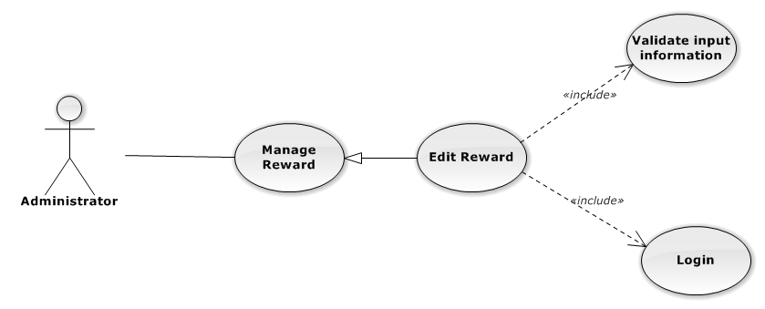

Figure 129: Manage Office Use-Case Diagram

Edit Reward Use-Case Specification

|  |  |  |  |
| --- | --- | --- | --- |
| USE CASE SPECIFICATION | | | |
| Use-case No. | UC0108 | Use-case Version | 1.0 |
| Use-case Name | Edit Reward | | |
| Author | Nguyễn Thanh Sang | | |
| Date | 24/03/2014 | Priority | Normal |
| Actor:  Administrator.  Summary:  Administrator can update information of Reward.  **Goal:**  Helps Administrator update information of Reward and save to database system.  Triggers:   * Administrator goes to “Quản lý Tiền thưởng” screen, click button “Chỉnh Sửa” and modify information, after that click button “Lưu Chỉnh Sửa”.   Preconditions:   * Logged-in to system. * The page is fully loaded   Post Conditions:  Success:  Information of Reward is updated and saves to database, message show “Cập nhật chi tiết Tiền thưởng thành công” and display information after update on “Quản lý Tiền thưởng” screen.  Failure:  Show error message “Cập nhật chi tiết Tiền thưởng thất bại!”  Main Success Scenario:   |  |  |  | | --- | --- | --- | | *Step* | *User* | *System* | | 1 | Administrator click on “Chỉnh sửa” button at “Quản lí Tiền thưởng” screen. | Modal popup is displayed with fields for input information of new Reward. | | 2 | Edit information into fields and click button “Lưu chỉnh sửa”  [Alternative 1]  [Exception 1], [Exception 2], [Exception 3] | Modal popup is close  System display successful message “Cập nhật chi tiết Tiền thưởng thành công!”  Update list Reward on page |   Alternative Scenario:   |  |  |  | | --- | --- | --- | | *#* | *User* | *System* | | 1 | Click on [X] button, “Đóng” button, or click out of modal | Modal popup is close. |   Exceptions:   |  |  |  | | --- | --- | --- | | *Step* | *User* | *System* | | 1 | Field “Tên nhân viên” are blank | Shows error message “Chọn một nhân viên!” | | Field “Ngày được thưởng”, are blank | Shows error message “Hãy chọn ngày được thưởng của nhân viên!” | | 2 | Input “Ngày được thưởng”, with month are not a current month | Shows error message “Chỉ được chọn tháng hiện tại!” | | Input “Số tiền” are not a number | Shows error message “Hãy nhập số chính xác!” | | 3 | System error insert Reward to data base. | Shows error message “Thêm Tiền thưởng thất bại!", "Hãy kiểm tra lại kết nối data base”. |   Relationships:  Manage Reward  Business Rules:  Only Staff with with role=”Admin” can be use this function. | | | |

###### Delete Reward

Delete Reward Use-Case Diagram

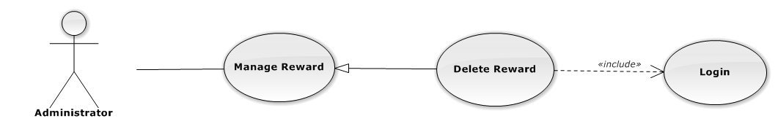

Figure 130: Manage Reward Use-Case Diagram

Delete Reward Use-Case Specification

|  |  |  |  |
| --- | --- | --- | --- |
| USE CASE SPECIFICATION | | | |
| Use-case No. | UC0109 | Use-case Version | 1.0 |
| Use-case Name | Delete Reward | | |
| Author | Nguyễn Thanh Sang | | |
| Date | 24/03/2014 | Priority | Normal |
| Actor:  Administrator.  Summary:  Administrator can delete Reward.  **Goal:**  Helps Administrator delete Reward and save to database system.  Triggers:  Administrator goes to “Quản lí Tiền thưởng ”page click button “Xóa”. After that click on “Bỏ qua” or“Xác nhận” button to confirm delete Reward.  Preconditions:   * User has logged-in as Admin role. * The page is fully loaded   Post Conditions:  Success:  Delete Reward and remove on database system, display message “Xóa Tiền thưởng của nhân viên thành công!”  Failure:  Show message “Xóa Tiền thưởng của nhân viên thất bại!", "Tiền thưởng này hiện đang được sử dụng!”.  Main Success Scenario:   |  |  |  | | --- | --- | --- | | *Step* | *User* | *System* | | 1 | Supper admin click on “Xóa” button at “Quản lí Tiền thưởng” screen. | Show Pop-up confirm “Bạn có muốn thực hiện thao tác này” with two button “Xác nhận” and “Bỏ qua” | | 2 | User click “Bỏ qua” button | Reward not delete, comeback to “Quản lí Tiền thưởng” screen. | | 3 | User click “ Xác nhận” button  [Exception 1], [Exception 2] | Show message “Xóa Tiền thưởng của nhân viên thành công!” |   Alternative Scenario:  N/A  Exceptions:   |  |  |  | | --- | --- | --- | | *#* | *User* | *System* | | 1 | Delete Reward fail because Reward is use. | Shows error message “Xóa Tiền thưởng của nhân viên thất bại!", "Tiền thưởng này hiện đang được sử dụng!” | | 2 | Delete Reward error because Reward is use. | Shows error message “Xóa Tiền thưởng của nhân viên thất bại!", "Có lỗi xảy ra trong quá trình xóa!”. |   Relationships:  Manage Reward  Business Rules:  Only Staff with role=”Admin” can be use this function. | | | |

##### Calculate Salary

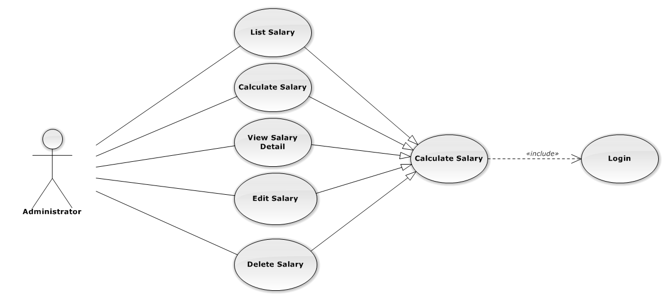

###### List Salary

List Salary Use-Case Diagrame

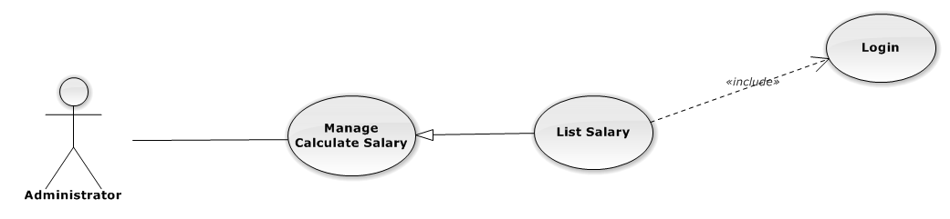

Figure 131: List Salary Use-Case Diagram

List Salary Use-Case Specification

|  |  |  |  |
| --- | --- | --- | --- |
| USE-CASE SPECIFICATION | | | |
| Use-case No. | UC0110 | Use-case Version | 1.0 |
| Use-case Name | List Salary | | |
| Author | Nguyễn Thanh Sang | | |
| Date | 16/05/2014 | Priority | Normal |
| Actor:  Administrator  Summary:  Redirect user to “Quản lí tiền thưởng” page and list all Salary.  Goal:  To allowing Administrator view any detail information of all Salary.  Triggers:   * User click on User Control Panel and then click on “Quản lí lương nhân viên” link * On sub menu click on “Lương nhân viên”.   Preconditions:   * Must be logged-in with “Admin” role. * The page is fully loaded   Post Conditions:  Success: System redirects user to “Quản lí Lương nhân viên” page.  Failure: Do nothing.  Main Success Scenario:   |  |  |  | | --- | --- | --- | | *Step* | *User* | *System* | | 1 | Click on “Lương nhân viên” link | Redirect to “Quản lí Lương nhân viên” page.Show all Salary |   Alternative Scenario:  N/A  Exceptions:  N/A  Relationships:  Management Salary  Business Rules:  Only Staff with role =”Admin” can be use this function. | | | |

###### View Salary Detail

View Salary Detail Use-Case Diagrame

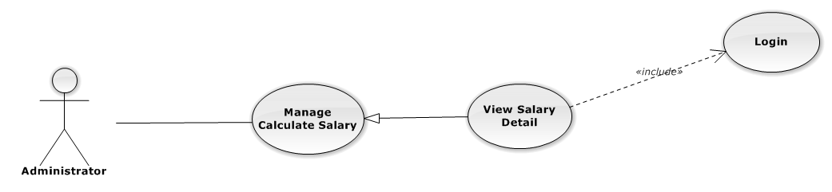

Figure 132: View Salary Detail Use-Case Diagram

View Salary Detail Use-Case Specification

|  |  |  |  |
| --- | --- | --- | --- |
| USE-CASE SPECIFICATION | | | |
| Use-case No. | UC0111 | Use-case Version | 1.0 |
| Use-case Name | View View Salary Detail | | |
| Author | Nguyễn Thanh Sang | | |
| Date | 30/01/2014 | Priority | Normal |
| Actor:  Administrator  Summary:  Administrator can view detail of Salary information  Goal:  Helps Administrator view Salary information  Triggers:   * On User Control Panel click on “Quản lí lương nhân viên**”,** * Click click on “Chi tiết” button * Click on name’s staff.   Preconditions:   * Must be logged-in with “Admin” role * The page is fully loaded   Post Conditions:  Success: The detail staff information is displayed  Failure: Do nothing  Main Success Scenario:   |  |  |  | | --- | --- | --- | | *Step* | *User* | *System* | | 1 | Administrator click on “chi tiết” button or click on image link  [Alternative 1] ,[Alternative 2] | The detail staff’ salary information is displayed. |   Alternative Scenario:   |  |  |  | | --- | --- | --- | | *#* | *User* | *System* | | 1 | Click on [X] button, “Đóng” button, or click out of modal | Modal popup is close | | 2 | If staff login with Id=”1”, Click on “Chỉnh sửa” button | Administrator can update information of office (ref 3.2.2.2.4. Edit Salary) |   Exceptions:  N/A  Relationships:  Manage Salary  Business Rules:  Only Staff login with role “Admin” can be use this function. | | | |

###### Calculate Salary

Calculate Salary Use-Case Diagram

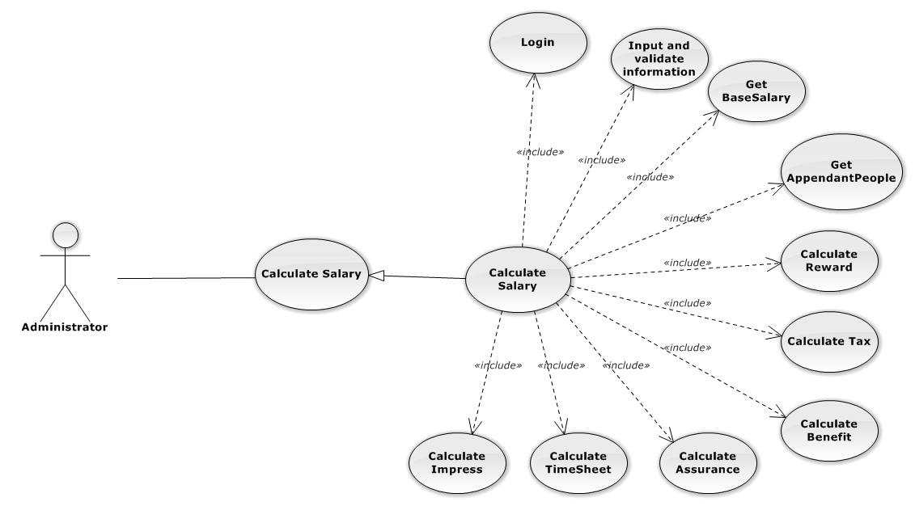

Figure 133: Manage Office Use-Case Diagram

Calculate Salary Use-Case Specification

|  |  |  |  |
| --- | --- | --- | --- |
| USE CASE SPECIFICATION | | | |
| Use-case No. | UC0112 | Use-case Version | 1.0 |
| Use-case Name | Calculate Salary | | |
| Author | Nguyễn Thanh Sang | | |
| Date | 16/05/2014 | Priority | Normal |
| Actor:  Administrator.  Summary:  Calculate and insert salary of staff in the system.  **Goal:**  Calculate staff’s salary .  Triggers:  At “Quản lí Lương nhân viên” page click on “Tính lương nhân viên” button.  Preconditions:   * Logged-in to system. * The page is fully loaded   Post Conditions:  Success:   * Calculate staff’s salary and add new staff’s salary to Database message show “Tính lương nhân viên thành công”. * Add current staff’s assurance, staff’s benefit , staff’s tax to data system.   Failure:  Show error message “Tính lương nhân viên thất bại, hãy kiểm tra lại kết nối database”.  Main Success Scenario:   |  |  |  | | --- | --- | --- | | *Step* | *User* | *System* | | 1 | Administrator click on “Tính Lương nhân viên” button at “Quản lí Lương nhân viên”page. | Modal popup is displayed with fields for input information of new Salary. | | 2 | Fill information into fields and click button “Tính lương mới”  [Alternative 1]  [Exception 1], [Exception 2] , [Exception 3] | Modal popup is close  System display successful message “Thêm Lương nhân viên thành công!”  Update list Salary on page |   Alternative Scenario:   |  |  |  | | --- | --- | --- | | *#* | *User* | *System* | | 1 | Click on [X] button, “Đóng” button, or click out of modal | Modal popup is close |   Exceptions:   |  |  |  | | --- | --- | --- | | *Step* | *User* | *System* | | 1 | Field “Tên nhân viên” are blank | Shows error message “Chọn một nhân viên!” | | Field “Ngày tính lương”, are blank | Shows error message “Hãy chọn ngày được thưởng của nhân viên!” | | Field “Trợ cấp”, are blank | Shows error message “Chọn một trợ cấp” | | Field “Bảo hiểm”, are blank | Shows error message “Chọn một bảo hiểm” | | 2 | Input “Ngày tính lương”, with month are not a current month | Shows error message “Chỉ được chọn tháng hiện tại!” | | Input “Ngày tính lương” of staff is exitst calculate in system | Shows error message “Tháng này bạn đã tính lương rồi!” | | 3 | System error insert Salary to data base. | Shows error message “Tính lương nhân viên thất bại!", "Hãy kiểm tra lại kết nối data base”. |   Relationships:  Manage Salary  Business Rules:   * Only Staff with role=”Admin” can be use this function. * Total Salary = Base Salary(get to Staff Group) + Total Benefit + Total Reward * One Staff have leave 12 day in month, if leave > 12 day then deduction salary by date leave. Deduction base on Total Salary * Total Tax caculate base on VietNam’s General Department of Taxation. * Actual Salary = Total Salary – Total Tax – Assurance Money – Total Impress | | | |

###### Edit Salary

Edit Salary Use-Case Diagram

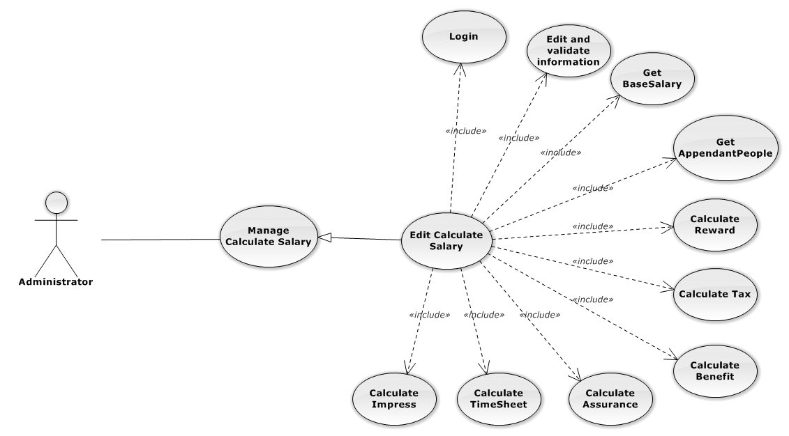

Figure 134: Manage Office Use-Case Diagram

Edit Salary Use-Case Specification

|  |  |  |  |
| --- | --- | --- | --- |
| USE CASE SPECIFICATION | | | |
| Use-case No. | UC0113 | Use-case Version | 1.0 |
| Use-case Name | Edit Salary | | |
| Author | Nguyễn Thanh Sang | | |
| Date | 24/03/2014 | Priority | Normal |
| Actor:  Administrator.  Summary:  Administrator can update information of staff’s salary.  **Goal:**  Helps Administrator update information of staff’s sSalary and save to database system.  Triggers:   * Administrator goes to “Quản lý Lương nhân viên” screen, click button “Chỉnh Sửa” and modify information, after that click button “Lưu Chỉnh Sửa”.   Preconditions:   * Logged-in to system. * The page is fully loaded   Post Conditions:  Success:   * Calculate staff’s salary and add new staff’s salary to Database message show “Cập nhật chi tiết Lương nhân viên thành công”. * Add current staff’s assurance, staff’s benefit , staff’s tax to data system.   Failure:  Show error message “Cập nhật chi tiết lương nhân viên thất bại!”  Main Success Scenario:   |  |  |  | | --- | --- | --- | | *Step* | *User* | *System* | | 1 | Administrator click on “Chỉnh sửa” button at “Quản lí Lương nhân viên” screen. | Modal popup is displayed with fields for input information of new Salary. | | 2 | Edit information into fields and click button “Lưu chỉnh sửa”  [Alternative 1]  [Exception 1], [Exception 2], [Exception 3] | Modal popup is close  System display successful message “Cập nhật chi tiết Lương nhân viên thành công!”  Update list Salary on page |   Alternative Scenario:   |  |  |  | | --- | --- | --- | | *#* | *User* | *System* | | 1 | Click on [X] button, “Đóng” button, or click out of modal | Modal popup is close. |   Exceptions:   |  |  |  | | --- | --- | --- | | *Step* | *User* | *System* | | 1 | Field “Tên nhân viên” are blank | Shows error message “Chọn một nhân viên!” | | Field “Ngày tính lương”, are blank | Shows error message “Hãy chọn ngày được thưởng của nhân viên!” | | Field “Trợ cấp”, are blank | Shows error message “Chọn một trợ cấp” | | Field “Bảo hiểm”, are blank | Shows error message “Chọn một bảo hiểm” | | 2 | Input “Ngày tính lương”, with month are not a current month | Shows error message “Chỉ được chọn tháng hiện tại!” | | Input “Ngày tính lương” of staff is exitst calculate in system | Shows error message “Tháng này bạn đã tính lương rồi!” | | 3 | System error insert Salary to data base. | Shows error message “Tính lương nhân viên thất bại!", "Hãy kiểm tra lại kết nối data base”. |   Relationships:  Manage Salary  Business Rules:   * Only Staff with role=”Admin” can be use this function. * Total Salary = Base Salary(get to Staff Group) + Total Benefit + Total Reward * One Staff have leave 12 day in month, if leave > 12 day then deduction salary by date leave. Deduction base on Total Salary * Total Tax caculate base on VietNam’s General Department of Taxation.   Actual Salary = Total Salary – Total Tax – Assurance Money – Total Impress | | | |

###### Delete Salary

Delete Salary Use-Case Diagram

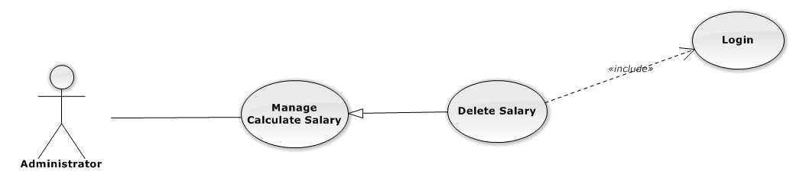

Figure 135: Manage Salary Use-Case Diagram

Delete Salary Use-Case Specification

|  |  |  |  |
| --- | --- | --- | --- |
| USE CASE SPECIFICATION | | | |
| Use-case No. | UC0114 | Use-case Version | 1.0 |
| Use-case Name | Delete Salary | | |
| Author | Nguyễn Thanh Sang | | |
| Date | 24/03/2014 | Priority | Normal |
| Actor:  Administrator.  Summary:  Administrator can delete Salary.  **Goal:**  Helps Administrator delete Salary and remove on database system.  Triggers:  Administrator goes to “Quản lí Lương nhân viên ”page click button “Xóa”. After that click on “Bỏ qua” or“Xác nhận” button to confirm delete Salary.  Preconditions:   * User has logged-in as Admin role. * The page is fully loaded   Post Conditions:  Success:  Delete Salary and remove on database system, display message “Xóa lương nhân viên của nhân viên thành công!”  Failure:  Show message “Xóa lương nhân viên của nhân viên thất bại!", "Lương nhân viên này hiện đang được sử dụng!”.  Main Success Scenario:   |  |  |  | | --- | --- | --- | | *Step* | *User* | *System* | | 1 | Supper admin click on “Xóa” button at “Quản lí lương nhân viên” screen. | Show Pop-up confirm “Bạn có muốn thực hiện thao tác này” with two button “Xác nhận” and “Bỏ qua” | | 2 | User click “Bỏ qua” button | Salary not delete, comeback to “Quản lí lương nhân viên” screen. | | 3 | User click “Xác nhận” button  [Exception 1], [Exception 2] | Show message “Xóa lương nhân viên của nhân viên thành công!” |   Alternative Scenario:  N/A  Exceptions:   |  |  |  | | --- | --- | --- | | *#* | *User* | *System* | | 1 | Delete Salary fail because Salary is use. | Shows error message “Xóa lương nhân viên của nhân viên thất bại!", "Lương nhân viên này hiện đang được sử dụng!” | | 2 | Delete Salary error because Salary is use. | Shows error message “Xóa lương nhân viên của nhân viên thất bại!", "Có lỗi xảy ra trong quá trình xóa!”. |   Relationships:  Manage Salary  Business Rules:  Only Staff with role=”Admin” can be use this function. | | | |

#### Other Cost

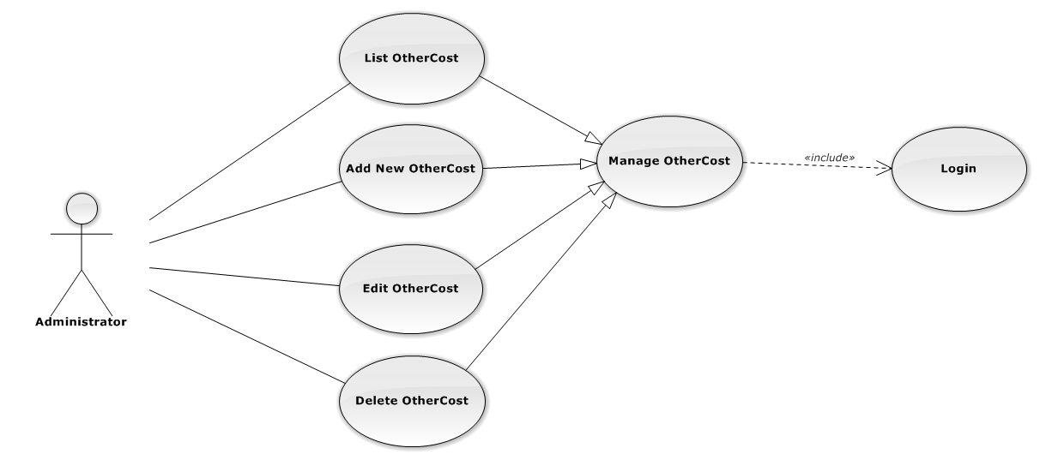

Figure 100: Manage OtherCost Use-Case Diagram

##### List Other Cost

###### List Other Cost Use-Case Diagram

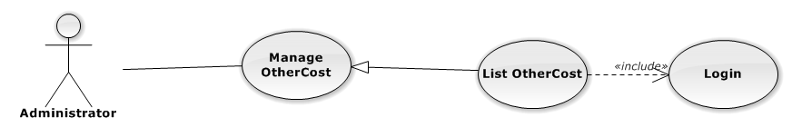

Figure 101: List Other Cost Use-Case Diagram

###### List Other Cost Use-Case Specification

|  |  |  |  |
| --- | --- | --- | --- |
| USE-CASE SPECIFICATION | | | |
| Use-case No. | UC0080 | Use-case Version | 1.0 |
| Use-case Name | List Other Cost | | |
| Author | Lê Duy Hoàng | | |
| Date | 16/05/2014 | Priority | Normal |
| Actor:  Administrator  Summary:  Redirect user to “Quản lí Chi phí khác” page and list all other cost.  Goal:  To allowing Administrator view any detail information of all Other cost.  Triggers:   * User click on User Control Panel and then click on “Quản lí Chi phí khác” link   Preconditions:   * Must be logged-in with “Admin” role. * The page is fully loaded   Post Conditions:  Success: System redirects user to “Quản lí Chi phí khác” page.  Failure: Do nothing.  Main Success Scenario:   |  |  |  | | --- | --- | --- | | *Step* | *User* | *System* | | 1 | Click on “Quản lí Chi phí khác” link | Redirect to “Quản lí Chi phí khác” page.Show all Other cost |   Alternative Scenario:  N/A  Exceptions:  N/A  Relationships:  Management Other cost  Business Rules:  Only Staff with role =”Admin” can be use this function. | | | |

##### Add New Other Cost

###### Add New Other cost Use-Case Diagram

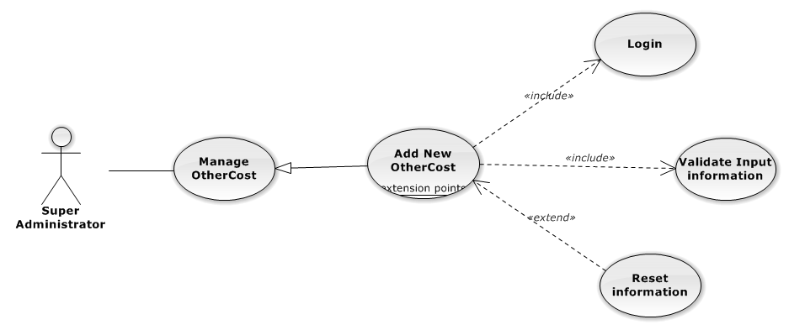

Figure 103: Add New Other Cost Use-Case Diagram

###### Add New Other Cost Use-Case Specification

|  |  |  |  |
| --- | --- | --- | --- |
| USE CASE SPECIFICATION | | | |
| Use-case No. | UC0082 | Use-case Version | 1.0 |
| Use-case Name | Add New Other Cost | | |
| Author | Lê Duy Hoàng | | |
| Date | 16/05/2014 | Priority | Normal |
| Actor:  Administrator.  Summary:  Insert new other cost in the system.  **Goal:**  Add new other cost.  Triggers:  On User Control Panel click on “Quản lí nhân viên” link, at “Quản lí nhân viên” page click on “Thêm Chi phí khác” button.  Preconditions:   * Logged-in to system. * The page is fully loaded   Post Conditions:  Success:   * New other cost is inserted into database, message show “Thêm Chi phí khác thành công” and display on “Quản lí Chi phí khác” screen. * New other cost’s status is “Đang hoạt động”.   Failure:  Show error message “Thêm Chi phí khác thất bại, hãy kiểm tra lại kết nối database”.  Main Success Scenario:   |  |  |  | | --- | --- | --- | | *Step* | *User* | *System* | | 1 | Administrator click on “Thêm Chi phí khác” button at “Quản lí Chi phí khác”page. | Modal popup is displayed with fields for input information of new other cost. | | 2 | Fill information into fields and click button “Thêm mới”  [Alternative 1]  [Exception 2], [Exception 3] | Modal popup is close  System display successful message “Thêm Chi phí khác thành công!”  Update list other cost on page |   Alternative Scenario:   |  |  |  | | --- | --- | --- | | *#* | *User* | *System* | | 1 | Click “đóng” button | Pop up close. |   Exceptions:   |  |  |  | | --- | --- | --- | | *Step* | *User* | *System* | | 1 | Field “ngày mua” are blank | Shows error message “Hãy chọn ngày thêm chi phí!” | | Field “Số tiền”, are blank | Shows error message “Nhập số tiền!” | | 2 | System cannot insert other cost to data base. | Shows error message “Thêm Chi phí khác thất bại!” | | 3 | System error insert other cost to data base. | Shows error message “Thêm Chi phí khác thất bại!", "Hãy kiểm tra lại kết nối data base”. |   Relationships:  Manage Other cost  Business Rules:  Only Staff with Role “admin” can be use this function. | | | |

##### Edit Other Cost

###### Edit Other Cost Use-Case Diagram

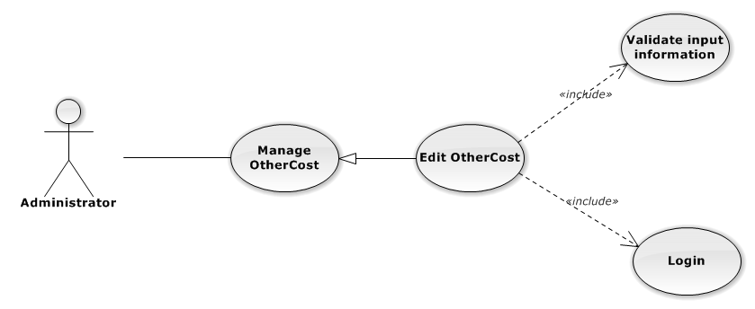

Figure 104: Edit Other cost Use-Case Diagram

###### Edit Other Cost Use-Case Specification

|  |  |  |  |
| --- | --- | --- | --- |
| USE CASE SPECIFICATION | | | |
| Use-case No. | UC0083 | Use-case Version | 1.0 |
| Use-case Name | Edit Other cost | | |
| Author | Lê Duy Hoàng | | |
| Date | 16/05/2014 | Priority | Normal |
| Actor:  Administrator.  Summary:  Administrator can update information of other cost.  **Goal:**  Supper Administrator update information of other cost and save to database system.  Triggers:   * Administrator goes to “Quản lý Chi phí khác” screen, click button “Chỉnh Sửa” and modify information, after that click button “Lưu Chỉnh Sửa”. * Administrator goes to “Chi tiết nhân viên” Popup screen, click on “Chỉnh Sửa” button and modify information, after that click button “Lưu Chỉnh Sửa”.   Preconditions:   * Logged-in to system. * The page is fully loaded   Post Conditions:  Success:  Information of other cost is updated and saves to database, message show “Cập nhật chi tiết Chi phí khác thành công” and display information after update on “Quản lý Chi phí khác” screen.  Failure:  Show error message “Cập nhật chi tiết Chi phí khác thất bại!”  Main Success Scenario:   |  |  |  | | --- | --- | --- | | *Step* | *User* | *System* | | 1 | Administrator click on “Chỉnh sửa” button at “Quản lí Chi phí khác” screen. | Modal popup is displayed with fields for input information of new other cost. | | 2 | Edit information into fields and click button “Lưu chỉnh sửa”  [Alternative 1]  [Exception 1], [Exception 2], [Exception 3] | Modal popup is close  System display successful message “Cập nhật chi tiết Chi phí khác thành công!”  Update list other cost on page |   Alternative Scenario:   |  |  |  | | --- | --- | --- | | *#* | *User* | *System* | | 1 | Click on [X] button, “Đóng” button, or click out of modal | Modal popup is close. |   Exceptions:   |  |  |  | | --- | --- | --- | | *Step* | *User* | *System* | | 1 | Field “ngày mua” are blank | Shows error message “Hãy chọn ngày thêm chi phí!” | | Field “Số tiền”, are blank | Shows error message “Nhập số tiền!” | | 2 | System cannot update other cost to data base. | Shows error message “Cập nhật chi tiết Chi phí khác thất bại!” | | 3 | System error update other cost to data base. | Shows error message “Cập nhật chi tiết Chi phí khác thất bại! ", "Hãy kiểm tra lại kết nối database”. |   Relationships:  Manage Other cost  Business Rules:  Only Staff with Role admin can be use this function. | | | |

##### Delete Other Cost

###### Delete Other Cost Use-Case Diagram

Figure 105: Delete Other Cost Use-Case Diagram

###### Delete OtherCost Use-Case Specification

|  |  |  |  |
| --- | --- | --- | --- |
| USE CASE SPECIFICATION | | | |
| Use-case No. | UC0084 | Use-case Version | 1.0 |
| Use-case Name | Delete Other Cost | | |
| Author | Lê Duy Hoàng | | |
| Date | 16/05/2014 | Priority | Normal |
| Actor:  Administrator.  Summary:  Administrator can change status of Other cost to De active or Active.  **Goal:**  Helps Administrator update Status of Other cost and save to database system.  Triggers:   * Administrator wants to update Status of other cost.   Preconditions:   * Logged-in to system. * The page is fully loaded   Post Conditions:  Success:  Information of Other cost is updated and saves to database, message show “Chi phí khác đã hoạt động lại!” or “Chi phí khác đã ngừng hoạt động!” and display information after update on “Quản lý Chi phí khác” screen.  Failure:  Show error message “Chỉnh sửa chi phí thất bại!  Main Success Scenario:   |  |  |  | | --- | --- | --- | | *Step* | *User* | *System* | | 1 | Administrator click on “Chỉnh sửa” button at “Quản lí văn phòng” screen. | Show “Chi tiết văn phòng” Pop-up information. | | 2 | Click “delete button” | Display message box confirm “Bạn có muốn thực hiện thao tác này” with two button “Xác nhận” and “Bỏ qua” | | 3 | User click “Bỏ qua” button | Back to screen | | 4 | User click “ Xác nhận” button  [Exception 1], [Exception 2] | Delete other cost |   Alternative Scenario:   |  |  |  | | --- | --- | --- | | *#* | *User* | *System* | | 1 | Click on [X] button, “Đóng” button, or click out of modal | Modal popup is close |   Exceptions:   |  |  |  | | --- | --- | --- | | *#* | *User* | *System* | | 1 | System error update status other cost to data base. | Shows error message “Chỉnh hoạt động văn phòng thất bại!", "Hãy kiểm tra lại kết nối database!”. | | 2 | System error update status other cost to data base. | Shows error message “Chỉnh hoạt động văn phòng thất bại!", "Có lỗi xảy ra trong quá trình xóa văn phòng!”. |   Relationships:  Manage Other cost  Business Rules:  Only Staff with role =Admin can be use this function. | | | |

#### Statistic

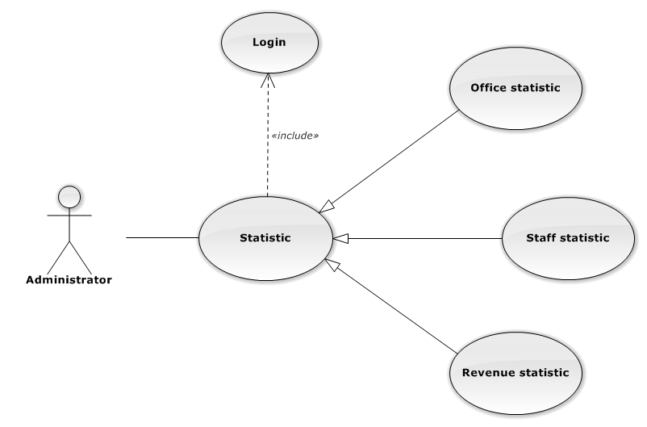

Figure 136: Statistic Use-Case Diagram

##### Office Statistic

###### Office Statistic Use-Case Diagram

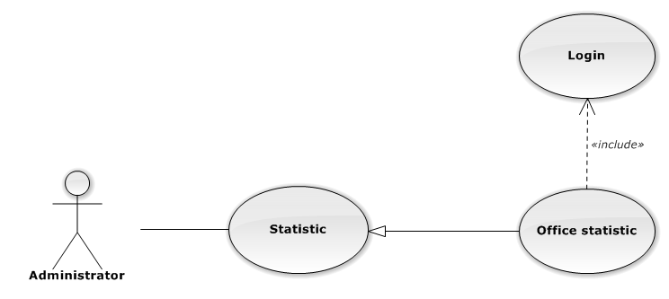

Figure 137: Office Statistic Use-Case Diagram

###### Office Statistic Use-Case Specification

|  |  |  |  |
| --- | --- | --- | --- |
| USE CASE SPECIFICATION | | | |
| Use-case No. | UC0115 | Use-case Version | 1.0 |
| Use-case Name | Office Statistic | | |
| Author | Lê Duy Hoàng | | |
| Date | 30/01/2014 | Priority | Normal |
| Actor:  Administrator.  Summary:  The statistic about office.  Goal:  The purpose of Office Statistic use case is allowing User to view Office index in graphs.  Triggers:  User choose “Thống kê” link in menu.  Preconditions:  User is authenticated.  Post Conditions:  Success: The graphs are showed.  Failure: N/A  Main Success Scenario:   |  |  |  | | --- | --- | --- | | *Step* | *User* | *System* | | 1 | Click “Văn phòng” tab in statistic page. | The graphs are loaded. |   Alternative Scenario:  N/A  Exceptions:  N/A  Relationships:  Statistic  Business Rules:  N/A | | | |

##### Staff Statistic

###### Staff Statistic Use-Case Diagram

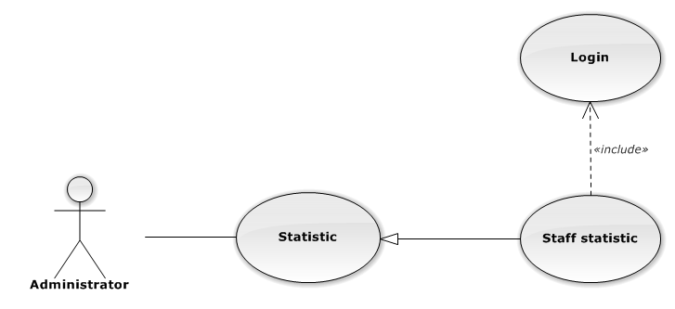

Figure 138: Staff Statistic Use-Case Diagram

###### Staff Statistic Use-Case Specification

|  |  |  |  |
| --- | --- | --- | --- |
| USE CASE SPECIFICATION | | | |
| Use-case No. | UC0116 | Use-case Version | 1.0 |
| Use-case Name | Staff Statistic | | |
| Author | Lê Duy Hoàng | | |
| Date | 30/01/2014 | Priority | Normal |
| Actor:  Administrator.  Summary:  The statistic about staffs.  Goal:  The purpose of Staff Statistic use case is allowing User to view Staff index in graphs.  Triggers:  User choose “Thống kê” link in menu.  Preconditions:  User is authenticated.  Post Conditions:  Success: The graphs are showed.  Failure: N/A  Main Success Scenario:   |  |  |  | | --- | --- | --- | | *Step* | *User* | *System* | | 1 | Click “Nhân viên” tab in statistic page. | The graphs are loaded. |   Alternative Scenario:  N/A  Exceptions:  N/A  Relationships:  Statistic  Business Rules:  N/A | | | |

##### Revenue Statistic

###### Revenue Statistic Use-Case Diagram

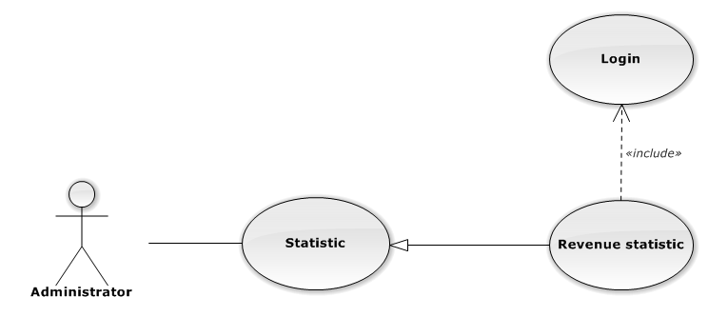

Figure 139: Revenue Statistic Use-Case Diagram

###### Revenue Statistic Use-Case Specification

|  |  |  |  |
| --- | --- | --- | --- |
| USE CASE SPECIFICATION | | | |
| Use-case No. | UC0117 | Use-case Version | 1.0 |
| Use-case Name | Revenue Statistic | | |
| Author | Lê Duy Hoàng | | |
| Date | 30/01/2014 | Priority | Normal |
| Actor:  Administrator.  Summary:  The statistic about revenue.  Goal:  The purpose of Revenue Statistic use case is allowing User to view Revenue index in graphs.  Triggers:  User choose “Thống kê” link in menu.  Preconditions:  User is authenticated.  Post Conditions:  Success: The graphs are showed.  Failure: N/A  Main Success Scenario:   |  |  |  | | --- | --- | --- | | *Step* | *User* | *System* | | 1 | Click “Doanh thu” tab in statistic page. | The graphs are loaded. |   Alternative Scenario:  N/A  Exceptions:  N/A  Relationships:  Statistic  Business Rules:  N/A | | | |

### Non-Functional Requirements

#### Reliability

The systems with high reliability, can be used like “always on” system. However, if exist accident, it's not need require immediate repair. All information and Cases can be updated later.

#### Availability

The system always responds to every user who got permission. The expected downtime for maintenance is about 5 minutes each time.

#### Security

Users must login for using the system. The user passwords are MD5 encrypted before being put into Database. Staff are restricted to view other user’s information and any function. Super Administrator has full permission to use the system.

#### Maintainability

Each component only perform specific functions so the modification of a component will not affect other components.

#### Portability

The system can be accessed anywhere with a web browser and Internet connection. It can be run on any browser, but recommend for user is Mozilla Firefox with highest version.

#### Performance

N/A

## Entity Relationship Diagram

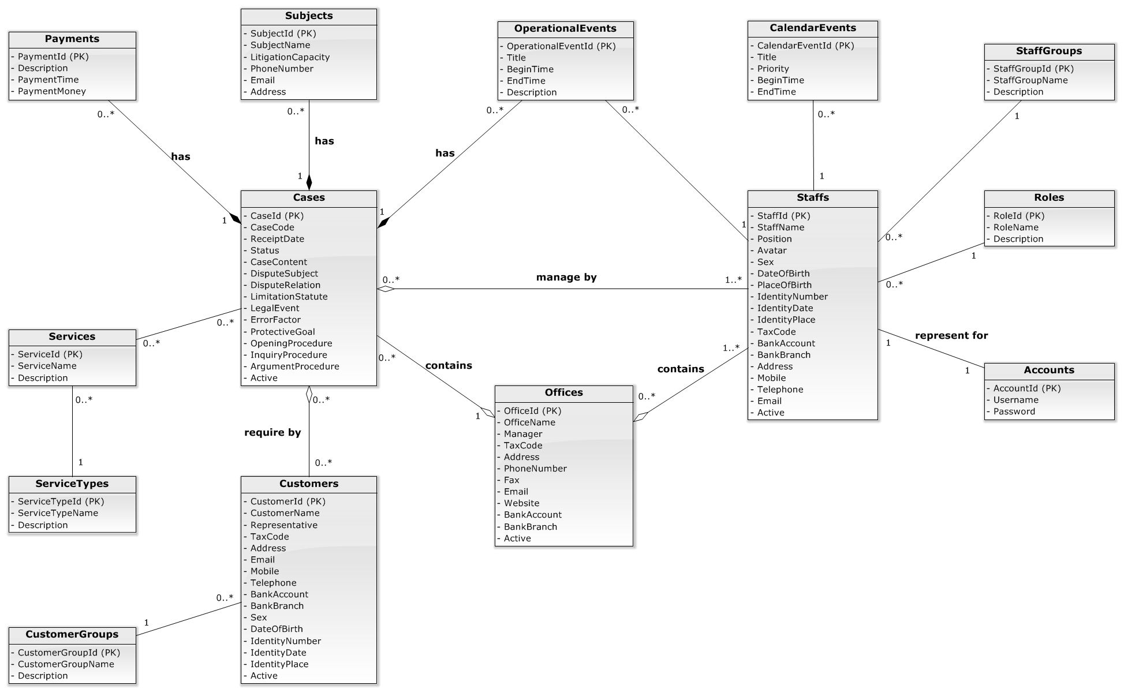

Figure 140: Entity Relationship Diagram